Creating a Custom Account Code
The FREDmart customization feature titled Custom Field and Accounting Code Defaults will be an extremely beneficial tool for users who purchase repetitively from the same account number(s). Using the User Code Favorites application will also eliminate the need to select the fiscal year on every purchase. Set-up goes like this:
- Select View My Profile
- Select Default User Settings
- Select Custom Field and Accounting Code Defaults
- In the tabs at the top, click User Codes Favorites.

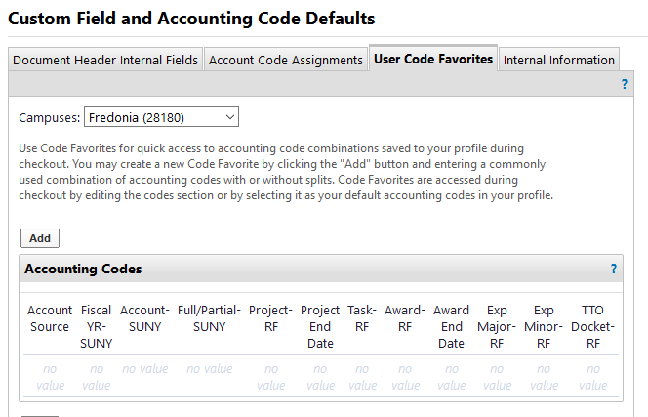

Click Add to add your favorite Accounting Codes and current Fiscal Year. Users can save more than one “favorite” accounting code, by repeating the process and save using a different name.

User ALERT: At the beginning of the new Fiscal Year, users will have to Edit and Update their defaults to the new fiscal year.
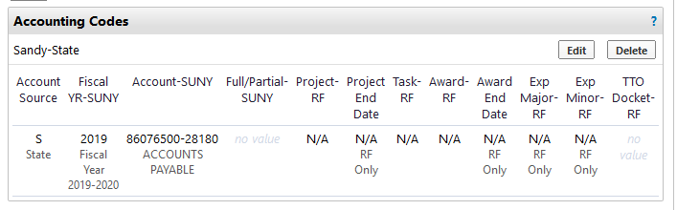
When “shopping,” user can click Accounting Codes, Edit and Select from their code favorites.

