Ordering a Non-Catalog Item
Before placing a Non-Catalog Item order, always search for the item using Shop Search as this is the only way to ensure contract pricing. If you do not find the item, create the order as Non-Catalog Item as follows:
- Click “Non-Catalog Item” from the Shortcuts options on the home page.
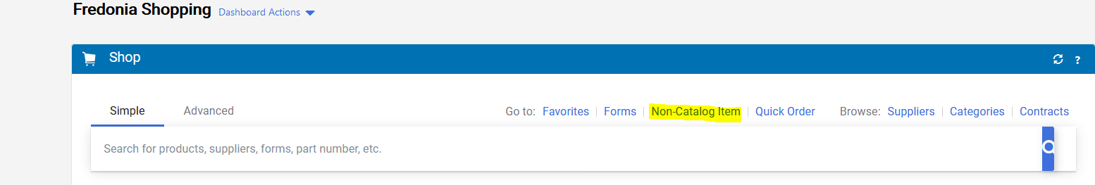
- In the Non-Catalog Item pop-up window, enter the supplier by either typing the name and then selecting from the options or clicking supplier search and selecting the supplier there.
  - If you are using State funds, you will most likely Select the supplier whose, correct, street address starts with the letter “S.”
- If the supplier you wish to use cannot be found, you must type and select New Supplier as the supplier.
- A default address Fulfillment Address (PO Address) will be listed. You may select a different fulfillment address if desired. Procurement Services will be reviewing and editing fulfillment addresses for these orders. Please note that addresses that start with an S are State addresses and addresses that start with a 180 are most likely Research Foundation (RF) addresses.
- Complete fields as follows:
  - Product Description: enter a detailed product description of the goods or services.
    - Keep in mind, the descriptions you type, must be clear and descriptive. The supplier, Fredonia, SUNY, and Office of State Comptroller will be reading the description you are typing.
  - Catalog No: enter catalog number, if applicable.
  - Quantity: enter how many units.
  - Price estimate: enter price estimate.
  - Packaging: enter unit of measure.
    - Please note: If you are submitting an order for a service or an item that is a quantity of ONE that is cost (not quantity) driven, you must select USD as the unit of measure.
  - Check boxes for any relevant features, if applicable (e.g., Recycled, Hazardous Material, etc.)
- Click “Save and Add Another Line” to add any additional items (up to a total of 40 items). Users must enter each separate item as a separate line (This includes any shipping costs, if applicable.).
- When finished adding items, click on “Add Internal Attachments” and then click on “Select Files.” You should select and attach all necessary attachments (i.e. quotes, justifications, back-up documentation, etc.) and then click “Done.”
  - Please note: If attaching multiple quotes, please attach the “winning bidders” quote as a separate attachment and the “higher bidders” as a second attachment. Please be sure to give your attachments an easy to understand name.
- Click “Save and Close.”
- Click the “shopping cart icon” at the top right-corner of the page.
- Click on “Checkout” to create a Draft Purchase Requisition.
