Searching Order Status
There are many ways users can search for their order status in FREDmart. Below are four examples.
- Users can search for any document status by using the Quick Search field in the top navigation bar.
- User can use the left navigation bar and the Order icon to search
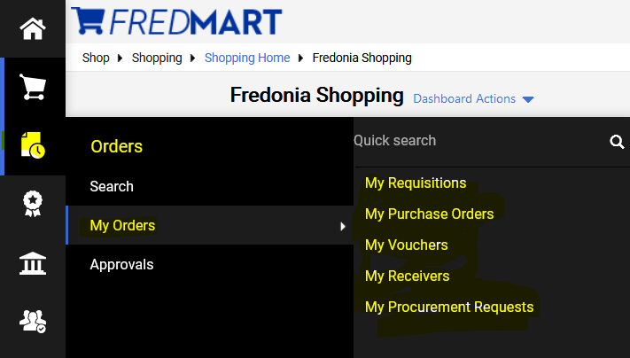
- Users can also use the My Draft Carts section, located at the bottom of the Shopping Home screen to find their requisitions.
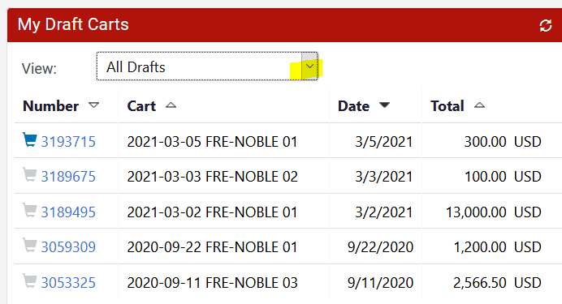
- All documents related to the purchase are linked together. Users can view all documents from any one documents. In a purchase order user can get to the linked documents using Tabs and PR Approval bar.
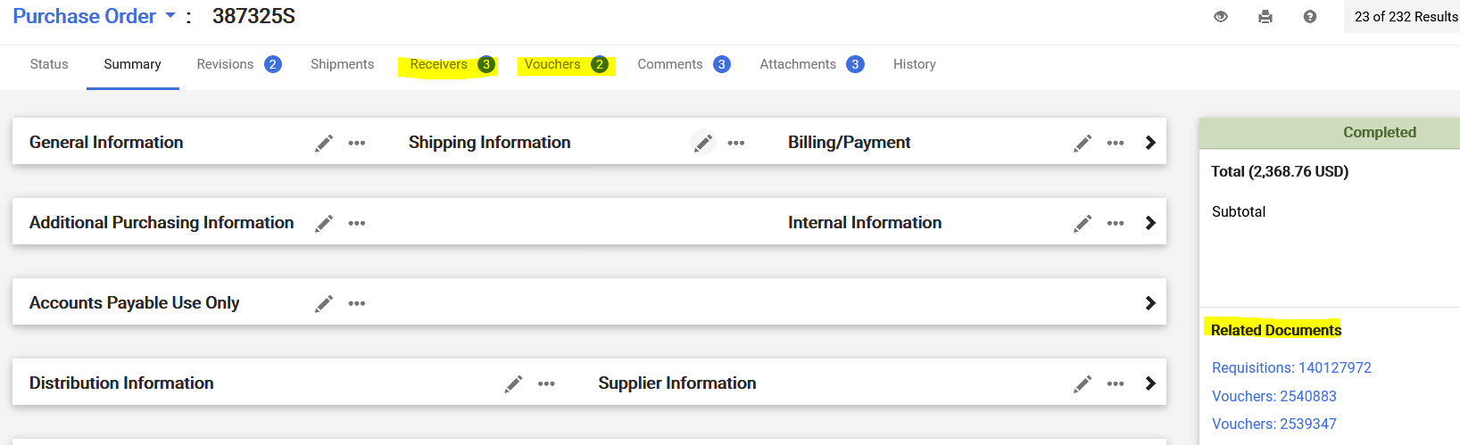

User TIP: If your order has successfully gone through FREDmart and SUNY FMS, “Revision 1” (or higher) will be displayed after the order number. “Revision 0” indicates your order is still pending.
