Using Shop Search
If not certain where to find an item, use Shop Search – On the Shopping home screen, there is a search field at the top of the screen that lets users search all Hosted Catalogs and some Punch-out Catalogs. This is a good tool to use if you would like to search multiple supplier catalogs at once.

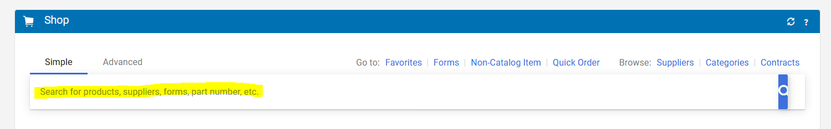

Type in the item you are looking for. Click magnifying glass or enter key to start search:
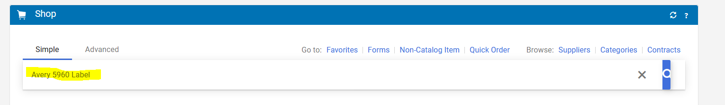

Search will pull back items, meeting the search criteria. In this example, four “Avery 5960 Labels” were found. User can use the Filters on the left side to narrow down choices OR click on each item in the results. If “Not Available for your campus” shows under the product, item is NOT available for Fredonia to purchase.
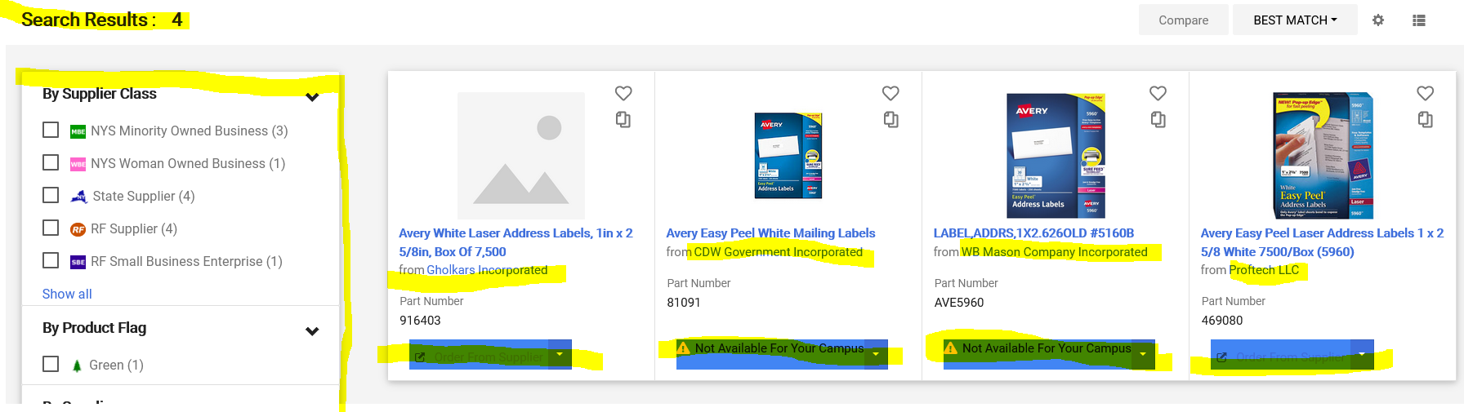

At this time, “Compare” does not display prices, so user will have to click the Gholkars and Proftech links independently to compare pricing between the two suppliers.

