Standing Order Request Form – This form is used to create a Standing AKA Blanket purchase order with a Supplier for a specific timeframe (typically lasting no longer than the SUNY “fiscal year,” which is July 1st to June 30th). A Standing Order is created for the total dollar amount estimated to be paid to the supplier for the life of the order. Standing Orders create an external PO and will encumber the funds in the account numbers listed on the PO.
Complete the sections of the form as you would for any other form:
Section 1 (Enter Supplier), select the Payee/Supplier. If user does not find the payee address, please pick “New Supplier” and have the payee complete a Substitute W9. Purchasing will process the Substitute W9 to obtain/establish a new New York State Vendor ID No. from the Statewide Financial Software (SFS) for a new payee.
Section 2 (Start and End Date), user must input a Start Date and End Date.
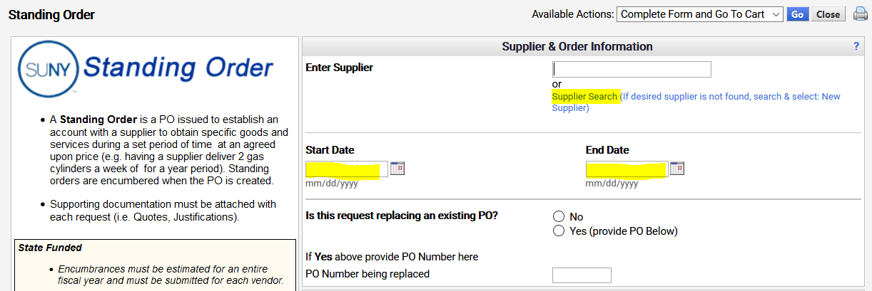
Section 3 (Replacing an existing or prior PO) can be left blank, BUT if there was a previous PO, it is extremely beneficial to list the prior PO Number.
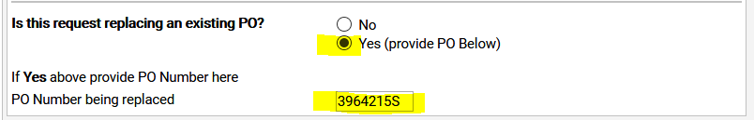

Section 4 (Justification) specify nature of the University Business and the reason(s) why a Standing Order is necessary. User MUST include justification how often the item(s) will be needed. Attach any supporting documents.
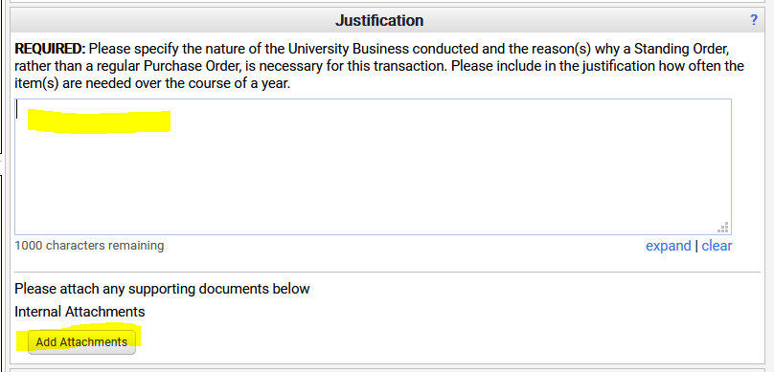
Section 5 (Information/Description) this is the item description and price that will show on the PO. Please note, quantity is 1 and Unit of Measure default to “USD – US Dollar.” All Standing/Blanket Orders are received in by creating a “Cost Receiver.”
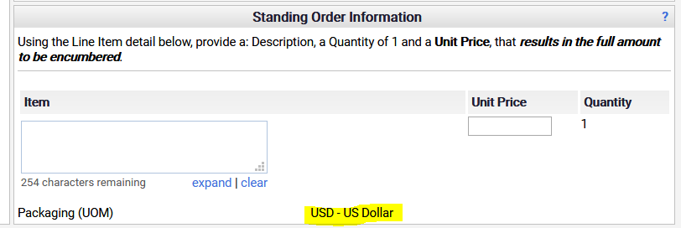
The Standing Order Request Form is designed for only one Item to be added at a time. However, a user can add multiple Items to ONE Standing Order by completing the form for the first item; going to the Available Actions (in upper right-hand corner) and selecting “Save to Cart and Add Another” then click GO.
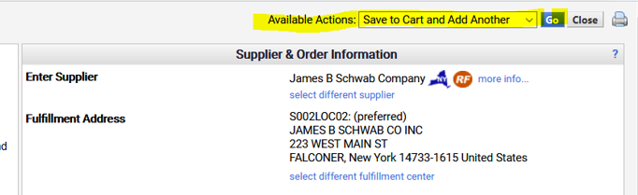

The first item will be added to the user’s Cart, the form will remain open and the user can continue adding more Items to the form by scrolling down and changing the Standing Order Information Item Description and Unit Price. When last Item has been added, go to the top and change Available Actions to “Add to Cart and Reset Form,” click GO and CLOSE.
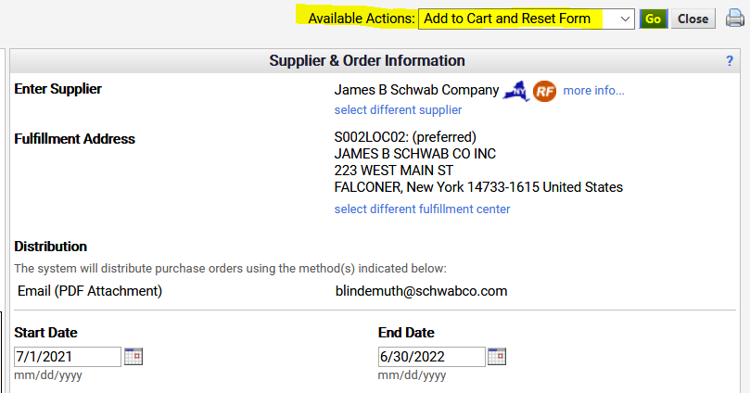

Click on your Active Cart Icon and click “Checkout” (to open a new Requisition)
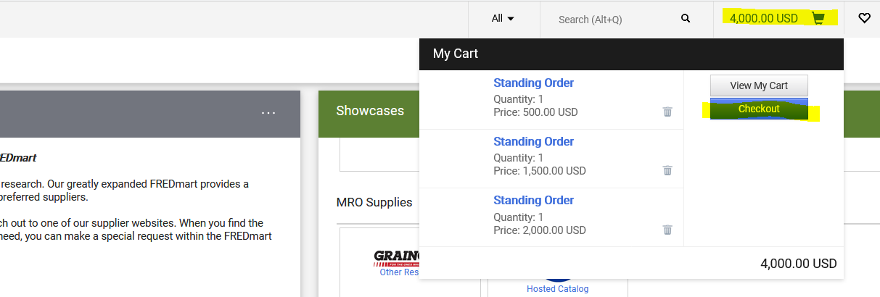
Shopping Tip: Because the “life” of a Standing Order can be for the entire fiscal year, it is HIGHLY RECOMMENDED that requisitioners use the Prepared For field (found on the General Header area) to add another employee’s name to the purchase order. Adding the Prepared For field, will allow this user to view and create Receivers throughout the “life” of the purchase order, should the Prepared By be unavailable.
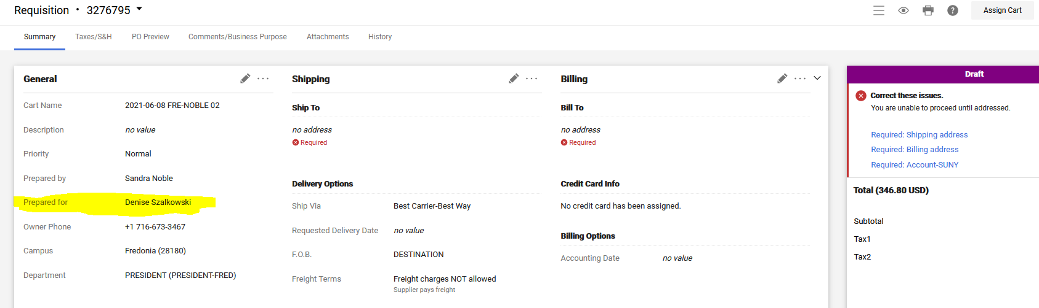

Open your Draft Cart and Correct Issues. Users should NOT click the “Required” Account SUNY” under Correct Issues. This link will add account numbers at the Header. Best Practice is to always scroll down to the Items (which are always at the bottom) and add account numbers on the Items.
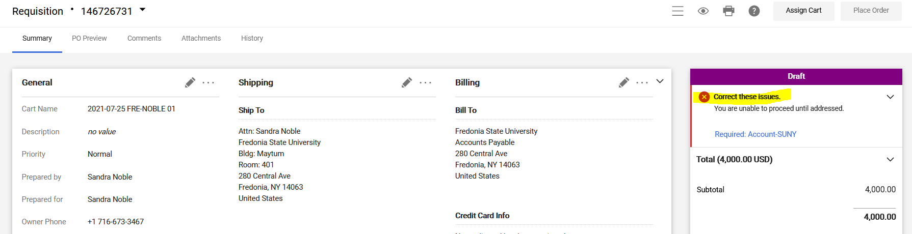
Scroll Down to the Items. Click on the 3 dots (to the right of the price) and select “Accounting Codes.”
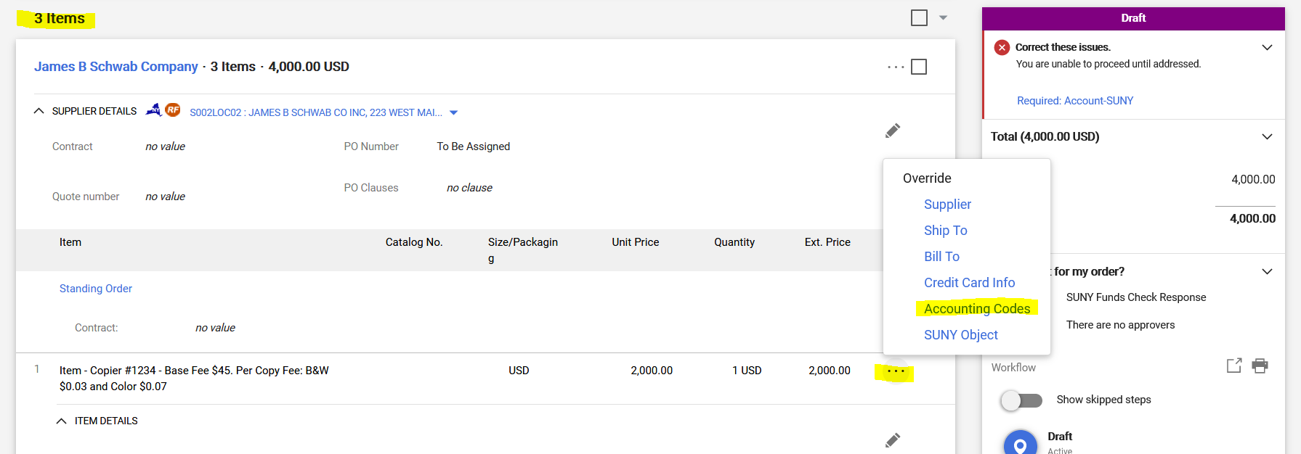

Complete the Requisition as usual.

IMPORTANT TO REMEMBER: .” All Standing/Blanket Orders are received in by creating a “Cost Receiver.”

Shopping Warning:
Users CANNOT split funding between more than one account number on a single item/line, if at the time of payment, the invoice amount will not be charged to ALL account numbers.
Example: The Athletics Department has a purchase order for “charter bus service.” The order has ONE item/line, but the funding is split between each team’s account number. The swim team takes a charter bus to a meet and the Supplier sends Accounts Payable Department an invoice. When the invoice is input into SciQuest/Jaggaer, for payment, Accounts Payable will have to delete all, but the swim team’s account number.
Not using all the account numbers split on the item/line is creating an issue in SUNY FMS. The encumbrance is being reduced on the first account number showing on the order, but the expense is being charged to the swim team.
When creating requisitions, the user CANNOT split funding between more than once account number on a single item/line, if the invoice is not going to be paid against ALL the account numbers.
SOLUTION: – The Athletics Department will create an order with multiple items/lines. Instead of ONE item/line for “charter bus service.” The order will have:
Item #1 “Charter bus service for swim team,”
Item #2 “Charter bus service for basketball team,”
Item #3 “Charter bus service for hockey team,” etc.
Each item/line will have the team’s account number.
This solution is best, because SciQuest/Jaggaer will automatically calculate and display each team’s beginning balance, amount invoiced and remaining balance.

Advance User Reminder: If you have created any Custom Account Codes, you can add them by typing in the name you assigned. See Creating a Custom Account Code for more details.

