Cart Management
A powerful function within Jaggaer is the “Shopping Cart” module, which allows the user to create, compile, maintain, and manage multiple carts, in various stages of completion, all at one time and in one place. Please reference the Site Navigation Guide to learn more about the navigational tool bars and how to access shopping carts.
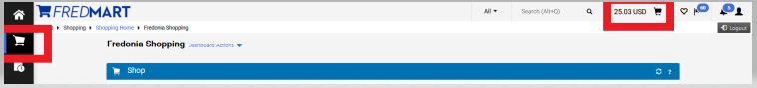
Clicking the Cart icon will open a list of ALL your carts
This is your ACTIVE cart

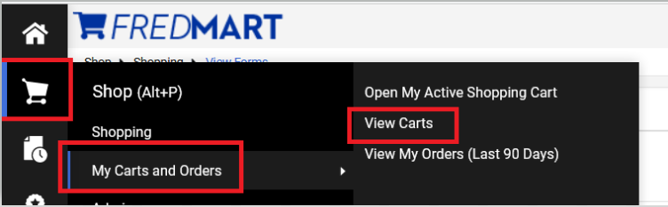

After clicking “View Carts,” user will be brought to the “Cart Management” page. Notice along the top of the page users may see three different tabs; “Draft Carts,” “Assigned Carts” and “Shared Carts.” In this guide we will only be looking at how to manage “Draft Carts.” Draft Carts are carts you created and have not yet clicked on Proceeded to Checkout.
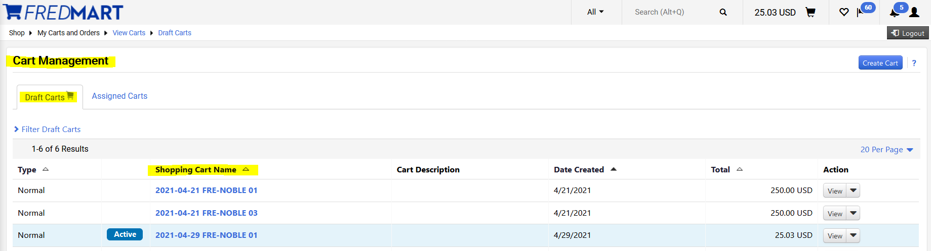

Users can create carts from the Cart Management page, by clicking on “Create Cart.”
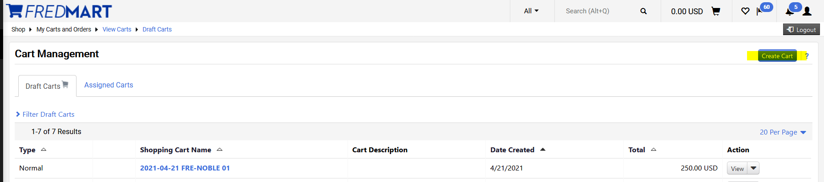

After clicking on “Create Cart,” user will be brought to the “Shopping Cart” screen. Users can use the Simple or Advance Search field OR by clicking on the 3 dots located on the right, user can go directly to a Non-catalog Item, Favorites or Specialty Form.
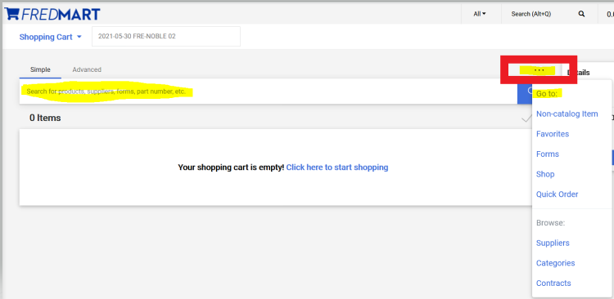

Users can also create a new cart, by clicking on the Shopping Cart drop-down arrow and clicking on Create New Cart.
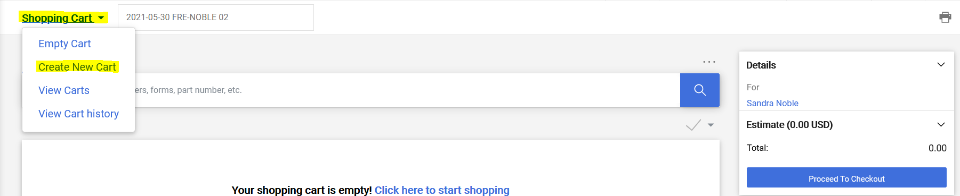

Please know that Jaggaer has a default cart naming convention. Jaggaer will automatically name the new cart using current date, user’s campus code and name, and number of carts created on that date. Users are highly encouraged to change that name of their cart to a name that will help them and any user they will Assign their cart to, stay better organized.
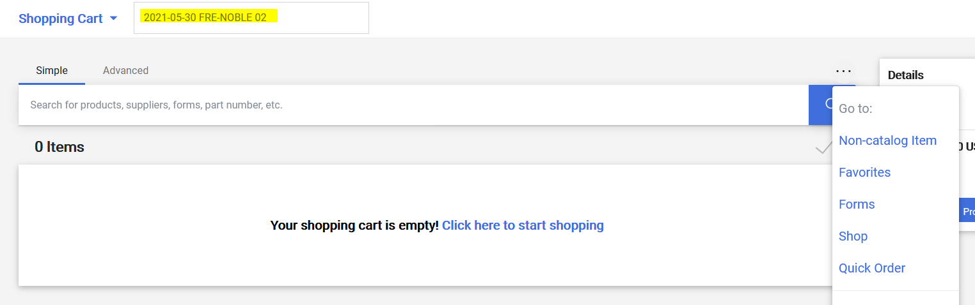

Using the steps above, I have now created two new carts, which I can see by clicking on “View Carts.”
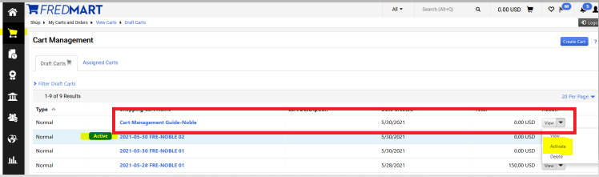

The ACTIVE cart will be the cart the user last created or worked on last. Users, at any time, can switch between carts by clicking on the cart they need to work on. Scrolling to the right, click on the drop-down arrow next to View and selecting Active.

To open and work on the Active cart, click View.
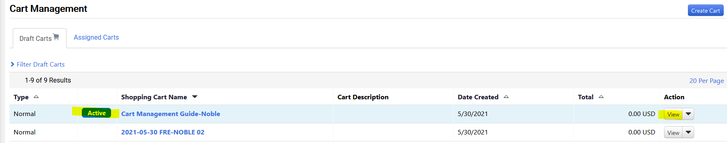

Users can complete carts as usual and click on Proceed to Checkout when ready to create the Requisitions and move through the approval workflow and be made into a Purchase Order.

Please reference the Assigning a Cart Guideline if your cart needs to be assigned to another user, before it can move through the approval workflow.

