Setting up Your Default Ship To and Bill To Addresses
Also, in View My Profile on the Default Addresses link, users should set their default Ship To and Bill To Addresses. Setting these addresses in your profile will save you time each time a purchase requisition is created. Click on the Ship To Tab, click FRE-Campus Default on the left (located under Shipping Addresses)
Check the Default box and type in your Bldg. and Room, click Update when finished.
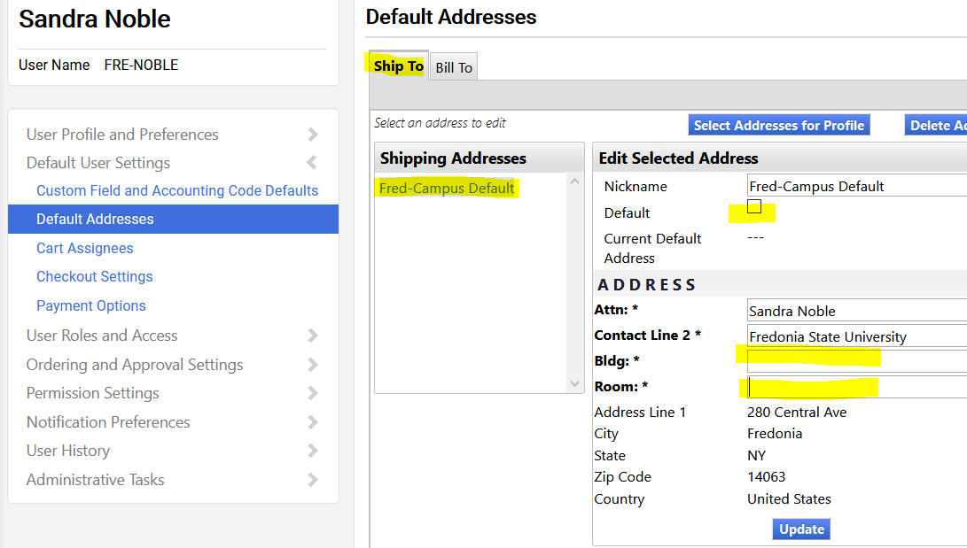

On the Bill To Tab, click FRED – Bill To on the left (located under Billing Addresses).
Check the Default box and click Update when finished.
