Shopping a Punch-out Catalog
When purchasing through Punch-out Catalogs, user will be redirected to the supplier’s website, where user will create their cart, and then when user checks out of that website, user will return to FREDmart. Back in FREDmart, the items added at the supplier’s website will be in one FREDmart cart.
It is important to note that a single FREDmart cart cannot mix on-contract and not on-contract items, so once back in FREDmart, be sure to check that your cart only has one type of item and that all the items have the same contract number.
- On the Shopping home page, click on a punch-out supplier’s catalog or use Shop Search.
- Create your order at the supplier’s website and click “Checkout or Submit” (appearance/wording of supplier websites will differ).
- Back in FREDmart, carefully look at all lines to be sure each item for a contract number. If some of the items do not have a contract number or the contract numbers vary, check the box to the right of the item that is NOT on-contract and then select “Move to Another Cart” (which will then need to be processed in the separate cart, see step 5).
- Once all items have a contract number, you can name your cart if you wish and then continue with your order. Click “Assign Cart” if you need to assign the order to someone else to complete the order or click “Proceed to Checkout” if you are ready to complete the order by turning the cart into a draft purchase requisition.
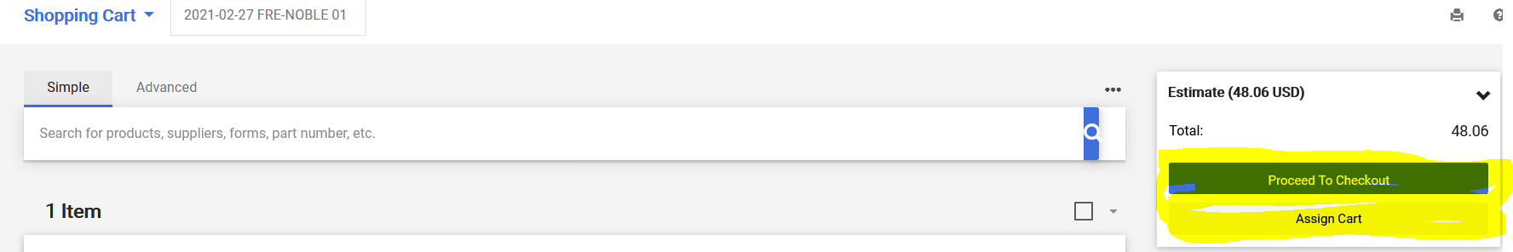

- If any items were moved to another cart (in step 3), navigate to the draft shopping cart and then continue with that cart by proceeding with steps 4.

