Site Navigation
There are two main navigation toolbars: One at the top and one on the left, which allow for easy access to FREDmart functions:
At the top -
- The blue highlighting is a drop down for your PO’s
- The green highlighting is your search bar to do searches in FREDmart
- The yellow highlighting is your shopping cart.
- The purple highlighting is a bookmark option
- The pink highlighting is your action items and notifications and:
- The orange is your profile drop down.

At the left –
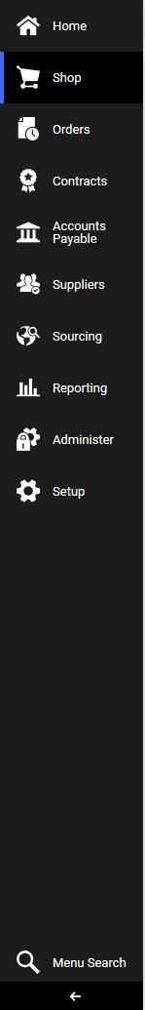
Click on the arrow at the bottom of the Navigation Bar to toggle between showing and not showing icon descriptions

