Understanding and Accessing FREDmart
FREDmart is an online requisition/purchasing tool. When users shop, items are routed through various stages: From shopping, through to any necessary approvals, the purchase order being sent to the supplier, the good/service being received, and then the account being payable to the supplier. Here is a sample workflow:
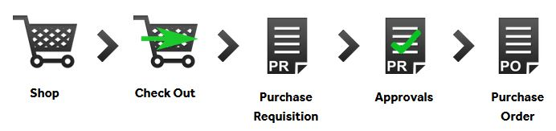
The two (2) primary user roles in FREDmart are Requester and Approver. Your access depends on your role. Because of these roles, a purchase may go through multiple people before officially becoming a Purchase Requisition.
- Requesters - Can “shop” by creating a shopping cart. Complete the accounting information and submit the “cart” for Authorized Signatory approval.
- Approvers - Can do everything a Requester can do, plus they are responsible for reviewing each line and approve and reject any as needed

FREDmart is an SSL (single sign-on link), so users must be logged into SUNY before clicking the FREDmart link.
If you are accessing FREDmart for the first time, please make sure you have first reached out the Director of University Accounting to make sure you are set-up with the correct access.

