User Guide

AKA SciQuest and/or Jaggaer

Revision Date: May 30, 2021

Table of Contents

Understanding and Accessing FREDmart 3
Setting up Your Profile 3
Setting up Your Default Ship To and Bill To Addresses 4
Changing Your Notification Preferences 5
Creating a Custom Account Code 6
Site Navigation 7
Shopping Overview 10
Using Shop Search 12
Shopping a Hosted Catalog 13
Shopping a Punch-out Catalog 14
Ordering a Non-Catalog Item 15
Order using a Special Request Form 16
Adding Account Number to a Purchase Requisition 16
Cart Management 19
Assigning a Cart 22
Ordering for Another Department/Altering Approval Workflow Using “Prepared for” 23
Purchase Requisition Navigation and Overview 24
Purchase Requisition Approval 27
Receiving 29
Searching Order Status 31
Returned Requisition 32
Housekeeping 33

Understanding and Accessing FREDmart
FREDmart is an online requisition/purchasing tool. When users shop, items are routed through various stages: From shopping, through to any necessary approvals, the purchase order being sent to the supplier, the good/service being received, and then the account being payable to the supplier. Here is a sample workflow:
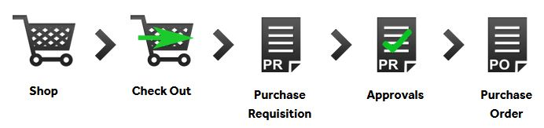
The two (2) primary user roles in FREDmart are Requester and Approver. Your access depends on your role. Because of these roles, a purchase may go through multiple people before officially becoming a Purchase Requisition.
- Requesters - Can “shop” by creating a shopping cart. Complete the accounting information and submit the “cart” for Authorized Signatory approval.
- Approvers - Can do everything a Requester can do, plus they are responsible for reviewing each line and approve and reject any as needed

FREDmart is an SSL (single sign-on link), so users must be logged into SUNY before clicking the FREDmart link.
If you are accessing FREDmart for the first time, please make sure you have first reached out the Director of University Accounting to make sure you are set-up with the correct access.

Setting up Your Profile
Your profile in FREDmart allows you to set-up basic information about yourself and allows you to customize your notification features. To get started, access your profile and check your User Profile like this:
Click the PERSON icon at the top (right highlighted in orange) and

Select View My Profile
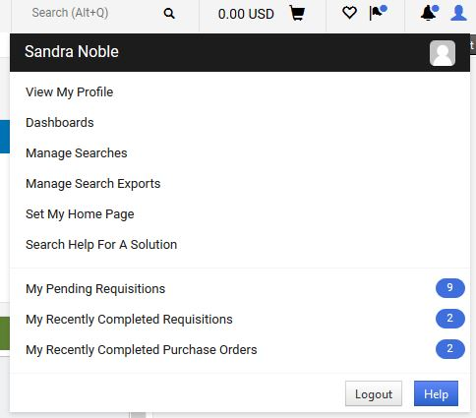

On the left, select User’s Name, Phone Number, Email, etc.; confirm the information is correct. If not correct, edit the fields you can, and then click Save. For fields you cannot edit, contact your FREDmart Campus Administrator (the Director of University Accounting).
PLEASE BE SURE TO INPUT YOUR OFFICE PHONE NUMBER!
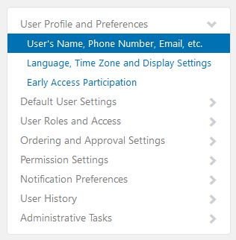
Set Billing and Ship To Default Addresses by clicking on the Default User Settings and Default Addresses:
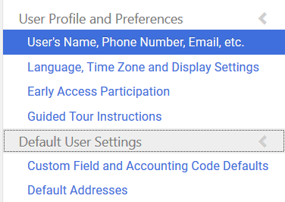

Setting up Your Default Ship To and Bill To Addresses
Also, in View My Profile on the Default Addresses link, users should set their default Ship To and Bill To Addresses. Setting these addresses in your profile will save you time each time a purchase requisition is created. Click on the Ship To Tab, click FRE-Campus Default on the left (located under Shipping Addresses)
Check the Default box and type in your Bldg. and Room, click Update when finished.
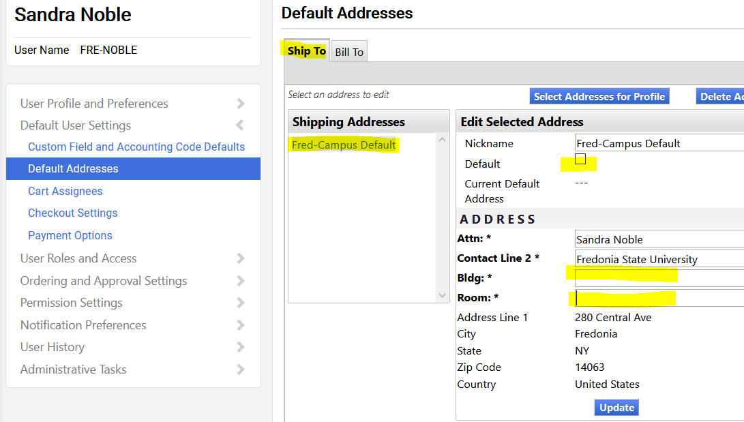

On the Bill To Tab, click FRED – Bill To on the left (located under Billing Addresses).
Check the Default box and click Update when finished.
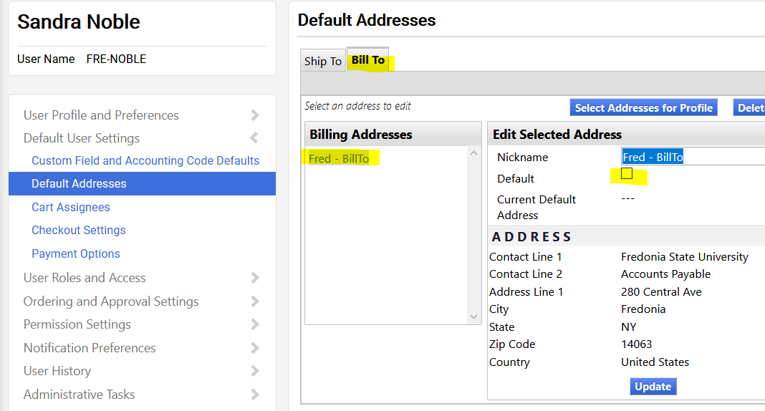

Changing Your Notification Preferences
Each user can customize various in-application functions by changing their Notification Preferences. As we become more familiar with FREDmart, users may change their preferences, to reduce the amount of emails they receive from FREDmart. To change your preferences, in View My Profile on the left then select Notification Preferences. Each user’s Notification Preference choices will vary depending on their FREDmart “role(s).” Select the notification category you would like to change, either Administration & Integration; Shopping, Carts & Requisitions; or Purchase Orders – Make sure you click EDIT SELECTION on the upper right had side.
Click OVERRIDE on any in-application functions you would like to customize. Using the dropdown arrow to the right of OVERRIDE, select the type of notification you would like to receive.
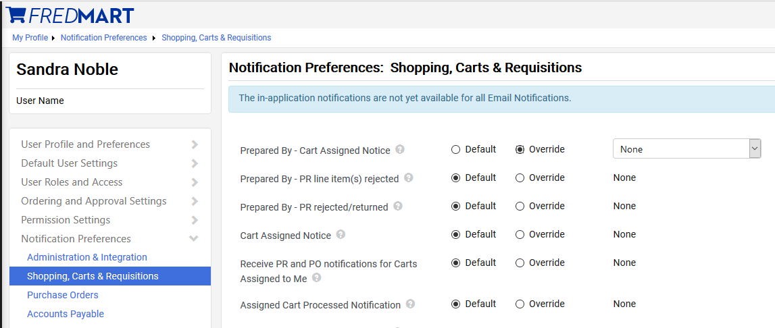

Creating a Custom Account Code
The FREDmart customization feature titled Custom Field and Accounting Code Defaults will be an extremely beneficial tool for users who purchase repetitively from the same account number(s). Using the User Code Favorites application will also eliminate the need to select the fiscal year on every purchase. Set-up goes like this:
- Select View My Profile
- Select Default User Settings
- Select Custom Field and Accounting Code Defaults
- In the tabs at the top, click User Codes Favorites.
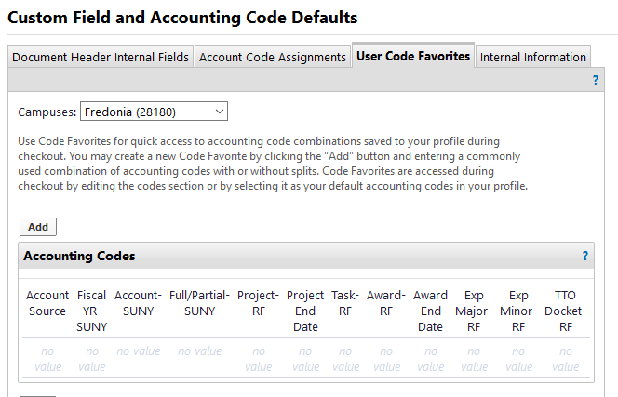
Click Add to add your favorite Accounting Codes and current Fiscal Year. Users can save more than one “favorite” accounting code, by repeating the process and save using a different name.

User ALERT: At the beginning of the new Fiscal Year, users will have to Edit and Update their defaults to the new fiscal year.
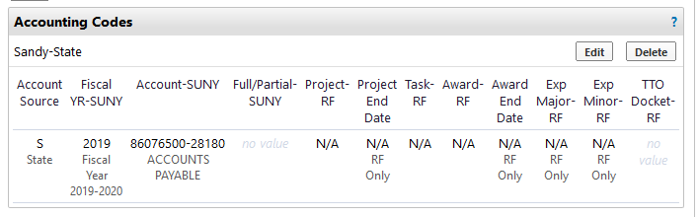
When “shopping,” user can click Accounting Codes, Edit and Select from their code favorites.

Site Navigation
There are two main navigation toolbars: One at the top and one on the left, which allow for easy access to FREDmart functions:
At the top -
- The blue highlighting is a drop down for your PO’s
- The green highlighting is your search bar to do searches in FREDmart
- The yellow highlighting is your shopping cart.
- The purple highlighting is a bookmark option
- The pink highlighting is your action items and notifications and:
- The orange is your profile drop down.
At the left –
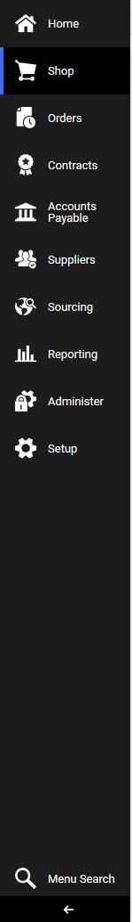
Click on the arrow at the bottom of the Navigation Bar to toggle between showing and not showing icon descriptions

Shopping Overview
There are many ways to create orders in FREDmart. Users can submit a catalog order, non-catalog item order, and order using forms. This section will provide details on these different order types, so users can have a better understanding of what they are and which order type to use.
Ordering from the catalogs and using the Non-Catalog Form will be the two most popular ways users will create the majority of their orders.
- Catalog Orders - A catalog is a supplier’s product offering. There are two types of catalogs, hosted and punch out. Catalogs are found on the Home page under the Showcase section. These are described below.
- Hosted Catalog – In simplest terms, a hosted catalog is an online version of a supplier’s printed
catalog. Hosted catalogs are created and maintained by SUNY and contain product data and details, along with pricing information
for each item. When a product search is performed, the products in all of the hosted catalogs
are searched. Hosted catalog search results contain product information from all suppliers
depending on the search criteria entered by the user.
- Punch-out Catalogs – Punch-out catalogs are integrated EXTERNAL links to a supplier’s web-based catalog. Purch-out catalogs are crated and maintained by the supplier. The user exits the FREDmart application to search and select products from a supplier’s external web catalog, then returns the items to the FREDmart shopping cart. The selected items are then submitted through the standard requisition/order process. Punch-out products are NOT included in product search.

The first step is determining if the items you need to purchase are available from one of the catalogs. This can be done by clicking on the catalog.
Shopping Tip: Not certain where to find an item, use Shop Search – On the Shopping home screen, there is a search field at the top of the screen that lets users search all Hosted Catalogs and some Punch-out Catalogs.
Using Shop Search is a Best Practice, because user can search multiple catalogs at once.

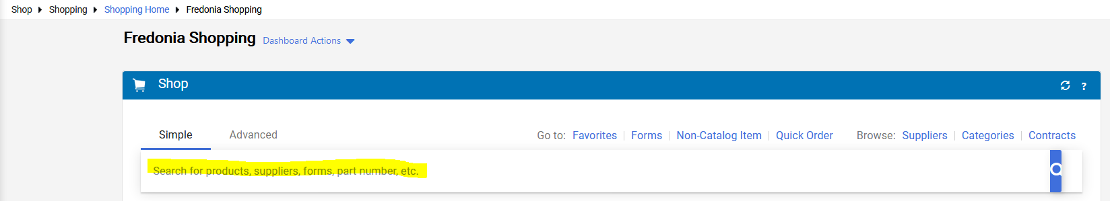
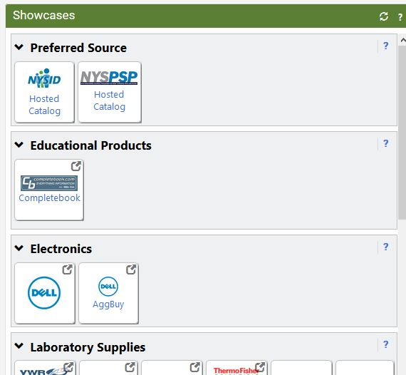

If the items you are purchasing are not found in a catalog, users will most likely then go to the Non-Catalog Form. However, some types of purchases may warrant the use of one of the Special Forms.
- Non-Catalog Item Orders – A non-catalog item order is an order for encumbered goods or services where there is not a hosted or punch-out catalog OR for items in which you receive special price quotes from a supplier. The non-catalog item order will send the supplier a purchase order. Non-Catalog Item Orders are created on the Home page under the Shop section.
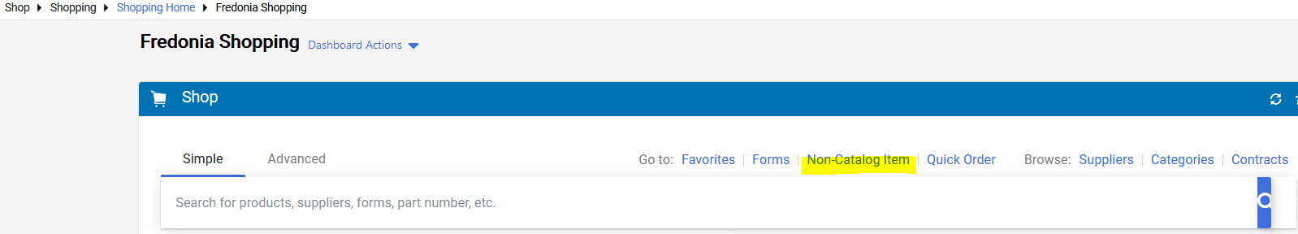

- Forms – Forms assist users with creating blanket orders and collecting the necessary information for specific types of non-encumbered payments. Forms are located on the Home page, at the bottom of the Showcase section under the Special Requests section. SUNY campuses have the ability to create and utilize different forms. FREDmart is currently using these forms:

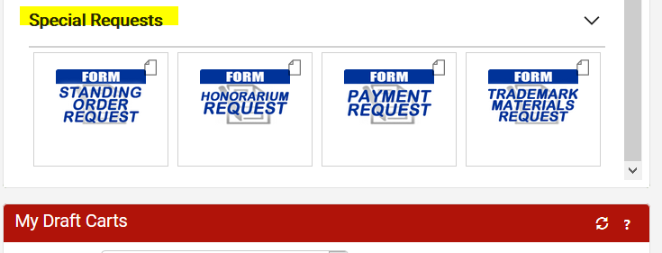

- Standing (Blanket) Order Request – This form is used to create orders that will (normally) be open for the entire fiscal year (July 1 through June 30). Departments and Buyers will work together to establish an annual encumbrance amount, based on the prior 2-3-year average. This form will create and send an external order to the supplier and encumber the expense.
- Honorarium Request - This form is used for payments to lecturers, guest speakers and any individual performing a service for our campus. Honorariums are a one-time payment for short-duration service (usually just one day, but not to exceed four consecutive days) and relatively small dollar amount (generally under $2,500). An honorarium is an ex gratia payment (i.e., the College has no obligation or liability to pay it); honorarium payments may not be used for the services of an independent consultant or independent contractor. Payee must be an individual (not a business entity) and payee cannot be performing a service in any way related to their NYS employment. An Honorarium Request Form signed by the payee must be attached to the requisition. A Substitute W9 should be attached. All Honorariums will be routed to Human Resources for employment review. Any Honorarium totaling $600 or more will be routed to our Contracts Department for contract approval, so be sure to allow enough time for processing.
- Payment Request - This form is used for payment of unencumbered goods such as dues and memberships or a one-time emergency service and repairs performed by a business entity (not an individual). FREDmart does not convert Payment Request Forms into an external order. User must have an invoice in-hand before using this form.
- Trademark Materials Request – This form must be used for any requests involving Campus logo imprinted materials. This includes; apparel, signage, banners, exact reprints, anything that has our logo. Form is also used when user needs artwork to be crated by the Publications Department. This form is routed to the Trademark and Licensing Committee and Publications Department.

All catalogs and forms are located on the Home page under the Showcase section.

Using Shop Search
If not certain where to find an item, use Shop Search – On the Shopping home screen, there is a search field at the top of the screen that lets users search all Hosted Catalogs and some Punch-out Catalogs. This is a good tool to use if you would like to search multiple supplier catalogs at once.

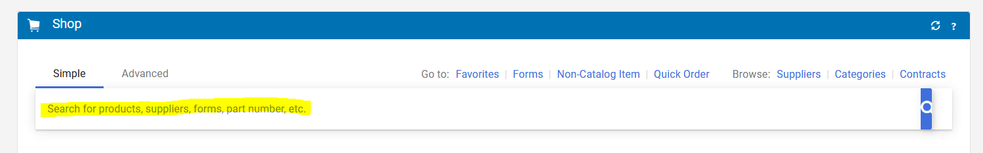

Type in the item you are looking for. Click magnifying glass or enter key to start search:
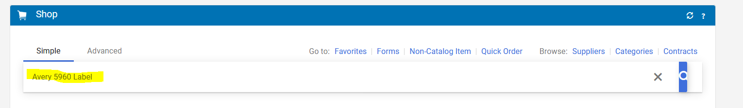

Search will pull back items, meeting the search criteria. In this example, four “Avery 5960 Labels” were found. User can use the Filters on the left side to narrow down choices OR click on each item in the results. If “Not Available for your campus” shows under the product, item is NOT available for Fredonia to purchase.
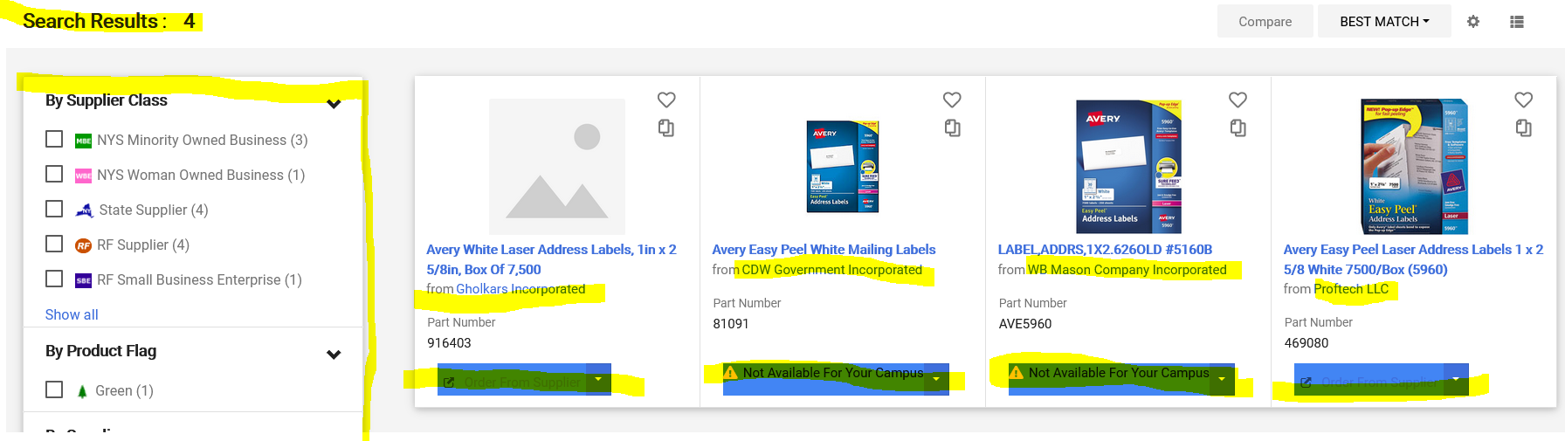

At this time, “Compare” does not display prices, so user will have to click the Gholkars and Proftech links independently to compare pricing between the two suppliers.

Shopping a Hosted Catalog
- When purchasing through Hosted Catalogs, users search for the items directly in FREDmart.
Shopping ALERT: To stay within our MWBE vendor requirements, please shop from the “Preferred Source” catalogs, whenever feasible.
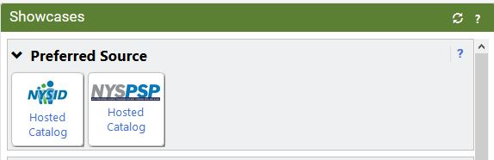

- Click on the Hosted Catalog. Users will know a vendor is a Hosted Catalog if a search box displays when they click on the vendor name.
- In the catalog search box that pops up, type the part number or item name and click the Search icon.
- You can filter the search results by using the Filter Results on the left of the screen. Always us Preferred Sources Suppliers before any other supplier class. In the near future, SUNY Research orders will also go through FREDmart, be sure you are using a State Supplier Class for state purchases. 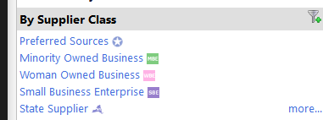
- To the right of the item you would like to purchase, enter the quantity needed and click “Add to Cart.”
- Continue to search for and add any other items needed from that supplier and then go to your cart by clicking the shopping cart icon at the top of the page and then click “View My Cart.”
- Note: For hosted catalog (and punch-out) purchases, do not add a Non-Contract items to your cart.
- Users can name their cart if they wish and then continue with order. Click “Assign Cart” if you need to assign the order to someone else to complete the order or click “Proceed to Checkout” if you are ready to complete the order by turning the cart into a draft purchase requisition.
Best Practice: Create and add items to a Shopping List whenever possible. Creating one large order once a week rather than several small orders every few days makes the workflow easier to follow and maintain.

It is important to note that a single FREDmart cart cannot contain both on-contract and not on-contract items, so once back in FREDmart, be sure to check that your cart only has one type of item. For on-contract items, user’s cart can also contain only ONE contract number per cart.

Shopping a Punch-out Catalog
When purchasing through Punch-out Catalogs, user will be redirected to the supplier’s website, where user will create their cart, and then when user checks out of that website, user will return to FREDmart. Back in FREDmart, the items added at the supplier’s website will be in one FREDmart cart.
It is important to note that a single FREDmart cart cannot mix on-contract and not on-contract items, so once back in FREDmart, be sure to check that your cart only has one type of item and that all the items have the same contract number.
- On the Shopping home page, click on a punch-out supplier’s catalog or use Shop Search.
- Create your order at the supplier’s website and click “Checkout or Submit” (appearance/wording of supplier websites will differ).
- Back in FREDmart, carefully look at all lines to be sure each item for a contract number. If some of the items do not have a contract number or the contract numbers vary, check the box to the right of the item that is NOT on-contract and then select “Move to Another Cart” (which will then need to be processed in the separate cart, see step 5).
- Once all items have a contract number, you can name your cart if you wish and then continue with your order. Click “Assign Cart” if you need to assign the order to someone else to complete the order or click “Proceed to Checkout” if you are ready to complete the order by turning the cart into a draft purchase requisition.
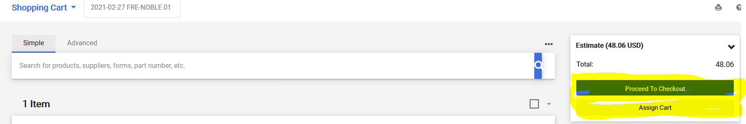

- If any items were moved to another cart (in step 3), navigate to the draft shopping cart and then continue with that cart by proceeding with steps 4.

Ordering a Non-Catalog Item
Before placing a Non-Catalog Item order, always search for the item using Shop Search as this is the only way to ensure contract pricing. If you do not find the item, create the order as Non-Catalog Item as follows:
- Click “Non-Catalog Item” from the Shortcuts options on the home page.
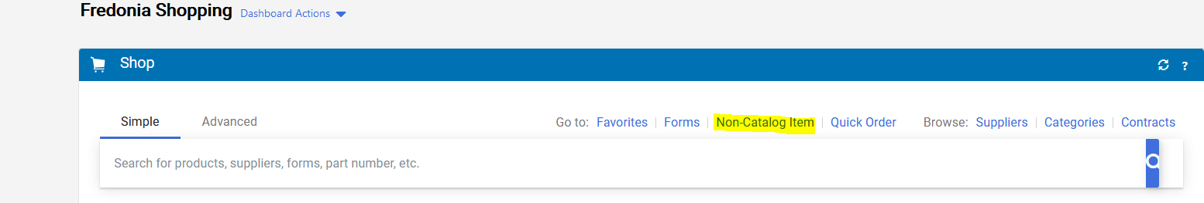
- In the Non-Catalog Item pop-up window, enter the supplier by either typing the name and then selecting from the options or clicking supplier search and selecting the supplier there.
  - If you are using State funds, you will most likely Select the supplier whose, correct, street address starts with the letter “S.”
- If the supplier you wish to use cannot be found, you must type and select New Supplier as the supplier.
- A default address Fulfillment Address (PO Address) will be listed. You may select a different fulfillment address if desired. Procurement Services will be reviewing and editing fulfillment addresses for these orders. Please note that addresses that start with an S are State addresses and addresses that start with a 180 are most likely Research Foundation (RF) addresses.
- Complete fields as follows:
  - Product Description: enter a detailed product description of the goods or services.
    - Keep in mind, the descriptions you type, must be clear and descriptive. The supplier, Fredonia, SUNY, and Office of State Comptroller will be reading the description you are typing.
  - Catalog No: enter catalog number, if applicable.
  - Quantity: enter how many units.
  - Price estimate: enter price estimate.
  - Packaging: enter unit of measure.
    - Please note: If you are submitting an order for a service or an item that is a quantity of ONE that is cost (not quantity) driven, you must select USD as the unit of measure.
  - Check boxes for any relevant features, if applicable (e.g., Recycled, Hazardous Material, etc.)
- Click “Save and Add Another Line” to add any additional items (up to a total of 40 items). Users must enter each separate item as a separate line (This includes any shipping costs, if applicable.).
- When finished adding items, click on “Add Internal Attachments” and then click on “Select Files.” You should select and attach all necessary attachments (i.e. quotes, justifications, back-up documentation, etc.) and then click “Done.”
  - Please note: If attaching multiple quotes, please attach the “winning bidders” quote as a separate attachment and the “higher bidders” as a second attachment. Please be sure to give your attachments an easy to understand name.
- Click “Save and Close.”
- Click the “shopping cart icon” at the top right-corner of the page.
- Click on “Checkout” to create a Draft Purchase Requisition.
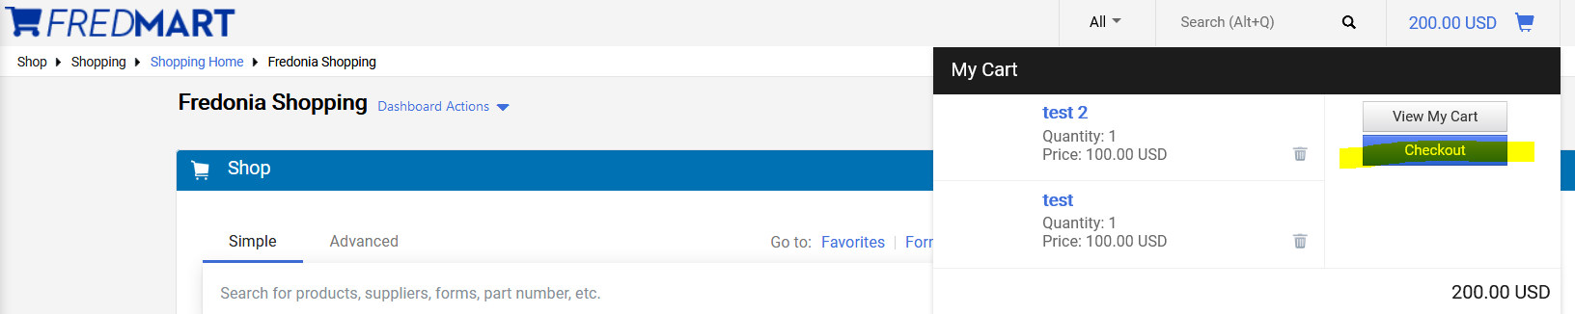

Ordering using a Special Request Form
Before placing an order using a Specialty Form, please review the Ordering Overview Section to make sure the appropriate form is being used in the correct way. Once you have determined that a Specialty Form is the appropriate way to place your order, use the instructions below:
- Select the appropriate form and follow the instructions while entering information for all of the required fields. If a form requires attachments, you must include the required attachments by clicking on the Add Attachments button. If a supplier cannot be found, you must enter “New Supplier” as the supplier name.

- Once all sections of the form are complete, scroll to the top of the form and select “Update” from the Available Actions dropdown and then click on “Go.”

- After that, select “Complete Form and Go To Cart” from the “Available Actions” dropdown and then click on “Go.”
- Click the “shopping cart icon” at the top of the page and click “View My Cart.”
- You can name your cart if you wish and then continue with your order. Click “Assign Cart” if you need to assign the order to someone else to complete the order or click “Proceed to Checkout” if you are ready to complete the order by turning the cart into a draft purchase requisition.

- If you forgot to include any required information on the form, you will be prompted with an error message at the top of the Requisition screen after you click “Proceed to Checkout.” If you click on the error message it will take you back to the form and highlight any required fields that were left blank. Once all sections of the form are complete, scroll to the top of the form and select “Update” from the “Available Actions” dropdown and then click on “Go.” Then click “Close.” The error message referencing the form should be gone.

Adding Account Numbers to a Purchase Requisition

Account numbers can be added at the “Header” or on each “Line” in a Requisition. Where on the Requisition to add the account number(s) plays a critical role in the ability to update the purchase order in the future. Requisitioners should always take into consideration the longevity of the purchase order and the possibility of further changes when deciding whether to add the account number to the “Header” or to the “Line.”

Adding the account number(s) to the “Line” is always the best option, especially when the Requisition:
- WILL BE TURNED INTO A STANDING/BLANKET PURCHAE ORDER.
- Has, even the slightest chance of being updated or Changed after the purchase order is created.
- Contains multiple lines, in which one line is being charged to one account number and another line is being charged to another account number.
Adding the account number(s) to the “Header” is an acceptable option when the Requisition:
- WILL NOT BE TURNED INTO A STANDING/BLANKET PURCHASE ORDER.
- Contains multiple lines all being charged to the same account number.
- Contains multiple lines all being charged to the same account numbers, using “Percentage of Splits.”

Shopping Tip: Adding account number(s) at the “Header” will override any account number on the “Line.” Account number(s) should be added at the “Header” or at the “Line,” but NOT in both places!

There are a couple ways to navigate to the “Header:”
- After Checkout the requisitioner is brought to the Draft Requisition (the coding/review stage). SciQuest/Jaggaer, on the right-hand side, under Correct these items (if a user has not saved a favorite account number) Required: Account-SUNY is a link. If the requisitioner clicks on the Correct these items Required: Account-SUNY link, the account number field that is automatically brought-up is the “Header.”
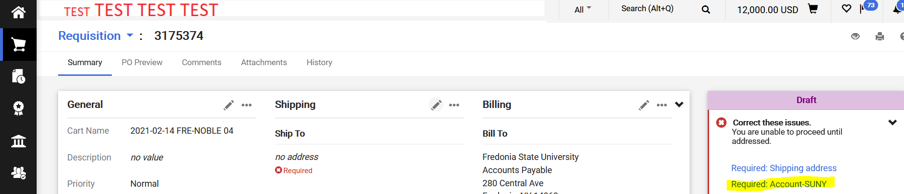

- Requisitioner can also get to the “Header,” by scrolling down the Draft Requisition to the Accounting Codes section
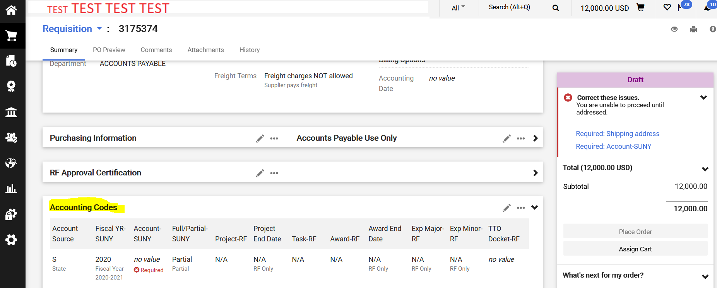

To navigate to the “Line,” requisitioner must scroll to the bottom of the Draft Requisition to get to the Items section. Once account number(s) have been added to the first line, user can Copy the information to subsequent lines.
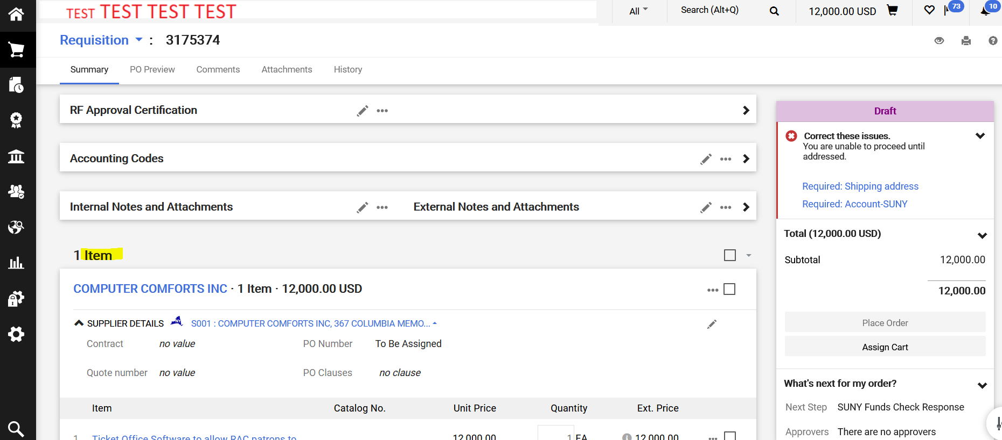
Shopping Tip: How do you know if you are at the “Header” or the “Line?” Notice in the above print screen, the Accounting Codes section above the Lines (Items) is the “Header” (Header is collapsed in the print screen to save space). Lines (Items) that contain account numbers, below the line description is account numbers on the “Line.”
To add account numbers at the Line, the requisitioner can click on the (three dots) … icon and select Override Accounting Codes. Then follow the same Search and Select key strokes to add the account number(s) to the Line. At the Line level, Percentage of Splits or Amount of Splits transactions can be performed.

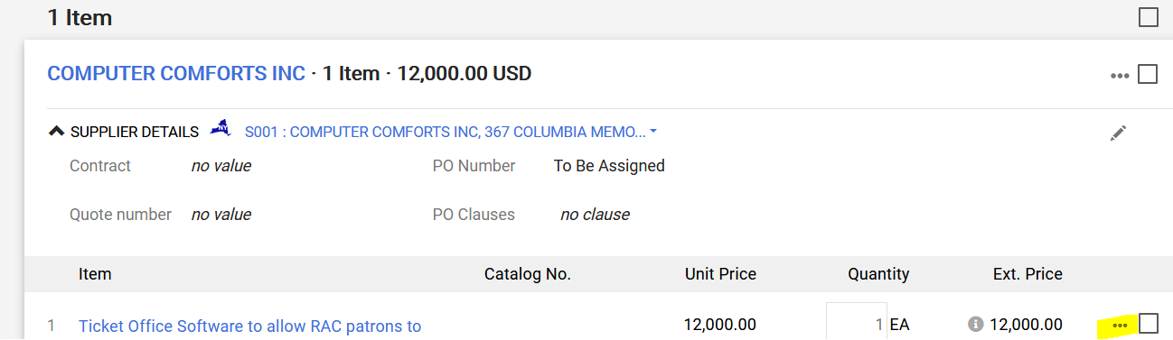
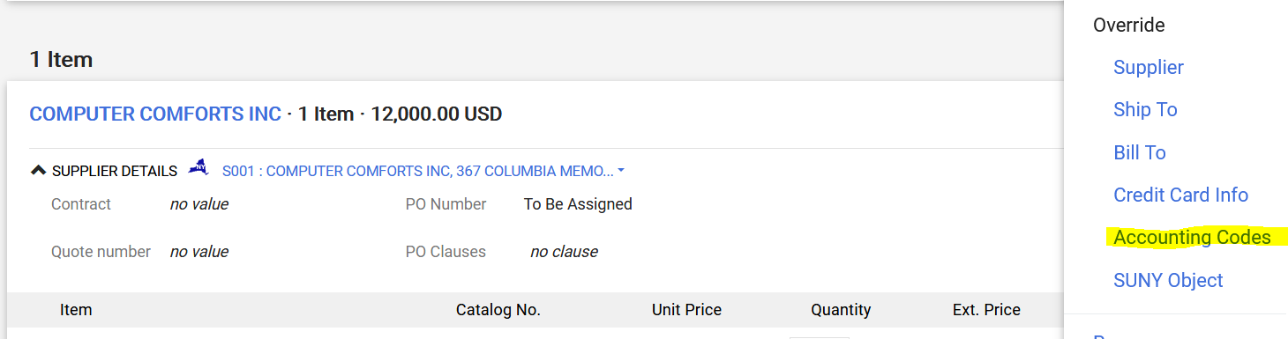
If you have created any Custom Account Codes, you can add them by typing in the name you assigned. See Creating a Custom Account Code section for more details.
Cart Management
A powerful function within Jaggaer is the “Shopping Cart” module, which allows the user to create, compile, maintain, and manage multiple carts, in various stages of completion, all at one time and in one place. Please reference the Site Navigation Guide to learn more about the navigational tool bars and how to access shopping carts.
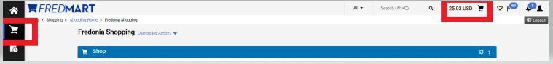
Clicking the Cart icon will open a list of ALL your carts
This is your ACTIVE cart

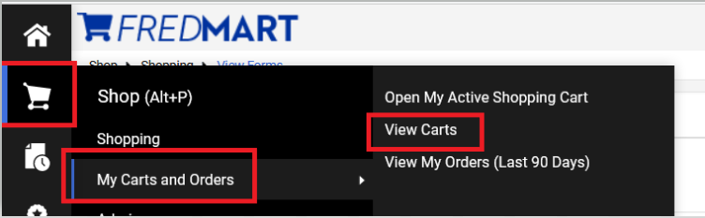

After clicking “View Carts,” user will be brought to the “Cart Management” page. Notice along the top of the page users may see three different tabs; “Draft Carts,” “Assigned Carts” and “Shared Carts.” In this guide we will only be looking at how to manage “Draft Carts.” Draft Carts are carts you created and have not yet clicked on Proceeded to Checkout.
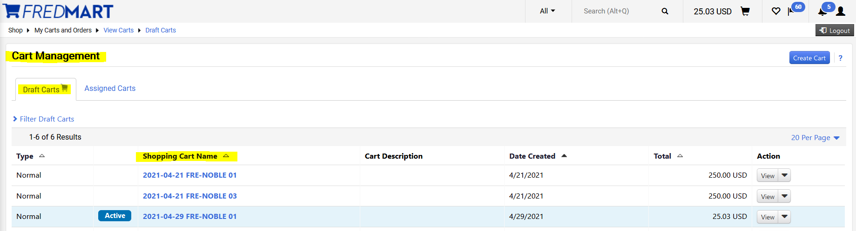

Users can create carts from the Cart Management page, by clicking on “Create Cart.”
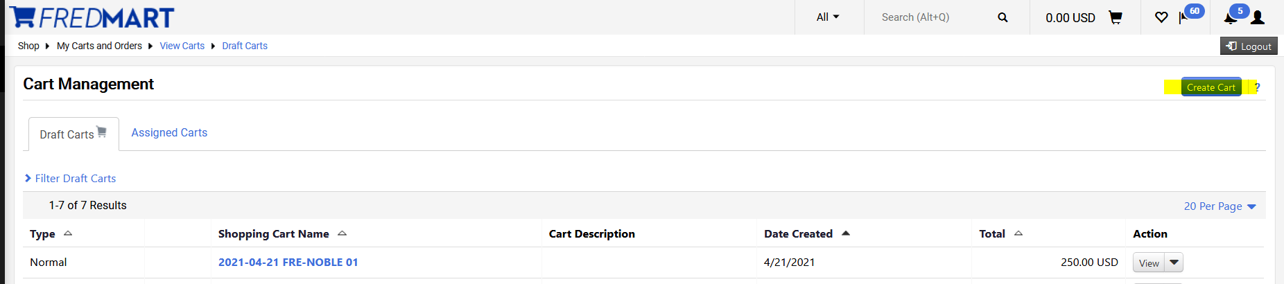

After clicking on “Create Cart,” user will be brought to the “Shopping Cart” screen. Users can use the Simple or Advance Search field OR by clicking on the 3 dots located on the right, user can go directly to a Non-catalog Item, Favorites or Specialty Form.
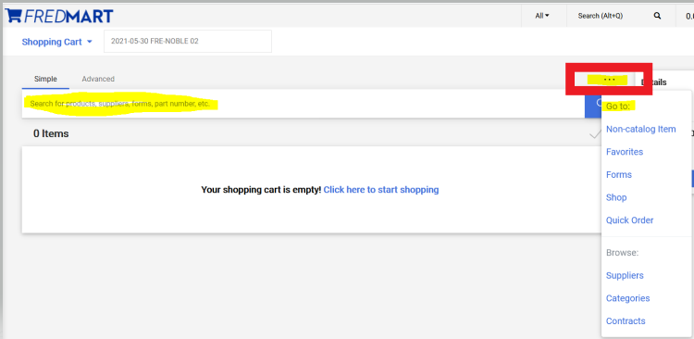

Users can also create a new cart, by clicking on the Shopping Cart drop-down arrow and clicking on Create New Cart.
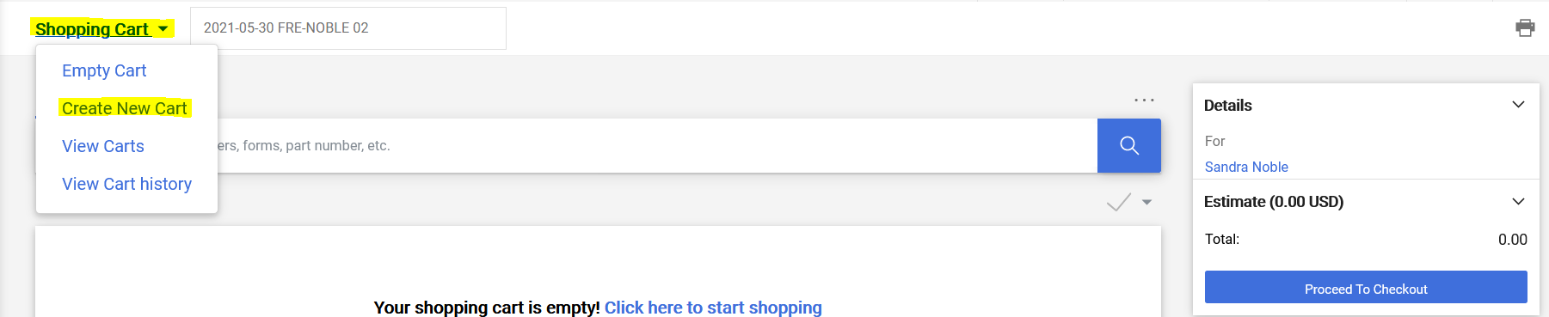

Please know that Jaggaer has a default cart naming convention. Jaggaer will automatically name the new cart using current date, user’s campus code and name, and number of carts created on that date. Users are highly encouraged to change that name of their cart to a name that will help them and any user they will Assign their cart to, stay better organized.
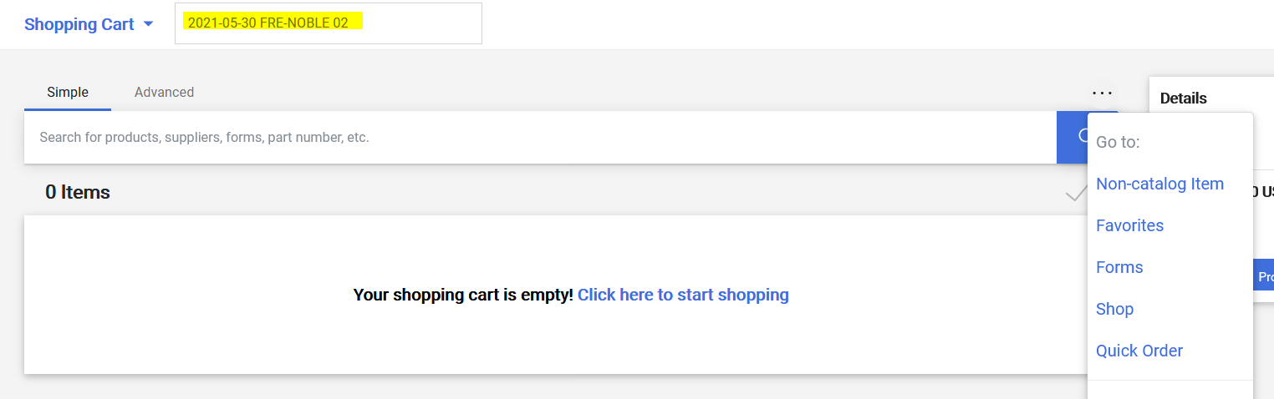

Using the steps above, I have now created two new carts, which I can see by clicking on “View Carts.”
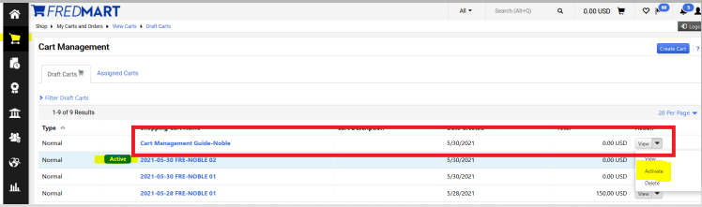

The ACTIVE cart will be the cart the user last created or worked on last. Users, at any time, can switch between carts by clicking on the cart they need to work on. Scrolling to the right, click on the drop-down arrow next to View and selecting Active.

To open and work on the Active cart, click View.
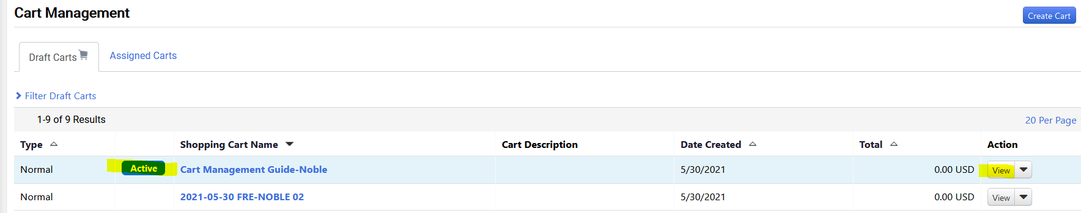

Users can complete carts as usual and click on Proceed to Checkout when ready to create the Requisitions and move through the approval workflow and be made into a Purchase Order.

Please reference the Assigning a Cart Guideline if your cart needs to be assigned to another user, before it can move through the approval workflow.

Assigning a Cart
Users can either assign their carts to other users or proceed to checkout to complete their order. A user may want to assign their cart to another user for a few reasons. The most common include; the user does not know what account to charge the order to. When applicable, users should make sure all necessary documentation has been attached before assigning a cart to another user. Follow the steps in this section to assign a cart to another user.
- Click the “Assign Cart” icon.
- Click on “Search for an assignee.”
- Use the “Last Name” field to enter the user’s last name and then click on “Search.”
- Click on “Select” for the user you wish to assign the cart to.
- If you regularly assign carts to this user, you may select the “Add to Profile” box. Otherwise, add a note to the user in the “Note To Assignee” field to provide detail to the user on why you are assigning this cart to them.
- Click “Assign.”
- The cart has now been assigned to the user selected and they have been notified.
If someone has assigned you a cart, you should receive an email notification. The email should contain comments from the user on why they assigned you the cart (usually to add an account number). Either click on the link in the email or copy and paste it into your web browser. Once at the requisition, click on “Activate Cart.” You should now be able to add your account number and any other needed information to complete the order.

Ordering for Another Department/Altering Approval Workflow using “Prepared for”

A “basic” feature to know about Jaggaer is that the Approval Workflow occurs automatically based on the Requisitioner’s Department (users can find their department under View My Profile). An “advanced” feature is using the “Prepared For” field on the Requisition to route the Approval Workflow to the correct Dean or VP for approval.

The “Prepared For” field will be extremely useful, in particular, to Office Assistants who place orders for multiple departments.

After Checkout the requisitioner is brought to the Draft Requisition (the coding/review stage). On the left-hand side, under the General section the Prepared For field will default to the user’s profile.
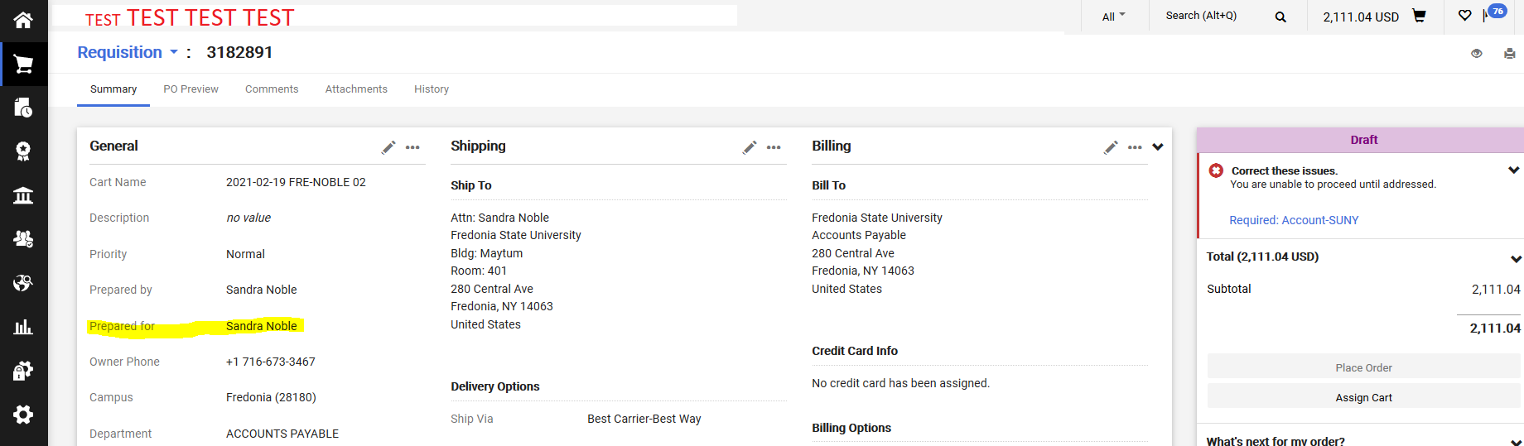

In this example I am preparing my requisition for a department in the Liberal Arts & Science Division. Because my department is Accounts Payable, if I did not change the Prepared For field, my requisition would be automatically forwarded to the VP of Finance and Administration. Users can see the Approval Workflow on the right-hand side. Before I change
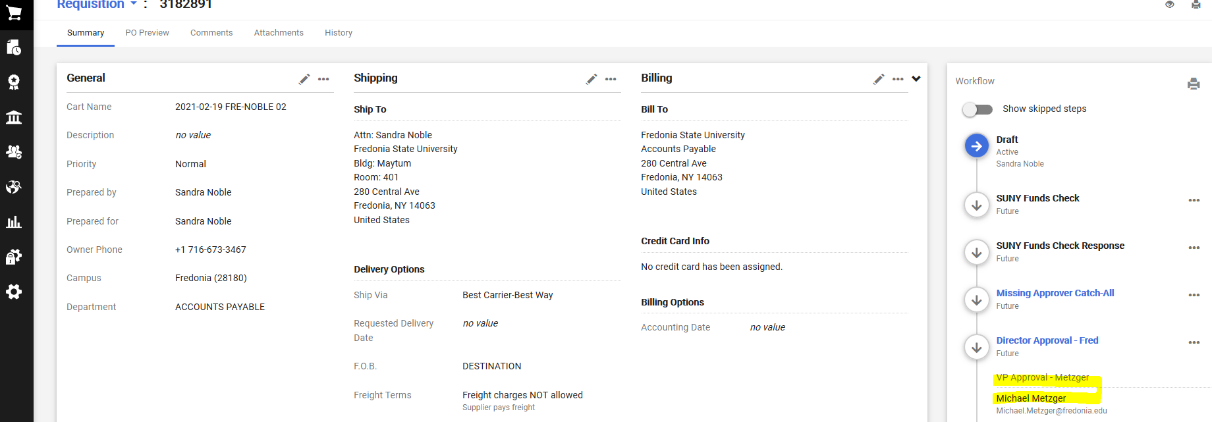

I need this requisition to be approved by the Dean of LA&S and subsequently the VP of Academics Affairs, so I will change the Prepared For field. Requisitioner will click on the pencil icon in the General section and change the Prepared For name to the appropriate name (only one name can be selected). For this example, I need to search for either one of the two Administrative/Office Assistants in the LA&S Dean’s office.
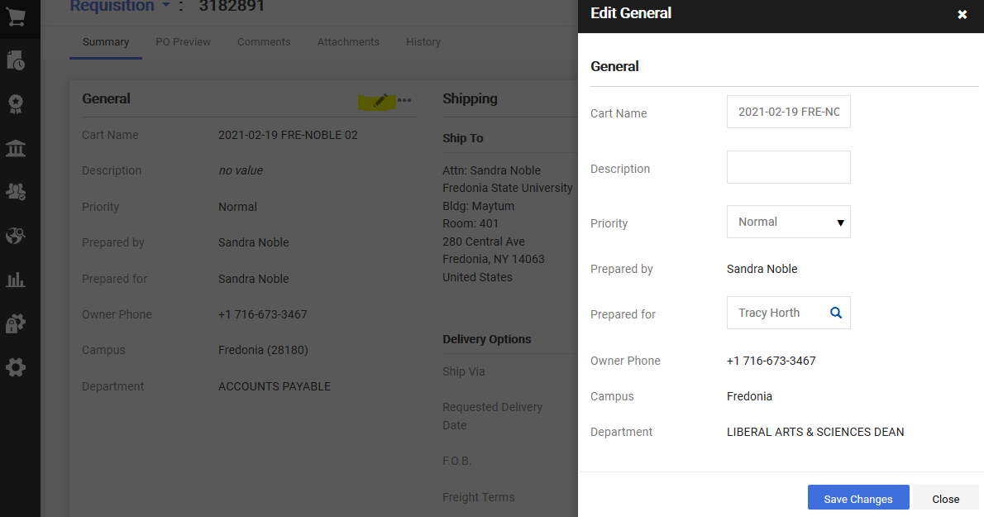

After clicking Save Changes, the Draft Requisition will require the requisitioner to edit (using the pencil icons) both the Shipping and Billing addresses.

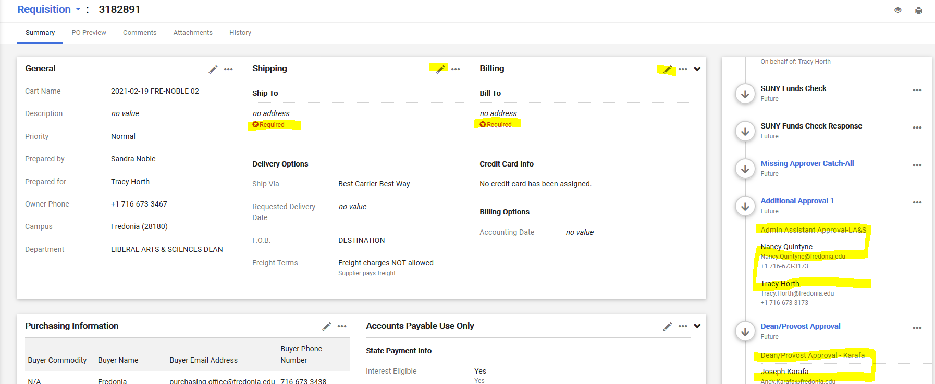

BEFORE the requisitioner clicks on Place Order, the requisitioner should review the Approval Workflow (on the right-hand side) to confirm that their requisition will be routed to the correct approvers.

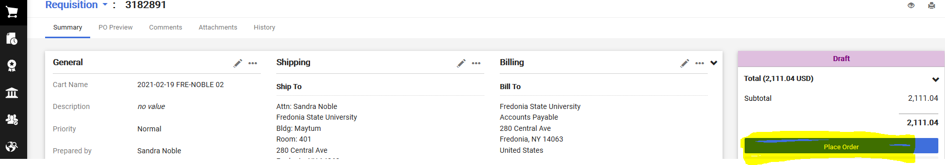

Purchase Requisitions Navigation and Overview
Once you click Checkout on your Shopping Cart, you will be brought to your Draft Purchase Requisition. User will see on the left side, under Draft any items the need to be corrected, before the purchase requisition will move through the approval workflow.
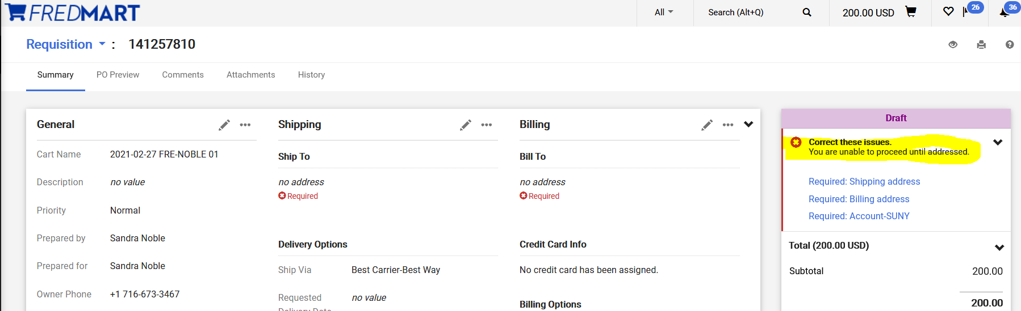
The purchase requisition is broken down into many Tabs and Sections. When user is on the Summary Tab they can update many Sections of their purchase requisition.
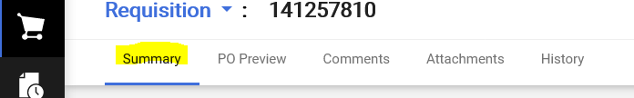
Below is an overview of each Section on the Summary Tab. User can click on the pencil icon to update each section.
General – The General section would be used to change the “Prepared for” field. The “Prepared for” field can be used to put a Purchase Requisition into the correct approval workflow. The “Prepared for” is the user whose name will appear on the purchase order to have questions directed to. It will also be the user who will get email notifications to acknowledge receipt of the order, when applicable. The “Prepared for” field can be used to redirect the Purchase Requisition through a different Dean and VP Approval workflow. User can view What’s Next for my Order? to see the approval workflow. To change the “Prepared For” user, click on “Select a different user” and search for the user you would like to have in this field.
Shipping – The Shipping section is where the order will be shipped. This field is automatically defaulted to be Central Receiving. User can also add a Requested Deliver Date. If the user changed the “Prepared for” field, user will have to update the Shipping, because FREDmart detected the general change.
Billing - The Billing section is where the order invoice will be sent. This field is automatically defaulted to the Accounts Payable office. If the user changed the “Prepared for” field, user will have to update the Billing, because FREDmart detected the general change.
Purchasing Information – If purchase requisition needs to be routed through ITS Approval. User will Edit this section and check the Route to IT box.
Accounts Payable Use Only – This section is used by the Accounting department only.
Accounting Codes – The Accounting Codes section should NOT be used. Best Practice is put the account number on the line items. However, if the order ONLY needs one account number and there are no anticipated changes to the purchase order this field could be used. Please see the Advanced User Guide for more information.
Internal Notes and Attachments – In this section, users should attach any documentation for the purchase (i.e. quotes, justifications, W-9’s, etc.) that would be needed by their office, Purchasing, and Accounting offices. These attachments would only be internal, meaning that they would not go to the supplier. Users can also click on edit in this section to write an internal note for the order.
External Notes and Attachments - In this section, users should attach any documentation for the purchase (i.e. quote or the winning bidder or artwork the vendor will need, etc.) that would be needed by the supplier. These attachments would be external, meaning that they would go to the supplier. Users can also click on edit in this section to write an external note for the supplier. Please be sure to name your attachments with easy to decipher names. The “winning bidder” quote should be a stand-alone attachment, so that Purchasing can make it an external attachment and send to the supplier. Quotes for the “higher bidders” can be together as a second attachment, because these will simply remain internal back-up.

User can use the PO Preview and Attachments Tabs to quickly find a review information about their purchase requisition.
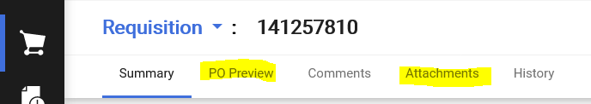

Users are to use the Comments Tab to communicate with other Fredonia employees about their order. Comments become a permanent part of the record and document to work that was done.
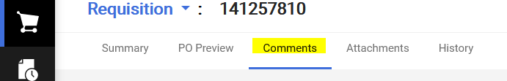
User can click on the + sign to add a comment or additional attachments.
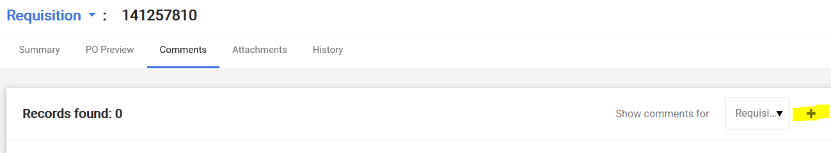
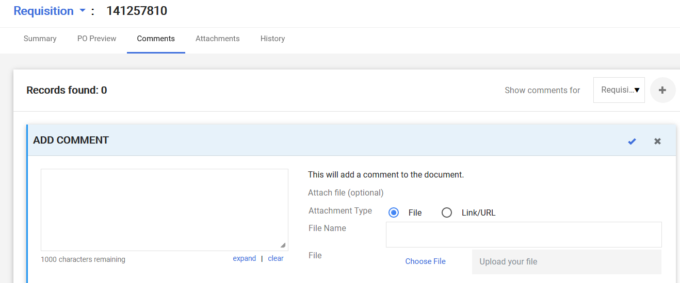
User can click on the History Tab to see a log of all the activity that has happened to the purchase requisition.
If user does not know the account number, user can Assign the cart to another person. If user knows all the necessary information, after reviewing and updated all Sections, on the right side, under Draft, user will see Place order or Assign.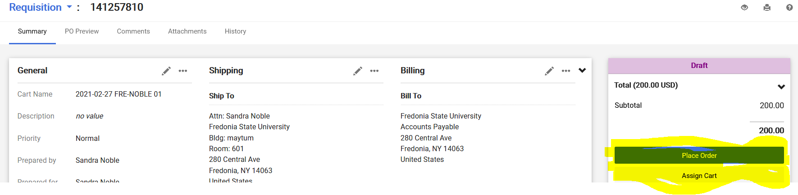

Purchase Requisition Approvals
Once a purchase requisition has been submitted, it will stop at different approval steps to ensure that all necessary parties have reviewed and approved the requisition before it goes to the supplier as a purchase order. User can, view on the right side, “What’s next for my order?” to see where their purchase requisition will go and where it is sitting.
Workflow stops in black are automatic approvals. Workflow stops in blue are stops that require manual approvals. User can click on the blue title to see the name or names of the individuals who are required to approve the stop.
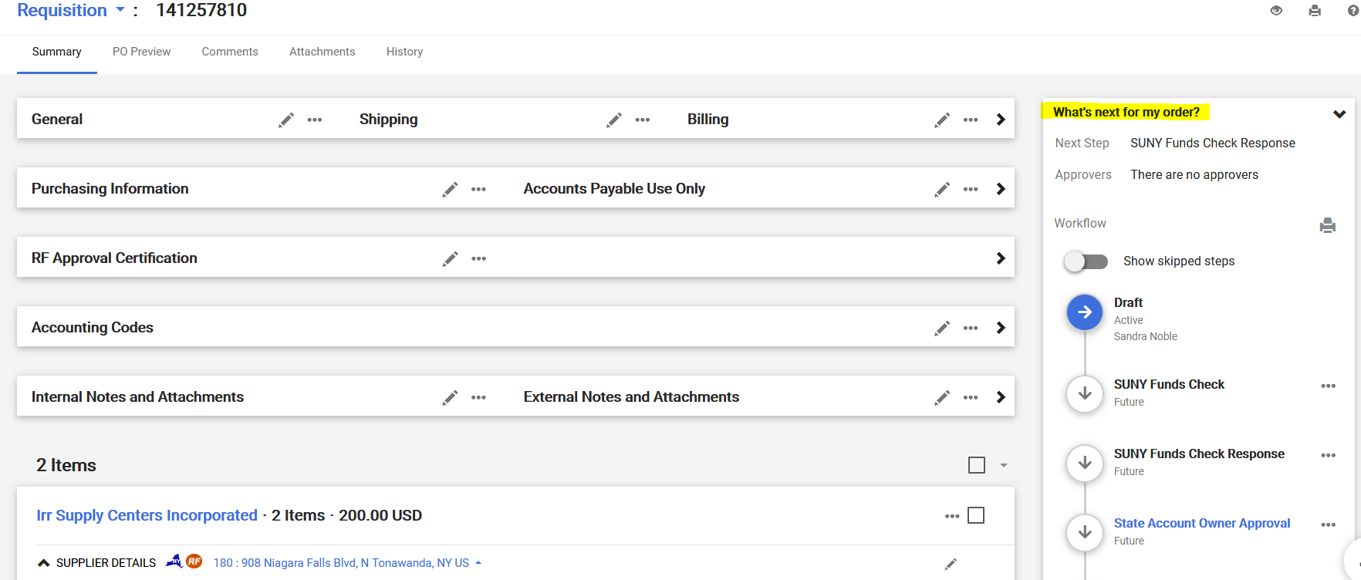
The first approver on a purchase requisition, by default is the Authorized Signatory on the account.
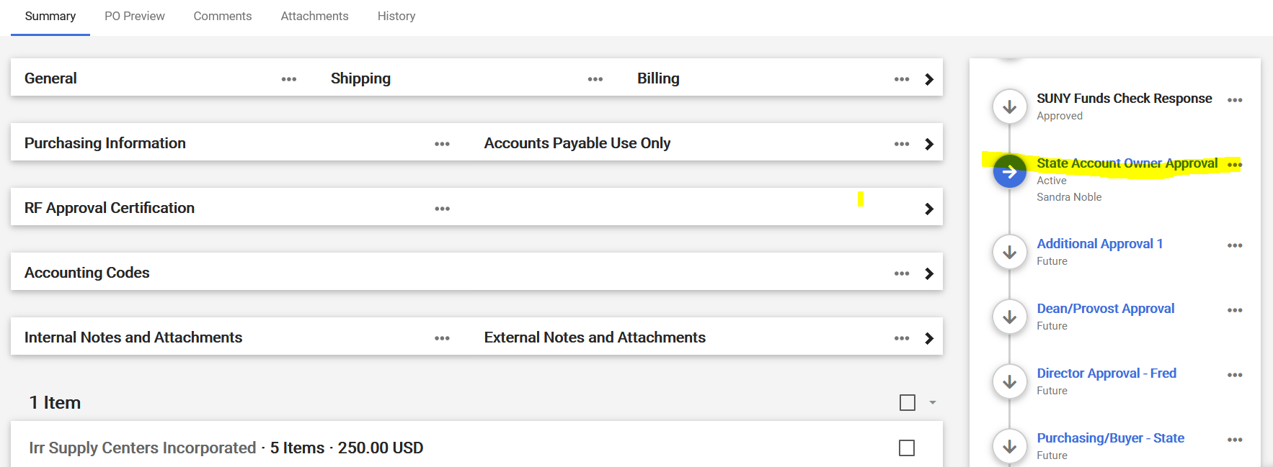
Approvers should get an email notifying them that they have a purchase requisition to approve. Refer to: Approvals Quick Reference Guide, there is a guide for approvals and it’s strongly encouraged that all approvers review it to get a better understanding of the approval function and what you can do. This section here will focus on the approval basics and Ad-hoc approvers, which is not covered in the reference guide.
- When an approver receives an email notifying them that they have a requisition to review, they should click on the “View Requisition Approvals” link in the body of the email. Approvers can also click on “Documents/Approvals/My Approvals” on the home screen at any time to see if they have any pending approvals or view any action items under the “Action Items Flag”.
- On this screen, the approver should see a list of folders, separating any pending approvals by account number and possibly other workflow approval steps. You can click on the individual folders to see the orders waiting approval. If the approver would prefer to see a list of all pending orders for approval not grouped in folders, they can select the dropdown in the upper left side of the screen titled “Group Results By” and change it to “List.”
- Click on the box on the right side of the screen for any requisition(s) you wish to review and approve.
- The dropdown at the upper right side of the screen should say Assign. Click “Go.” The requisitions will now be assigned to you for review.
- Click on the Requisition Number for the order you wish to review.
- Review the purchase requisition and make any edits if needed. (Please see Section 7 for a review on the different areas of a purchase requisition.)
- During the review process, if approver needs to Edit a field, Approver will have to “Assign” the purchase requisition to themselves. Once your review is complete, Approver will click on “Approve” towards the top of the screen.
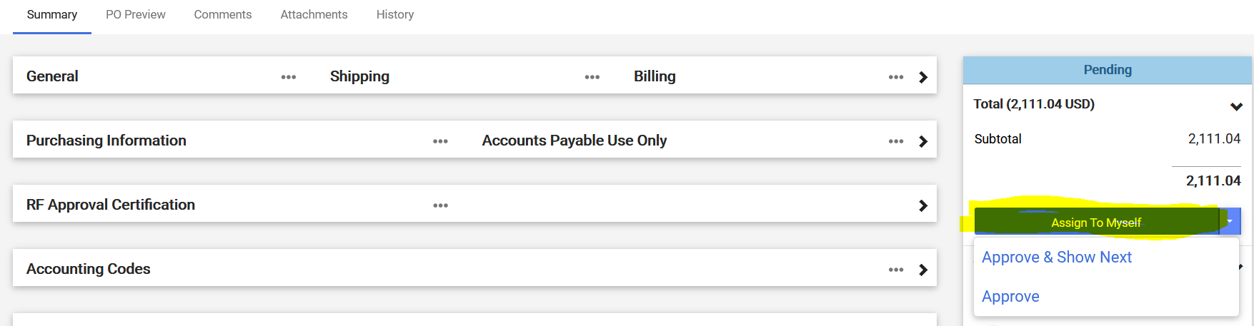
- Click on “Approve/Complete & Show Next” to view the next assigned requisition waiting for your approval or “Approve/Complete” if you only have one approval listed at that time.

Receiving
Central Receiving should do the receiving for all purchase orders that are delivered to the Receiving department. However, there are a few instances in which Central Receiving may forward a particular delivery to the department for the department to confirm items were received. In these instances, the user who was listed on the purchase requisition in the General section under “Prepared for” will do the receiving for the order. Central Receiving will write the date received on the outside of the carton and leave the packing slip on the carton. The department will create the Receiver for the goods on the purchase order and attach the Packing Slip to the receiver.
If the order is for a service or something Central Receiving cannot physically hold in their hand, the department is to create the Receiver.
PLEASE NOTE: FREDmart will NOT release a payment, if an order has not been received. The user listed under “Prepared for” on the purchase requisition will receive an email notification reminding them to Create a Receiver for the order after the Accounts Payable office receives an invoice for the order. The email will list the purchase order number and the lines on the PO that have been invoiced. If the Receiver is NOT done within 7 days, the invoice will error out.
Users should click on the “Click here to view purchase order” link in the email. Please note that users do not have to wait for the reminder email to acknowledge receipt. BEST PRACTICE would be that when goods or services are received, Central Receiving or the department would search for the corresponding purchase order.
Once at the purchase order, click on the Receivers section of the left side of the screen to verify if any receiving against this PO has already been done. If a Receiver exists, review before completing any additional receives.
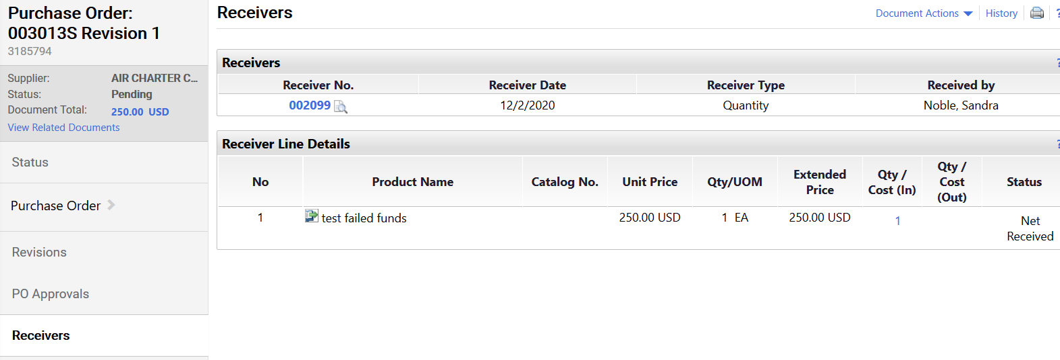
Click on the down-arrow located to the right of the word Purchase Order.
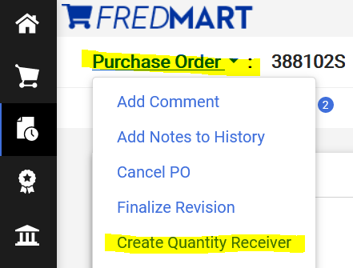
Click on “Create Quantity Receiver.” Please note that for service purchase orders with multiple payments or for standing orders, you should also see a choice to “Create Cost Receiver.” For these two types of purchase orders, click on “Create Cost Receiver.”
You will now be brought to the Receiver screen. On the Header Information screen, user must complete Receiver Date (the date the goods or services was received), Packing Slip No (type No Packing Slip no packing slip was received), Location of delivery, Carrier. Attaching any and all shipping documents, such as packing slip or bill of lading is required.
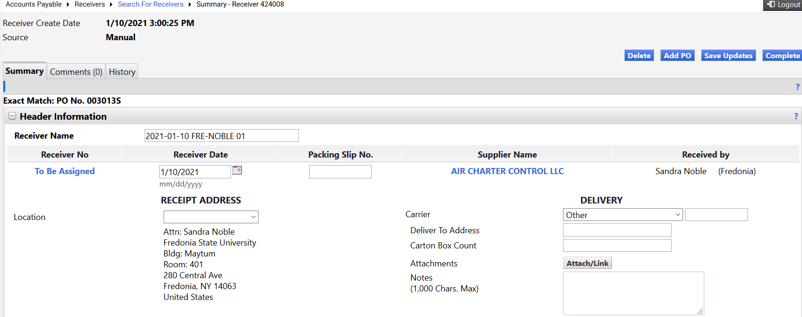
Then scroll down to the bottom of the screen and you will see the lines on the PO that need to be received. You will need to enter the quantities received.
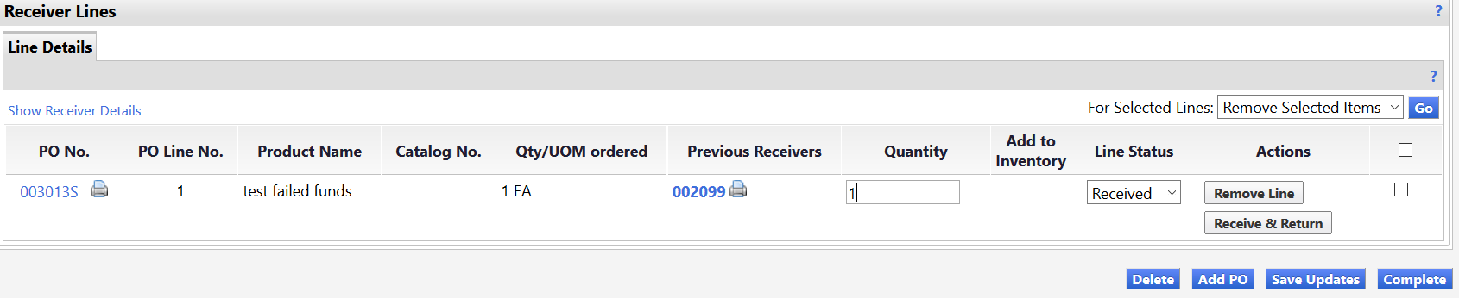
Once finished entering the quantities, click “Complete.” The Receiver for this PO is now finished.
Receiving ALERTS: Please note that for Cost Receivers you will need to enter the dollar amount of the invoice you are authorizing has been received.

If you have received some items, but not all items; user should FIRST check the box on items not received and click on “Remove Line” for the lines that have not been received yet.

If you are unsure what the unit of measure is that you should be receiving, click on the “printer icon” next to the PO number on the left side of the screen to see a PO summary, which has this information.

It is also important to know that if you accidentally duplicate a Receiver and receive the same items twice, you will need to submit another receiver using a negative quantity to remove the duplicate amount.

If you ever need to include a comment for Accounts Payable with your Receiver, you can use the Notes section in this screen.

Searching Order Status
There are many ways users can search for their order status in FREDmart. Below are four examples.
- Users can search for any document status by using the Quick Search field in the top navigation bar.
- User can use the left navigation bar and the Order icon to search
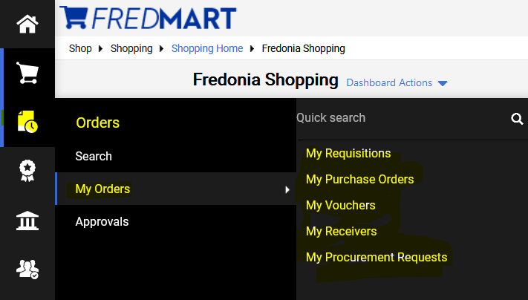
- Users can also use the My Draft Carts section, located at the bottom of the Shopping Home screen to find their requisitions.
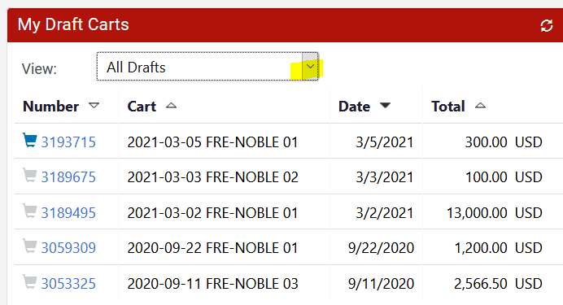
- All documents related to the purchase are linked together. Users can view all documents from any one documents. In a purchase order user can get to the linked documents using Tabs and PR Approval bar.
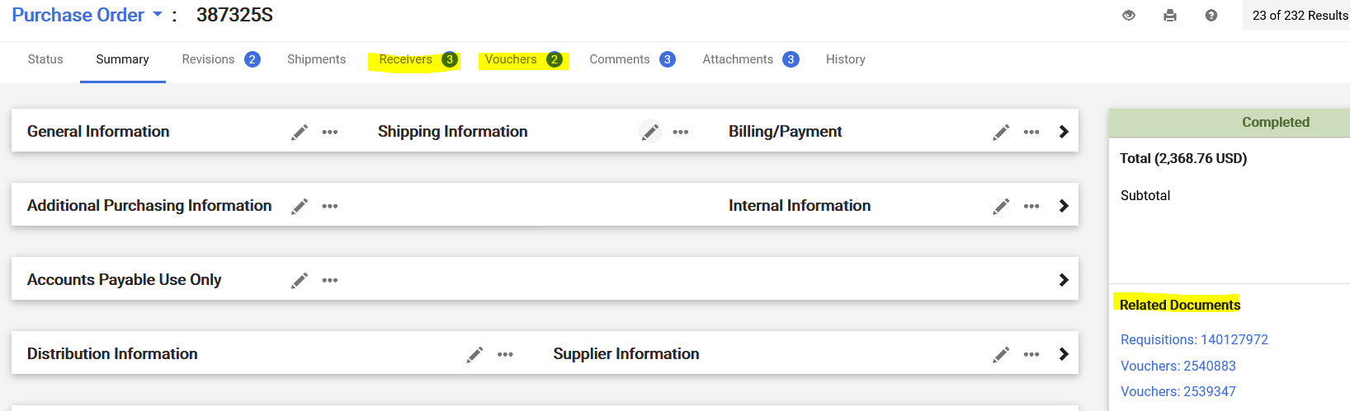

User TIP: If your order has successfully gone through FREDmart and SUNY FMS, “Revision 1” (or higher) will be displayed after the order number. “Revision 0” indicates your order is still pending.
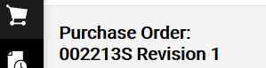
Returned Requisitions
An Approver or Purchasing can return a requisition to a user. If “manually” returned at not will be included. However, requisitions may be “automatically” returned to the user by FREDmart, when certain corrective actions are triggered by rules. Users can click on the History Tab or PR Approval for help in figuring out why their requisitions was returned. Two common corrective actions are detailed below.
Mix of On-Contract and not On-Contract Items for a Catalog order: Some catalogs in FREDmart contain a mix of contract and non-contract items. Contract items and non-contract items need to be submitted on separate purchase requisitions. You can take the following steps below to fix a returned requisition due to this issue.

- Click on “View Requisition” in the body of the email.
- Click on “Activate Cart.”
- Carefully look at all lines in your cart to be sure each has a contract number.
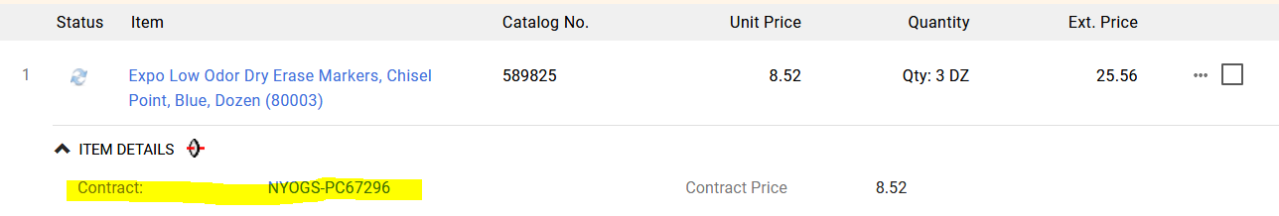

- Any item that says no value in the Contract field needs to be moved to another cart. To move, check the box to the right of the item.
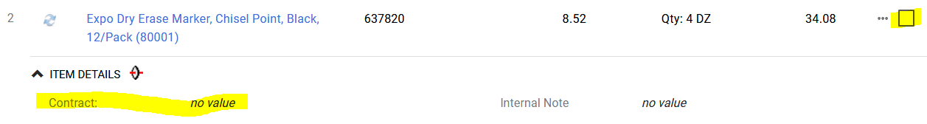
Scroll to the top of the Items and on the drop down, select Add to Draft Cart. User will have two carts to approve.
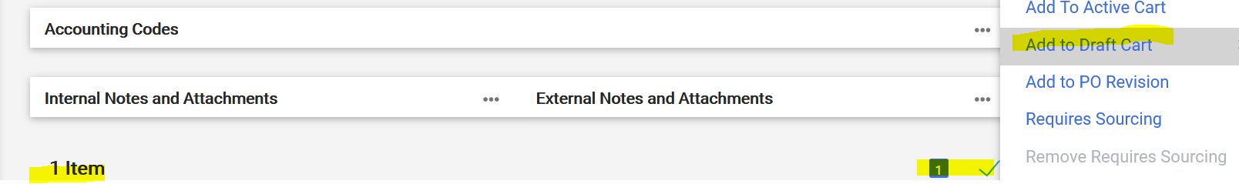

Missing Approver Catch-All: In PR Approval, if you see Missing Approver Catch-All it means that the account number used does NOT have an Authorized Signatory assigned to it. Use Internal Comments to notify Sandy Noble that the Authorized signatory needs to be added to FREDmart.
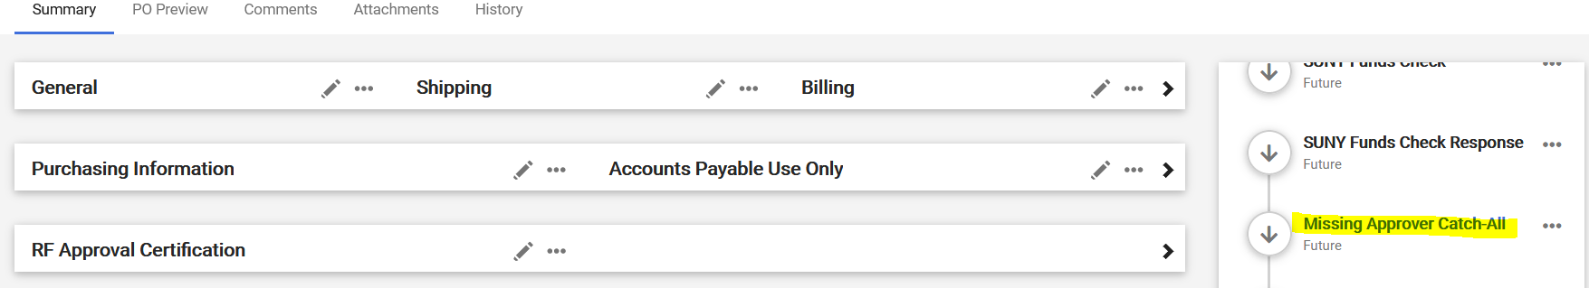

Housekeeping
Carts should NOT be copied for new requisitions, because if a Workflow or “coding” has been made. If an old Cart was created before the change was made, the new requisition will NOT follow the Workflow.
A Good Housekeeping practice is to Delete old Draft Carts.
Do this by clicking on Carts and under the Draft Cart Tab, use Action on the right, to delete the draft cart.
