Honorarium Request Form – This form is used for payments to lecturers, guest speakers and any individual performing a service for our campus. Honoraria’s are a one-time payment for short-duration service (usually just one day, but not to exceed four consecutive days) and relatively small dollar amount (generally under $2,500). An honorarium is an ex gratia payment (i.e., the College has no obligation or liability to pay it). Payee must be an individual (not a business entity).
A SUNY employee MUST be paid through Payroll. Human Resources can help departments with the “On-boarding” paperwork. If the payee is employed by any other agency in New York State, the payee may be paid using the Honorarium Request Form, as long as the service they are performing for SUNY Fredonia is not in any way related to the duties of their New York State position.
The department completes all the required information on the (paper version) of the Honorarium Request Form and the payee must sign the Honorarium Request Form. The signed Honorarium Request Form must be attached, before Accounts Payable can pay.
Complete the sections of the form as you would for any other form:
Section 1, select the Payee/Supplier. If user does not find the payee address, BEFORE selecting “New Supplier” please call the Purchasing Department for help. Purchasing can obtain a new New York State ID No. from the Statewide Financial Software (SFS) for a new payee.
Section 2, user must confirm if address shown is correct. If it is not, select NO and type in new address. If the payee’s address is incorrect, the payee MUST update their address in the Statewide Financial Software (SFS), which is a self-service portal. Purchasing cannot update the payee’s address.
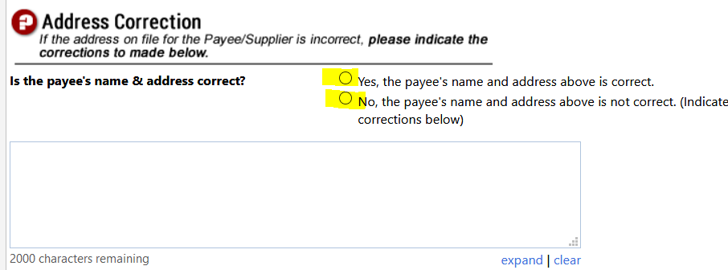
Section 3 can be left blank.
Section 4 Payment Type & Details
New York State employees performing a service that is directly related to their New York State employment cannot be paid via an Honorarium Request Form. Please contact Human Resources if you need guidance on paying a New York State employee.
The Invoice Number MUST follow the naming convention, which is HONOR-mm/dd/yyyy. Please note: Invoice numbers must be unique; a payee cannot be paid more than once using the same invoice number. The logic behind the naming convention is “HONOR” short for honorarium and “mm/dd/yyyy” is the date the service was performed. If service is for consecutive days, the Invoice Number would be HONOR-mm/dd-mm/dd/yy.
Invoice Date is the date the service is performed. If service is for consecutive days, the LAST day of the service is the Invoice Date.
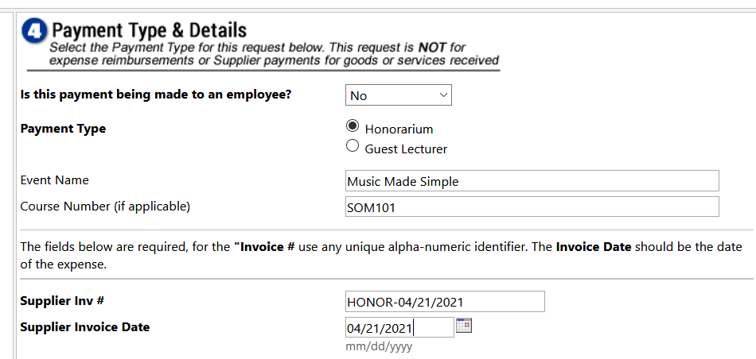
Section 5 Description & Amount provides a place for more detail on the services provided and the total cost of the service.
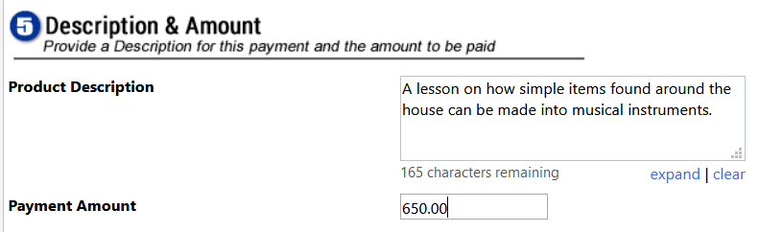

Section 7 Certify & Consent
Payee will sign the form in this section. Requisitioner must check the box.
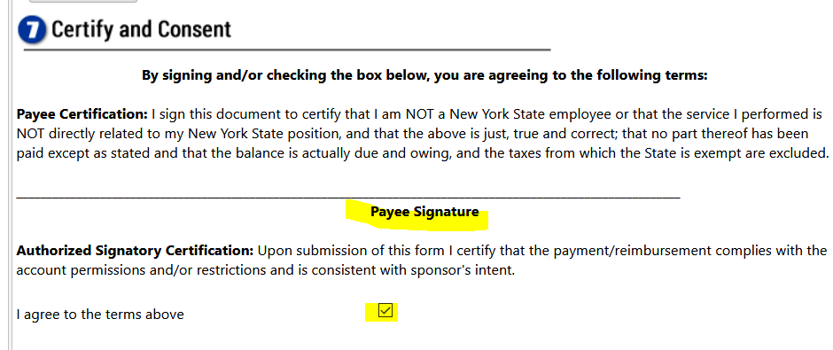

Scroll back to the top of the form. Change Available Actions: Add to new Cart. BEFORE selecting Go
PLEASE PRINT THE FORM, so the payee can sign.
Open your Draft Cart and Correct Issues.
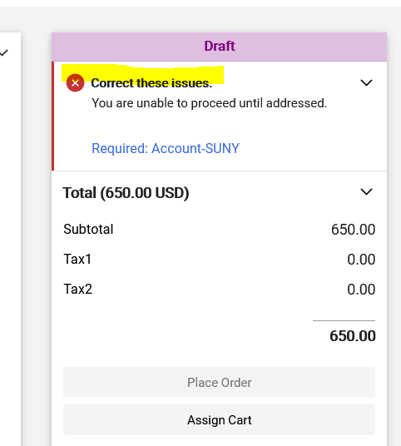
The payee MUST sign the Honorarium Request Form and the signed form MUST be attached to the Requisition, before Accounts Payable will process the payment.
The Honorarium Request Form workflow will stop for approval at the Account Owner, Human Resources (to verify if payee is not a New York State employee), Dean (if applicable), VP and Accounts Payable.

At what point in the approval workflow that the payee-signed Honorarium Form is attached can vary depending on the specifics of the event.
- If event is a low-dollar event in which the Requisitioner has prior verbal approval for, requisitioner could attach signed form, before clicking Place Order.
- Requisitioner may be a department secretary. Form may be given to a coach or professor, who will be obtaining the payee signature. In that case, the Account Owner may be the individual attaching the signed form to the Requisition, before approving.

Advanced Tips & Tricks:
A confident user can create multiple Requisitions from ONE Honorarium Request Form. Let’s use referees for a hockey game as an example. Two referees are required at each Hockey game. Requisitioner can create an Honorarium Request Form for the hockey game played on May 1st. Larry is referee #1. After completing all required fields, go back to the top, PRINT the form and change Available Action: Save to Cart and Add Another, select GO.
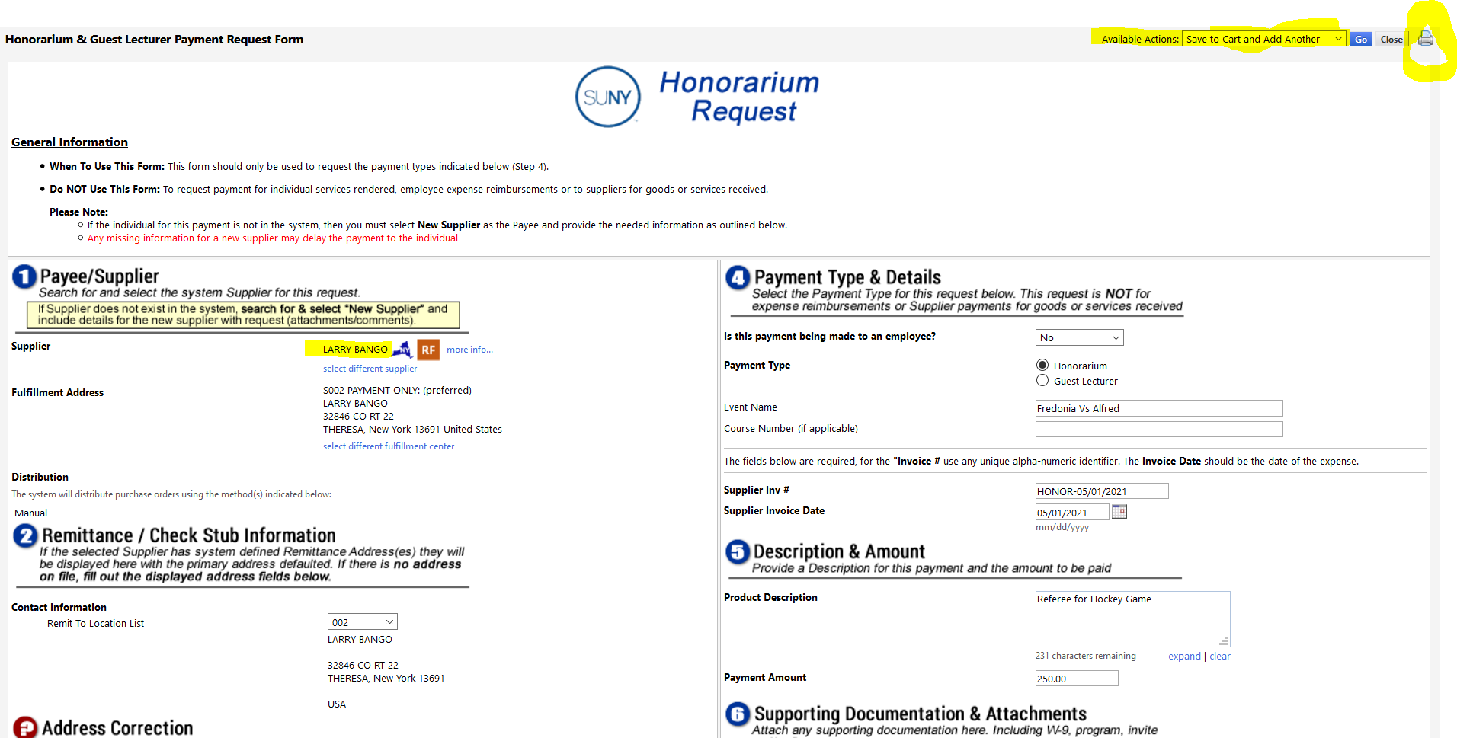

Referee #1 is now in your Active Cart and the Honorarium Request Form still contains all the information for the May 1st game that the requisitioner just typed. Select a different supplier, search and select Mary, referee #2. Go back to the top, PRINT the form and change Available Action: Add to Cart and Reset Form, select GO.

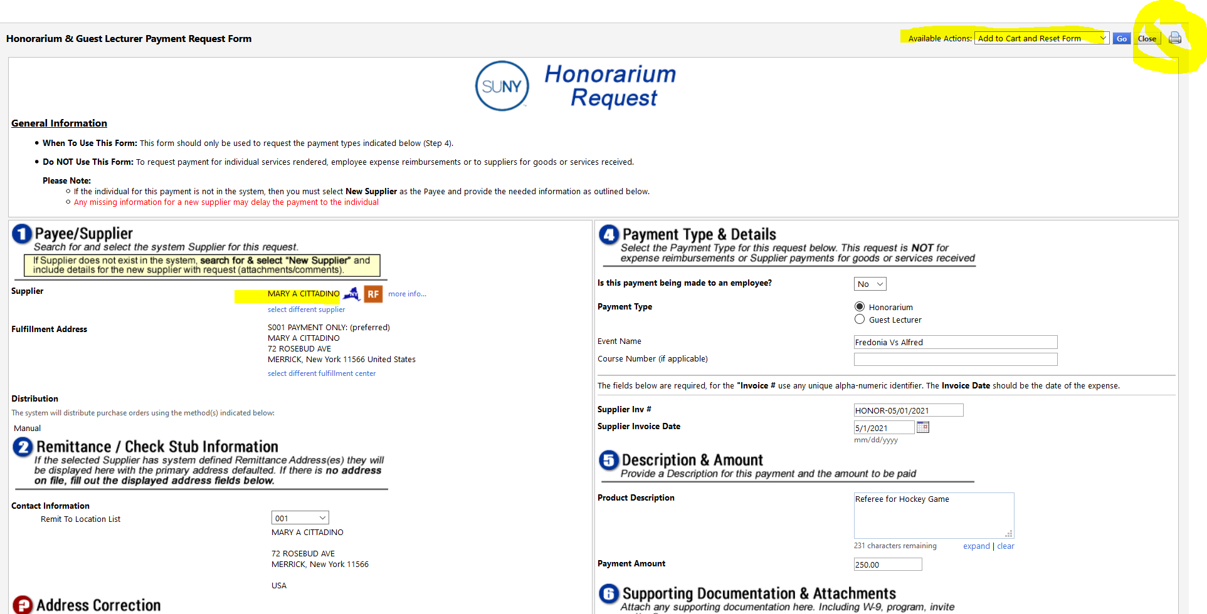

Referee #1 and #2 are both in your Active Cart (the requisitioner had to complete the Honorarium Request Form ONE time. All information stayed the same for both forms, only the Payee changed). Select Checkout.
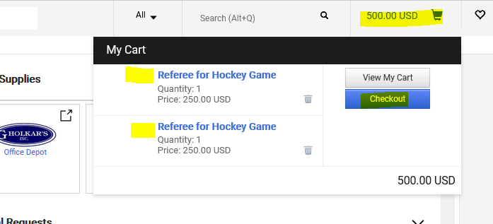

As we know: Jaggaer will only allow ONE supplier per each Requisition, so Correct these Issues contains the direction to Move one of the items to another draft cart.
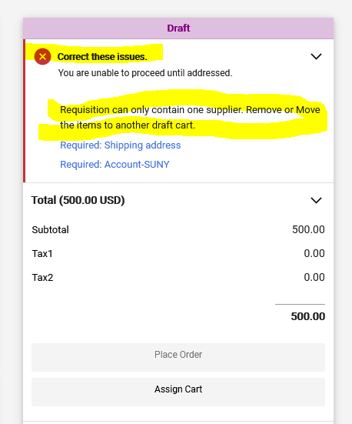

Scroll down to the Items (always at the bottom), click the checkbox to the right of one of the items.
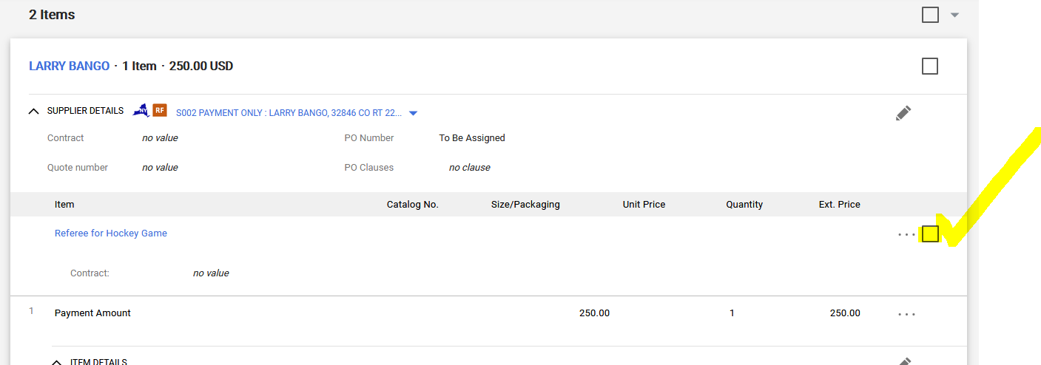

At the top of the Items, click on the down-arrow and select Move to Another Cart.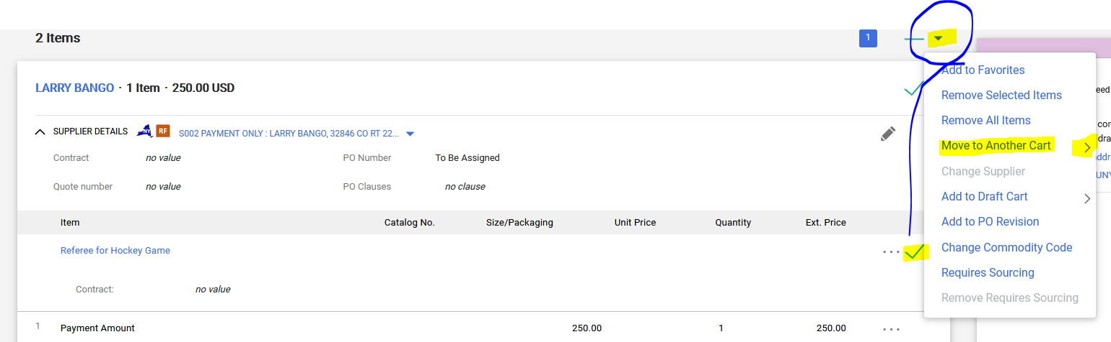
Referee #1 was moved to a new Cart and Referee #2 is now the ONLY payee in your Active Cart.
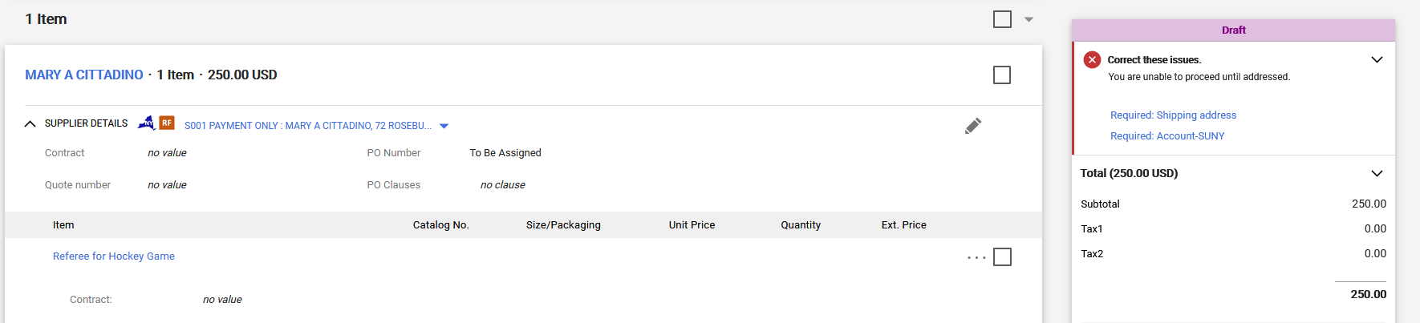
As always, Correct these Items and Place Order. Locate Cart for referee #1, Correct these Items and Place Order. Keeping in mind the payee MUST sign the Payment Request Form and the signed form MUST be attached BEFORE Accounts Payable will make payment.
Helpful Steps: As our tasks become more integrated and to speed-up the time it takes to process the Honorarium payment, we ask that the Requisitioner add to their requisition the following information:
- Accounting Codes: Change Full/Partial-SUNY to “Full.”
  - By making the field “Full,” Jaggaer will automatically Close the internal purchase order upon payment.
- UNSPC/Commodity Code: 80101508
- Object Code: 558130
  - This is the required SUNY coding we must use on ALL Honorariums.
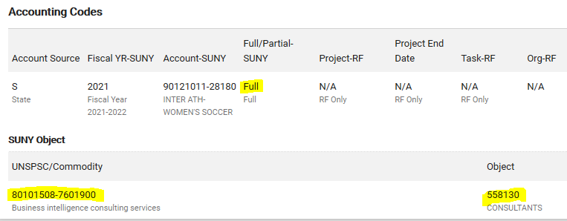
Did You Know: The secretary in Athletics gives the Honorarium Request Forms to the hockey coach. The hockey coach obtains the referee’s signature. The secretary, instead of PRINTING the from, can save the form as a PDF file and email the form to the hockey coach. The hockey coach can then PRINT the form.
To save the form as a PDF, click on the printer icon. Use the scroll bar to locate “print to PDF” function.
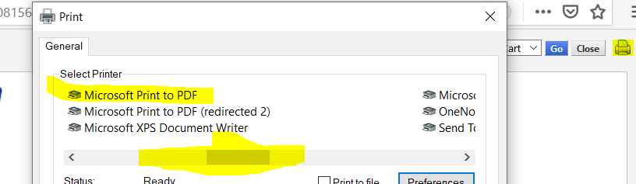

Double click “print to PDF” and the Save As function will appear. Name the PDF file and email to the coach.
