Advancement, ENGAGEMENT & ECONOMIC DEVELOPMENT
College Council Report
May 8, 2019

The results of the First Destination Survey for the Class of 2018 indicate that 94% of graduates are employed or enrolled in graduate school; 91% indicated that their job was directly or somewhat related to their major. Respondents were also asked to what extent they consider their present status as progress toward their career goal, and 91% of the students responded “very much or somewhat”. The Career Development Office (CDO) administers the survey in collaboration with Institutional Research, Assessment and Planning. Relatedly, CDO Director Tracy Collingwood created an exit survey for future Fredonia graduates in cooperation with Academic Affairs, Enrollment and Student Services, Alumni Affairs, Career Development, Campus Life, and the RAC Ticket Office.

AEED has completed the 2019 National Assessment of Service and Community Engagement (NASCE) survey. 482 Fredonia students responded to the NASCE survey, representing 11% of our undergrad population. Survey results will be summarized in NASCE’s final report which is expected in late May. The findings will provide valuable information and insight regarding student engagement, values, and civic knowledge.

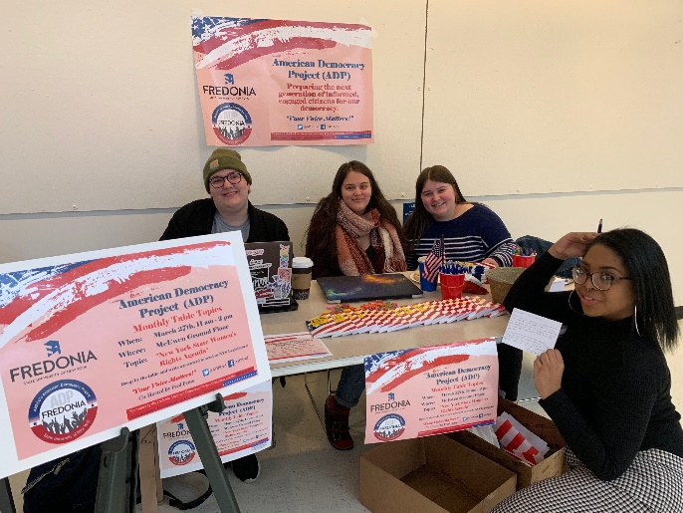
Fredonia’s American Democracy Project (ADP) committee, under the leadership of Dr. Angela McGowan, is hosting monthly “table topics” to encourage student education and involvement abut important civic and legislative issues. Monthly table top displays are set up in McEwen Hall to encourage students and faculty/staff to contact their legislators on the given topic for the month. In March, the topic was “New York State Women’s Rights Agenda”, co-hosted by Fredonia’s student group, Fred Feminists. April’s topic is “Environmental Issues”. On May 1st, Law Day, the ADP will co-host a voter registration drive with the Chautauqua County Women’s Bar Association in the hopes of increasing awareness on the importance of voting.

Kevin Kearns attended SUNY Days DC in Washington, DC where he met with senate and congressional staffers to advocate for issues affecting Fredonia and SUNY students. Eight alums

from the Washington, DC joined Kevin at a SUNY Alumni Reception at the Rayburn House office building during SUNY Days.

AEED has recruited a business startup from New Jersey, Building BOSS, to the area.
The President and CEO, Derek Johnson, is relocating his business to the Fredonia Technology Incubator later this spring. Kevin Kearns assisted BOSS with an application to the $1million 76 West energy business competition and they are exploring participation in the Fredonia StartUp NY program. Building BOSS was founded in 2015 to deliver Building Optimization Solutions and Services to commercial buildings.

Kevin Kearns and Chuck Cornell are collaborating on several business ventures with the Chautauqua Co. Industrial Development Agency (CCIDA), Local Economic Development Group, and local government officials. One recently announced venture is exploring a large hops and grains co-op in the county. A team of local economic development agencies, led by County Executive George Borrello, is supporting a feasibility study for the project. Preliminary discussions include exploring a grower’s co-op, a facility for storing and pelletizing hops, manufacturing product spinoffs – such as health food supplements, logistics, and a national sales hub.

Kevin Kearns continues to participate on the Board of the Chautauqua County Visitor’s Bureau attending their monthly meetings and will also be attending a Tourism and Marketing Workshop on Monday, April 15th, in Jamestown. This workshop will offer a series of topics that are essential for businesses trying to reach and keep customers in a fast-paced technological world. Kearns met with Andrew Nixon from the Chautauqua County Visitor’s Bureau, and Jeff Woodard , Fredonia Marketing and Communications Director, to incorporate links to area tourism spots on our Fredonia website for parents and students to refer to when planning their visits, etc.

AEED is collaborating with a coalition of county wide mental health professionals, from agencies including the Chautauqua Tapestry and the Chautauqua County Department of Mental Health, to offer a two-day Hope and Healing (H&H) Conference of Western New York. The conference will take place June 5-6 in the Williams Center. The H&H conference will include keynote speakers, informational wellness tables, and interactive educational workshops on mental health and chemical dependency in our region.

Fredonia Technology Incubator (FTI):

Since February 15 the Incubator held 13 events with 284 attendees. In addition, FTI hosted 28 community events with 410 visitors. FTI Clients held 18 events with 256 participants.
The first annual Women in Music Industry Seminar (4/13) addressed issues facing women who are working in the music business. Featured speakers included Laura B. Whitmore, WiMN founder, President, and producer of the “She Rocks” awards that are given out at the annual NAMM (National Association of Music Merchants) convention to honor female music industry luminaries. Ms. Divinity Roxx, renowned bass player and former music director for Beyoncé. Ms. Roxx has toured around the world and has backed up numerous artists, from Patti Labelle to Jay-Z, from Kayne West to George Michael. Ebonie Smith, award-winning music producer and audio engineer at Atlantic Records. Ms. Smith, a Forbes Magazine “30 Under 30” nominee, is President of Gender Amplified, Inc., a non-profit that supports women and girls in music production. She has a M.M. in Music Technology from New York University. Laura Clapp, a retail marketing development specialist for Shure Microphones. Ms. Clapp has toured in the United States and Japan with Howard Jones and has released three independent albums of her own music. This successful event was the result of a partnership between FTI and the Fredonia Music Industry program and it was funded through a NYS CFA incubator grant.
Student Business Competition.
FTI hosted the fourth annual Student Business Competition in April. Students pitched their business ideas to a panel of five judges. Student companies were rated on customer identification, problem/solution identification, channel to market, and revenue streams. The 2019 FTI Student Business Competition had 12 applicants, and the first prize was awarded to Rae-Anne Clarke for her business, “A Touch of Rae”, which is a custom wig manufacturer. Her startup manufactures and sews each wig, and sells them to students and staff and across the area. The target market is working class women, college students, and the LGBTQ community. Second place was awarded to Tyler Walsh for his “Record Label, Independent Musicians”. This record label gives power back to artists by providing them with proper tools and resources to turn their passion into a career. Tyler plans to use licensing, instrumentals/beats, live performances, royalties, and endorsements to generate revenue.
Entrepreneurial Education Program.
The incubator held five workshops, including: Developing an Effective Investor Pitch Workshop with Jack McGowan, Project Manager, Insyte Consulting. This workshop included discussion about the importance of being investor focused and what elements of a business plan should be included in an investor pitch. Business Model Canvas Workshop Featuring Manoj Poolery, Director, Venture For All, Launch NY EIR. This workshop included discussion on moving from a business idea to a startup company and identifying customer segments/value propositions. Leveraging Technology for the Modern Sales Team This workshop included discussion about tools and technologies that help companies build awareness, generate opportunities, and close new business. Tax Considerations for Small Businesses Workshop conducted by SCORE, included discussion about how to successfully manage taxes for your small business. Immersed Games: Educational Video Game Platform Entrepreneurial Seminar 4/3/2019, consisted of discussion on game development and what makes a good educational video game.
The popular Arts and Business Luncheon Series, an ongoing collaboration with the College of Visual and Performing Arts, hosted its 16th program featuring west coast artist, Ed Luce, a cartoonist who created the Wuvable Oaf Series, a two-time Ignatz nominated series of comics. This luncheon speaker provided insight into the business side of Ed’s career. He discussed developing, marketing, and publishing his book series, and managing both his teaching and comic book jobs.
Entrepreneurial Outreach Programs. The incubator hosts monthly Veterans Entrepreneurial Network meetings and sponsors the Northern Chautauqua Young Professionals (NCYP).
Art Exhibitions.
FTI Art Gallery featured community and campus art exhibitions under the direction of Barbara Racker, Director of the campus Cathy and Jesse Marion Art Gallery. The currently exhibit presents the works of Chautauqua County Art Teachers. A reception was held on March 9 with 53 attendees. Guests came to see works by local teachers Stephanie Baker, Stephanie Brash, Connie Lavelle, Brandy Noody, Amy Utzig, and Denise Williams-Stebbins.
NSF iCorps Short Course Program.
Director Chuck Cornell completed the two-week NSF iCorps Short Course Program with FTI Client Flight Data Tracker (Professor Junaid Zubairi). This course provided real-world, hands-on learning experience on how to successfully transfer technology into products and processes that benefit society. The team engaged with members of industry and interacted with over 200 contacts during the two-weeks.

The Career Development Office (CDO):
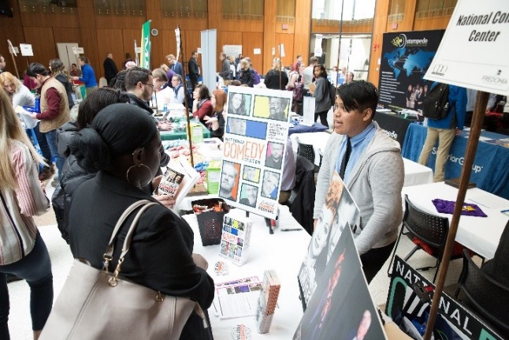
The Career Development Office (CDO) hosted the Ninth Annual Job & Internship Expo on Wednesday, March 20, from 12-3 p.m. in the Williams Center. Once again, the Expo reached the maximum space allowed in the Williams Center. A total of 89 employers attended bringing over 120 representatives, with over 30 representatives returning as alumni. Over 260 students attended and benefited from learning about job and internship opportunities with employers representing industries ranging from business, government, technology, nonprofits, health, and human services. Alumni were interviewed and videotaped during the event by the campus videographer, Jim Gibbons. The videos will be used for promoting future events.
The CDO's impact on student-employer engagement continues to soar with the successful launch of Handshake, a career service management system used by Fortune 500 companies. Positions and vacancies posted include 1,559 jobs, 540 internships, and 93 opportunities in experiential learning, volunteer, and on-campus student employment. Employers continue to seek Fredonia students and graduates to fill openings. On a daily basis, more than 3,700 jobs and internships are available in FREDNetwork. Engagement has increased by roughly 264% since the launch of the platform.
The CDO Internship Program continues to help students gain high-impact, hands-on experience and connect to employers. A total of 258 Learning Contracts have been processed for credit-bearing internships for the spring 2019 semester.
A host of employers participated in Employer Spotlights and held on-campus student interviews. Participant businesses included Cabana Sam’s, Cassadaga Central School District, Calpine (a power company in Texas), Greystone Nature Preserve, Lancaster Central School District, and alumni participating in Writers@Work events.
The Division of AEED continues to move forward with assessment. The director of the CDO is serving on the Watermark Assessment Management Steering Committee representing the AEED Division.

CDO Boards and Leadership Positions.
Under the direction of the director, CDO staff have a strong presence on boards and leadership positions locally and regionally in WNY including:
- The CDO internship coordinator continues to serve on the Board for United Way and participates in events such as SEFA board meetings and United Way community events.
- The CDO associate director and internship coordinator are serving as conference co-hosts for the SUNY Career Development Organization (SUNY CDO) being held at Beaver Hollow in June.
- The CDO director continues to co-chair a Middle States Working Group for Standard 1 – Mission and Goals. Additionally, the internship coordinator is serving on a Student Learning Experience (Standard 3) subcommittee as part of the Middle States review.
- The associate director serves as co-chair of Jobsapalooza (job fair held in Buffalo) and also on Fredonia’s Professional Development Committee.
- The internship coordinator represents the AEED Division serving on Fredonia’s University Senate.
- The director serves on the board of the Chautauqua Leadership Network, as the SUNY Applied Learning Liaison, Chair of the USA Buffalo Area Teacher Recruitment Days (TRD), and website manager of WNYACCC, Coalition of Chautauqua County Women and Girls, Chautauqua Leadership Network, and the Buffalo Area TRD.
Women’s Summit.
Tracy Collingwood assisted in the coordination of a Women’s Summit on April 4th, inviting Lisa Marsh Ryerson, President of the AARP Foundation in Washington, D.C. to serve as the distinguished keynote. The event was held at the Moon Brook Country Club in Jamestown with over 175 people in attendance.
Fredonia Alumni Association:

Alumni participated in the following Admissions recruitment initiatives:
- Rochester Area Regional Reception: March 4
- Long Island Regional Reception: March 10
- NYC Regional Reception: March 11
- Westchester Regional Reception: March 12

Reunions.

Recent Reunions: Phoenix, Arizona on Feb. 28, the Men of Color Conference here on campus on April 6, Jamestown on April 6, Atlanta on April 13, and an Alumni/Admissions night will be held at Yankee Stadium on May 28.

Writers@Work Committee.

The Committee invited the following alumni back to campus for a series of workshops and lectures: Scott Martelle ’84, an LA Times journalist, was on campus March 24 – 26. The following 2015 grads were here April 4-6: Naomi Coufal ’13,’15 (Welch Allyn), Maggie Gilroy (USA Today), Christopher Sanchez (Kaleida Health), and Andrea Vasiloff (Ingram Micro).

Scholarship Selection.

The Alumni Board Scholarship Committee met and selected twenty Children and Grandchildren of Alumni recipients for the academic year 2019-2020. These students were honored at the annual Leadership Recognition ceremony that was held in the Williams Center, on May 1.

Senior Challenge/Commencement.

The Class of 2019 has determined that they will gift the university a scholarship in the name of the class. The Alumni Association is providing honors cords for all eligible graduates, along with the diploma inserts. Commencement is scheduled for May 18.

Golf Tournament.

The annual golf tournament is scheduled for Friday, July 19, 2019, at Shorewood Country
Club. Proceeds will benefit Alumni/Foundation, and University Police Scholarships.
Homecoming 2019 (Oct. 18-20).

Highlights will include the 1970’s Reunion Jazz Concert, Class of 1969 fifty-year reunion, other class reunions, athletic contests and School of Music events. Thomas Quatroche, Jr., PhD ’92, current President and CEO of Erie County Medical Center, and Broadway Producer Brian Usifer ’03 will receive the Alumni Association’s Outstanding Achievement Awards.

Class Reunions.

During Homecoming, members of the Class of 1969 will celebrate their 50th reunion. Other significant anniversaries will also be recognized.

Scholarship Brick Walkway.

To date, over 300 bricks have been sold. The bricks will also be offered at Commencement.

Advancement/ College Foundation:

The Fredonia Foundation “Nurturing Innovation Campaign” is nearing its campaign goal of $20,000,000. Through March 31, 2019 the campaign has booked $19,105, 082 in donations!
Financials thru March 31, 2019.

Endowment market value: $ 37,881,959
2019 YTD Receipts: $ 369,560
2018 Scholarship & Program Support to University: $2,173,754

2019 Events.
Upcoming special events included the Fredonia Alumni Golf Tournament at Shorewood Country Club (Friday, July 19, 2019) and the Scholars Breakfast (Saturday, October 26^{th).}

2019 Donor Visits are scheduled for Arizona, Atlanta, Florida, New York City, Long Island, Cleveland, New Jersey, Pittsburg, Southern States, Colorado, Washington State, and WNY.

Board of Directors Meetings:
- Friday, May 3, 2019
- Friday, August, 2, 2019
- Friday, October 25, 2019

Native American Consortium:

The Native American Consortium participated in the College and Career Fair held on the Tuscarora Nation. Students from grades 9-12 attended several workshops on college prep and readiness. Fredonia was represented by Brandon Williamson. In addition, the Consortium had an information table displaying various college resources for distribution.

The director will be joining the National Indian Education Association of NY (NAIEA/NY) as an affiliate member. In March, a conference call was held for the executive members of the NAIEA/NY to discuss possible collaborations with NIEA and other affiliate organization members.

The consortium was represented at the Buffalo State College student meet and greet events recently. Buffalo State College is a member of the Native American SUNY: Western Consortium. The BSC Liaison, Dr. Lisa Marie Anselmi, and the Fredonia director, Cheryl John, are working to support students and assist them to establish student clubs. Student meetings included making plans for Native American Spring Heritage Month.

Consortium Events:

March 21 – American Indian Museum DC – Webcast – Safety for Our Sisters: Ending Violence Against Native Women
April 8 – RUMBLE documentary
April 16 – Exhibit of cornhusk dolls of the Haudenosaunee Nation leaders
April 30 – Lecture by Hugh O. Burnam, Ph.D. Candidate, Cultural Foundations of Education at Syracuse University. Title of the lecture is, A Grandmother’s Pedagogy: Learning about Experiences of Haudenosaunee Students in Higher Education. Hugh is a member of the Onondaga Nation.

