FAST FACTS from Internal Control February 2008
In an ongoing effort to increase awareness, safeguard assets, assure the accuracy of accounting data, promote operational efficiency, and encourage adherence to managerial policies and directives, SUNY Fredonia Internal Control will issue informational monthly FAST FACTS to all faculty and staff.
Locking your Computer

Did you know that you can secure your computer and prevent unauthorized use by locking the computer? Doing so prevents anyone except you or the campus administrator from unlocking the computer.
- To lock the computer, simply hold down the Windows key in the bottom left corner of your keyboard (between Ctrl and Alt), then press the “L” key. A “Computer Locked” dialogue box similar to this will appear:
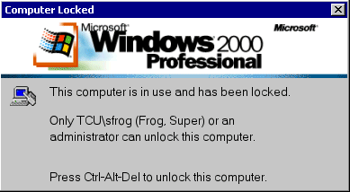

- To unlock the computer, press Ctrl-Alt-Delete.
- Type your password and click OK
What is the difference between locking my computer and logging off?
Logging off your computer closes all programs and data files. You are unable to access the applications you were in and must log on and restart all your programs again. By locking your computer, however, you keep all running programs in memory. When you return to your computer and enter your password, you can get right back to work.
If you have any questions, comments or suggestions regarding Internal Control FAST FACTS or any other Internal Control related issues, please contact Amy Beers, Director of Internal Control, at 673-4925 or amy.beers@fredonia.edu . Internal Control Committee members include Amy Beers, Tracy Bennett, Jean Blackmore, David Ewing, Karen Klose, Karen Porpiglia, Robyn Reger, Matthew Snyder, Denise Szalkowski and Daniel Tramuta.
Reference: www.kent.k12.wa.us/KSD/IT/TSC/prof_dev/windows_pc/locking.doc

