FAST FACTS from Internal Control October 2010
In an ongoing effort to increase awareness, safeguard assets, assure the accuracy of accounting data, promote operational efficiency, and encourage adherence to managerial policies and directives, SUNY Fredonia Internal Control will issue informational monthly FAST FACTS to all faculty and staff.

Understanding Risk Management in your Department

Risk management is a systematic approach to identifying, measuring, monitoring and managing business risks in an institution.

- Every Campus department is responsible for risk management in their area.
- Identify areas of risk in your department and develop a strategy to minimize such risk. Examples of situations or processes that are typically considered high risk are cash collection, storage of sensitive information such as Social Security numbers, segregation of duties, compliance with applicable laws and regulations etc.
- Utilizing the Risk Management Feedback Loop is a great way to get started.

The chart below represents the typical Risk Management Feedback Loop
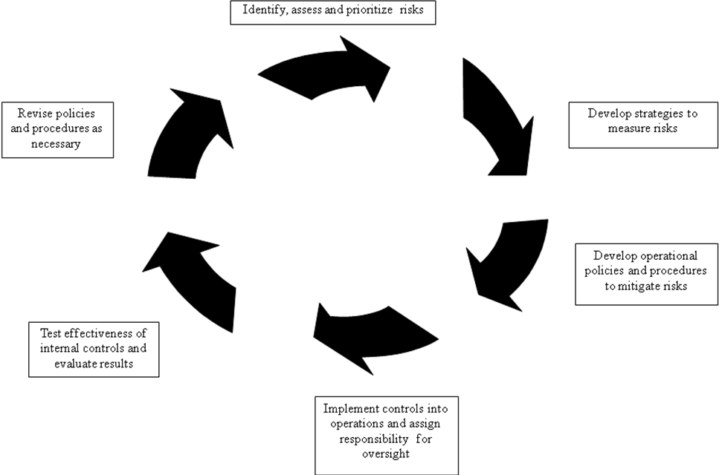

If you have any questions, comments or suggestions regarding Internal Control FAST FACTS or any other Internal Control related issues, please contact Amy Beers, Director of Internal Control, at 673-4925 or amy.beers@fredonia.edu . Internal Control Committee members include Amy Beers, Tracy Bennett, Jean Blackmore, Kevin Kearns, Karen Klose, Rebecca Nalepa, Karen Porpiglia, Matthew Snyder, Denise Szalkowski and Daniel Tramuta.

