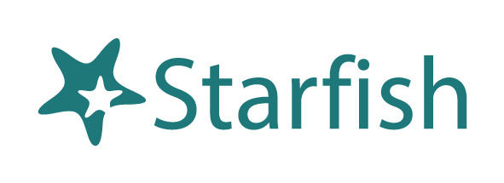
Student Getting Started Guide
Version 8.0

Welcome to Starfish ®
Starfish provides you with a central location to connect to the people and services that can help you finish what you start – all accessible from the side navigation menu of your Starfish Home page.
Using your e-services username and password, you can log in to your Starfish Home page by clicking on the blue “Starfish Log In” button at the top of the following page: https://home.fredonia.edu/starfish
The navigation menu includes access to a customizable profile and personalized channels that make it easy to schedule the dedicated time you need with your instructors, advisors, or counselors. Starfish can also help you manage the steps you need to take to stay on track and meet your goals.
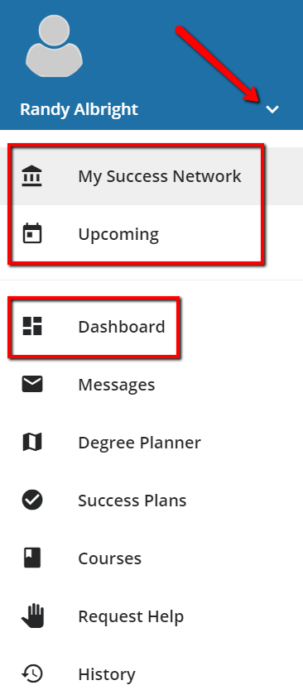
Here are three great ways to get started:
- Set up your profile
Make it easier for your instructors and advisors to get to know you and stay in contact.
- Connect to people and services that can help you
Use your personalized My Success Network and Courses channels for quick access to contact information, appointment scheduling, and course help.
Not sure what you need?
Browse the Services Catalog or use the Request Help (Fredonia calls it Raise Your Hand) option if you can’t find what you’re looking for through your personalized channels.

  - That’s it. Simple for you. Powerful for your future.

Set up your Profile
Begin by setting up your student profile. Your profile lets instructors and advisors know who you are and how to contact you. It also gives you control over how you wish to receive emails.
- Open the navigation menu and click your name, and then Profile to open your profile.
From here, you can customize your profile by uploading a photo, setting appointment reminders, and adding a secondary email address for receiving Starfish emails (e.g. your mobile phone).
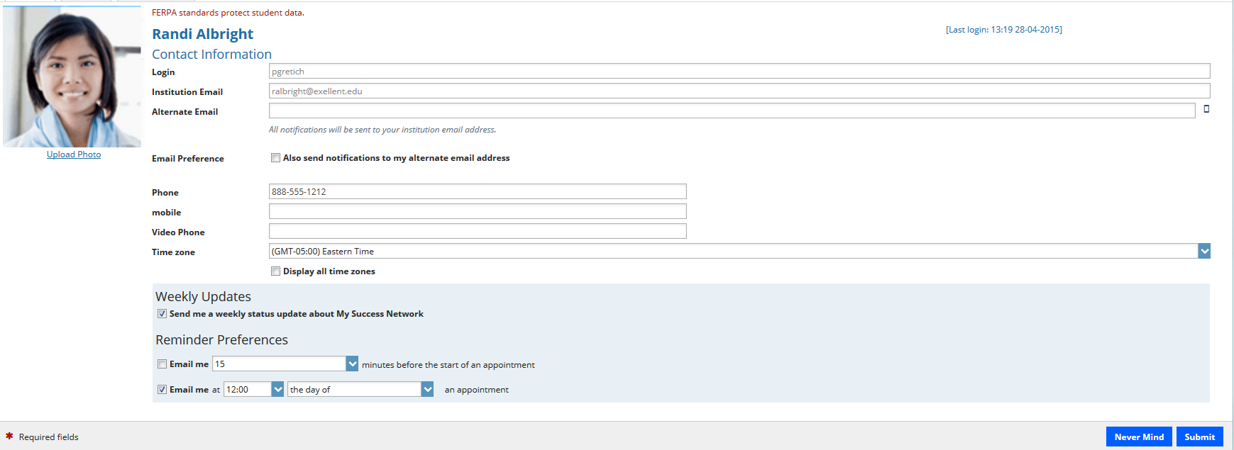
To have Starfish emails sent to your mobile phone (in addition to sending to your primary institutional email address):
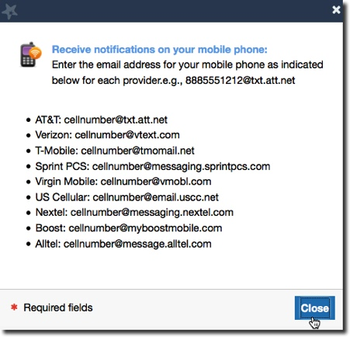
- Enter the email address of your mobile phone in the Alternate Email field. This address will be a combination of your phone number plus carrier information. Click the more information icon () for a list of common carriers and email address formats:
- Check the Also send notifications to my alternate email address radio button.

- Once you have made your desired changes to your profile, click the Submit button to save your updates.

Connect to people and services that can help you
The My Success Network and Courses channels display the people and services that are available to help you succeed. Here you can find key contact information as well as links to student service web sites and online appointment scheduling.

Messages
Select Messages to display messages sent to you in Starfish. Click on any message in the list to display the full contents of that message.
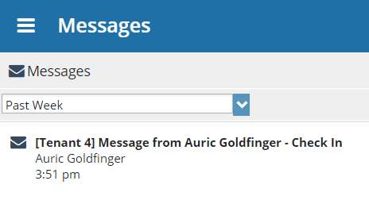

My Success Network
Select My Success Network from the navigation menu to display your personalized network. This channel lists the people and resources that are available to assist you. For each person or service listed, you will find contact information, supporting websites, and, if online scheduling is enabled, a link to Schedule Appointment.
The Services that are most relevant to you are displayed first. Select Show Other Services at the bottom of the page to see additional services.
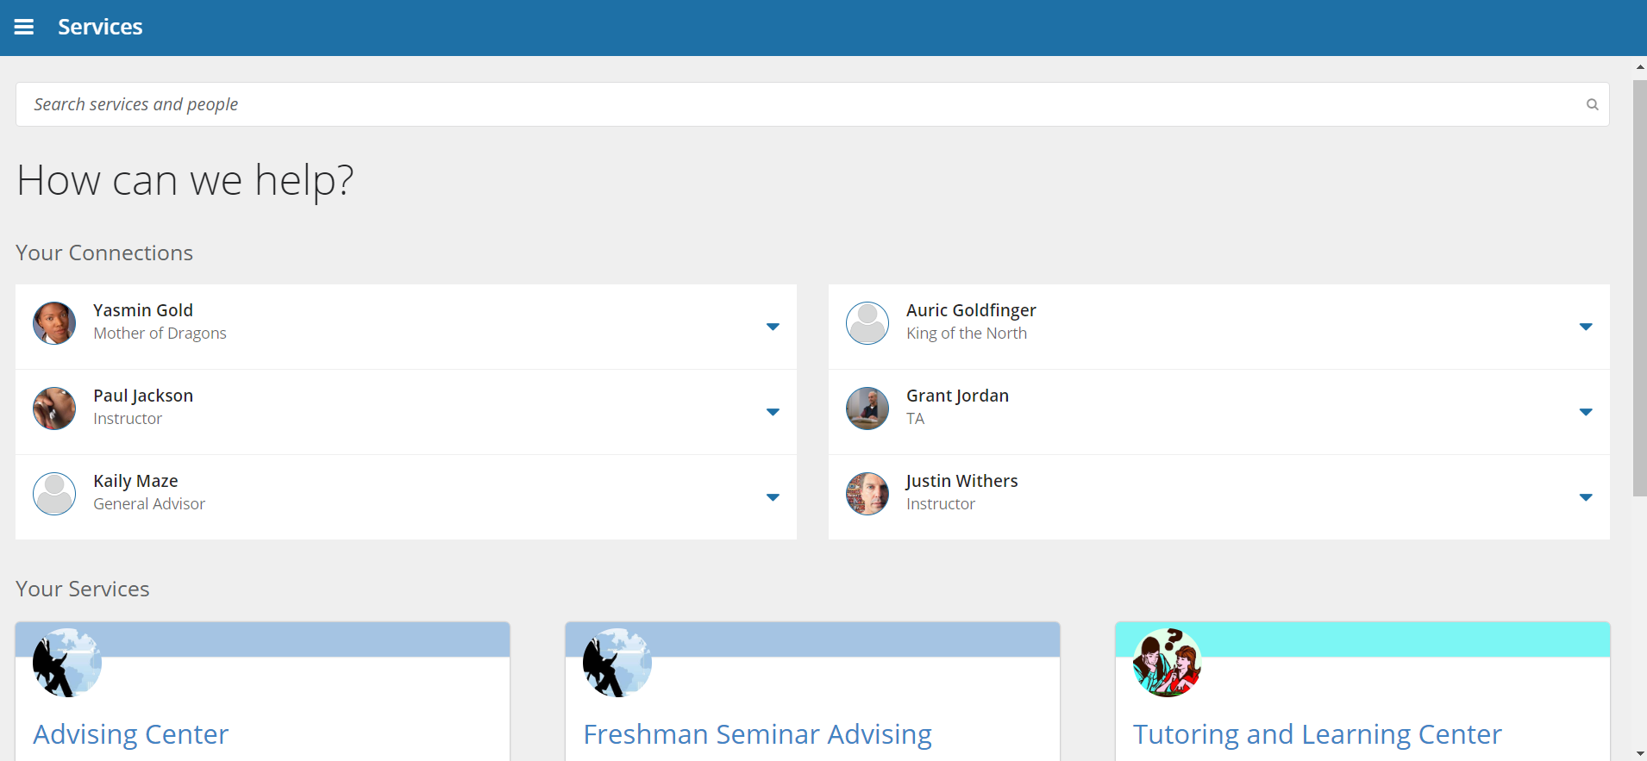

Courses
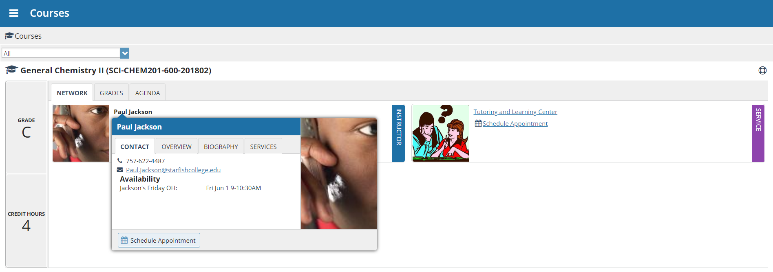
Select Courses from the side navigation menu to display information about courses you are enrolled in as well as contacts and available support related to each. Like the My Success Network channel, it is personalized to show the people and services specific to the courses you are taking, and gives you the ability to Schedule Appointment or Request Help related to a course.
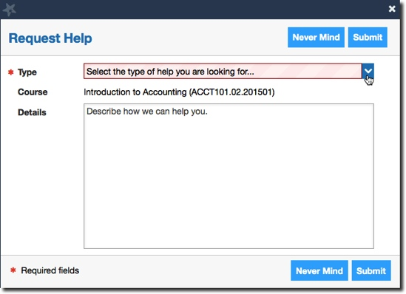
- Click the Help icon () link in the upper, right corner next to any of the courses in which you are currently enrolled.
- This will bring up the Request Help form. Select the Type of help needed from the drop down menu and give specific Details on how staff can assist you.
- Click the Submit button to submit your request when you are finished.

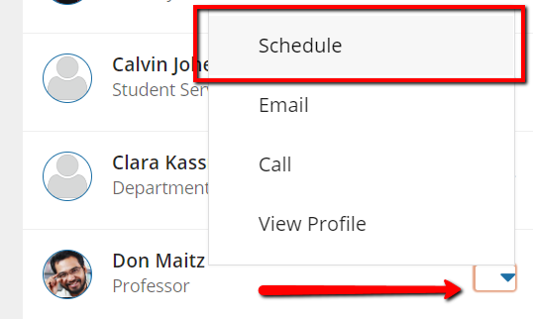
Make an Appointment (if online scheduling is enabled)
- From the My Success Network, click the triangle beside the name of the person you want to schedule an appointment with, and then select Schedule.
For Services where appointments are available, select Schedule for the desired service.
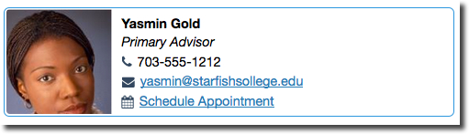
Or, from the Courses channel, select Schedule Appointment below the contact information for the desired person or service.

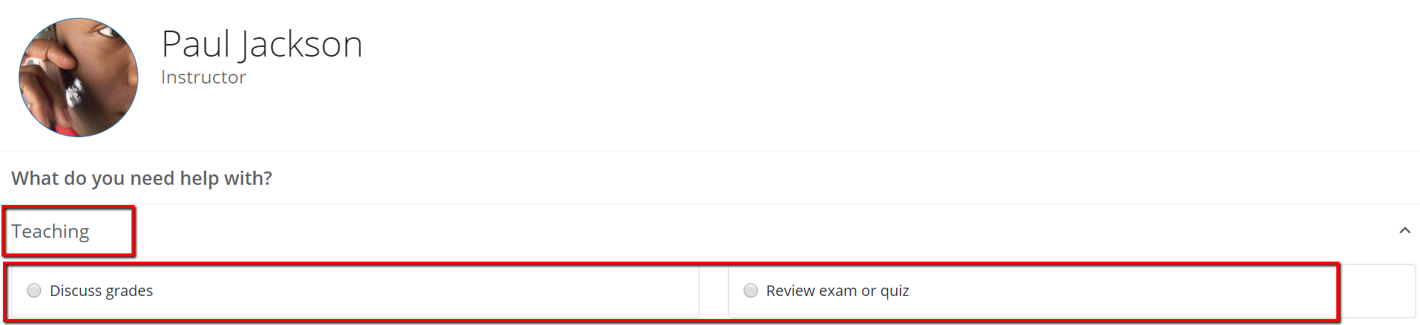
- Select the type of appointment you want to schedule and choose a reason from the list.

- Adjust the date range as needed to find days and times that work for your schedule, and then select a time from the list.
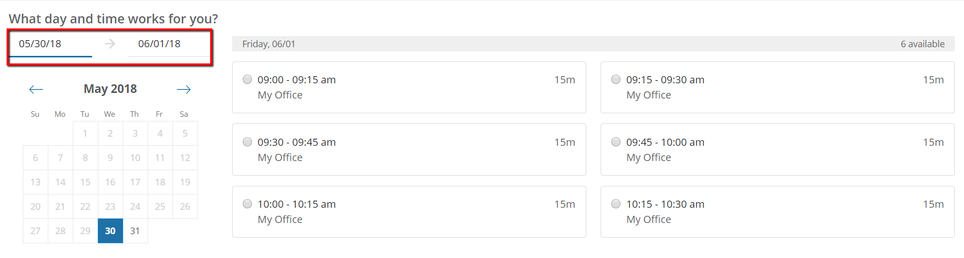
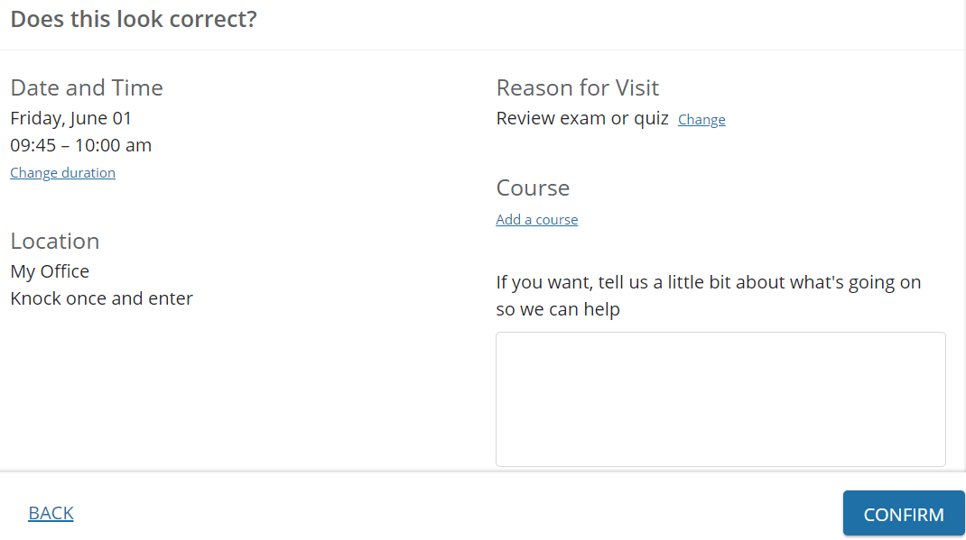
- Complete your sign up by adjusting any details, such as duration or course, where applicable, and add a description for why you want to meet.
- Click Confirm to finish scheduling the appointment. You will get an email with the appointment details and the appointment will be listed on the Upcoming tab.

Change an Appointment
On the Upcoming tab, you can view scheduled appointments and make changes. Click on an appointment to make changes to it, such as changing the location or duration, when available. You can cancel the appointment by clicking the ellipsis and selecting Cancel appointment.
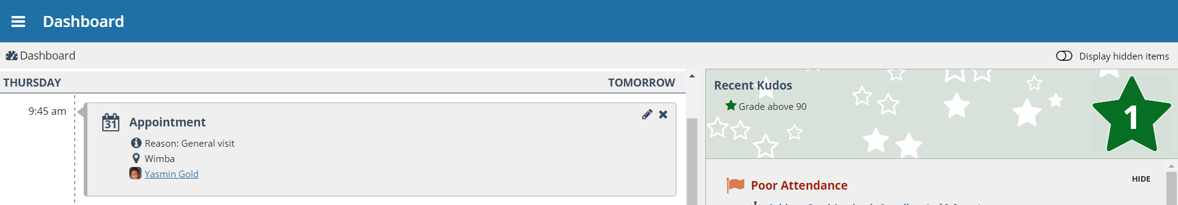

Stay on track

Dashboard
The right-hand column of your Dashboard highlights items that require your attention and may include alerts related to your class work, recommended referrals to campus support offices to help you succeed, and Kudos from your instructors.

Not sure what you need?

Request Help
Select Raise Your Hand from the navigation menu to see information about where to go for assistance.
From here, you can select Help Me to submit a request for help. You will be asked to provide additional information such as the type of help you are requesting, the related course (if applicable), and a description.
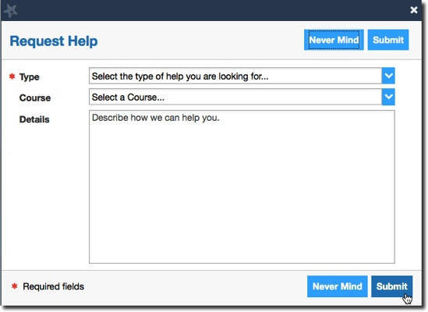
We encourage you to make your description as detailed as possible to insure you get the appropriate help needed. Click Submit to submit your request when done.

Frequently Asked Questions

What if I don’t see anyone listed in My Success Network?
Your specific advisors or counselors might not be assigned yet. Check back later or contact the Early Alert Coordinator at (716) 673-3188 for additional assistance.
What if I click the Starfish link and get a “You do not have access” message?
Contact the Early Alert Coordinator at (716) 673-3188 for assistance with accessing the Starfish system.

What if I need more help?
For technical issues, contact the Early Alert Coordinator at (716) 673-3188. For questions regarding a flag, please contact your instructor or advisor.

