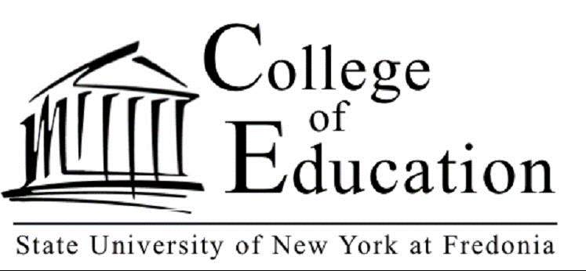

Student Teaching Evaluation Results: A Measure of Teaching Effectiveness

The College of Education provides high quality and clinically rich programs that facilitate the individual growth, competencies, and professionalism of our student teachers. As seen in the table below, a very high percentage of our student teachers successfully complete their full-time student teaching which is a meaningful measure of teaching effectiveness.

Undergraduate
Academic Year | Student Teaching Completers |  | Percentage Not Meeting Target Performance | Percentage Meeting Target Performance
2016-2017 | 173 |  | 1% | 99%
2015-2016 | 180 |  | 0% | 100%
2014-2015 | 196 |  | 3% | 97%
Graduate
2016-2017 |  | 38 | 0% |  | 100%
2015-2016 |  | 45 | 0% |  | 100%
2014-2015 |  | 48 | 0% |  | 100%

