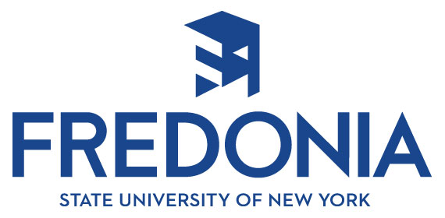

Community Partners Program

Agency Name _____________________________________________________________________

Contact Name _____________________________________________________________________

Address _____________________________________________________________________

Phone __________________________________ Fax ________________________

Email _____________________________________________________________________

Section A: Campaign

1) Do you have a public relations person on staff?  Yes:  Full time  Part time  Volunteer
❒ No
If not, have you ever utilized external public relations services?  Yes  No

2) Please describe the public relations situation with which you need assistance. You may use an additional sheet of paper, not to exceed one-half page. This summary will be used for the selection process.
_______________________________________________________________________________
_______________________________________________________________________________
_______________________________________________________________________________
_______________________________________________________________________________
_______________________________________________________________________________

Section B: Other Opportunities

If your organization is not selected for the SPRING Community Partners Program, would you like to be considered for the FALL 2017 program? We would email you to confirm your interest at that time.
❒ Yes  No
If your organization is not selected, would you be interested in hosting a student intern to assist you with current public relations projects?
❒ Yes  No
If yes, during which semester(s) could you accommodate an intern?  Fall  Spring  Summer

Please return this form via email no later than Jan. 18 at noon to Ann Carden at Ann.Carden@fredonia.edu. Questions? Call Ann at 716-785-3487.

