SUNY Fredonia
College of Arts & Sciences
Assessment Report Template
2011-2012
Instructions: Fill in all of the requested information, replacing any instructions/notes in italics with actual text.

Department Information
Department | Computer and Information Sciences
Academic Programs | Computer Science; Computer Information Systems
Degrees | BS
Contact Person (This should be the person coordinating/reporting on the department’s assessment efforts)
Name | Junaid Ahmed Zubairi | Reneta Barneva
Title | Professor | Professor
E-Mail Address | zubairi@fredonia.edu | Reneta.Barneva@fredonia.edu
Extension | 4694 | 4750

Department Mission Statement and Goals
Mission Statement:
In accordance with the SUNY Fredonia mission and SUNY principles, the mission of the Department of Computer and Information Sciences is to provide state-of-the-art education to our students to excel in key fields of computer and information sciences and engage them in activities that enhance the welfare of Western New York region and society at large. Through student-centered education in an environment that fosters creative thinking and innovative problem-solving, we prepare our graduates for an assortment of career goals including graduate studies. We view scholarly investigations and software development as an integral part of instruction, providing opportunities to students for active learning through practicum, research, and internship. Through active involvement in general education and interaction with cross-discipline course work, our programs embody students with life skills that help them become productive citizens of the society.
Is your department’s mission statement posted on your department’s webpage? X Yes No
Please specify your department’s current goals and the progress made toward those goals during 2011-2012. (Please refer to the agreed upon goals for the faculty and staff in the department resulting from the past 5-year (periodic) review, or from the most recent accreditation report if program(s) are approved by discipline-based accrediting bodies (e.g., NCATE). This is not the place to list student learning goals/outcomes.)

The goals are resulting from the 5-year review conducted last year, Goals and Action Plan Document and the MOU the Dean sent us.
Department Goals | 2011-2012 Progress
Curriculum:  - Revising and reducing the number of tracks in the CS program. Eliminating some of the courses which have low enrolment or are outdated, making them elective, or changing their frequency. | - Completed. We prepared and submitted a CS program revision. It passed Dean’s approval and is waiting for approval of Academic Affairs Committee.
- Revising the Business elective courses in the CIS program and making sure that they are offered by the School of Business, do not require many prerequisites, and are available for enrollment to our students. | - Completed. The proposal was submitted and approved.
- With the increased opportunities for internships, incorporating CSIT 300 as an option in our programs. | - Completed. The revision of the CIS Program incorporates CSIT 300 Internship as an elective course.
- Improving online teaching by getting feedback from the students several times a semester. | - Progress. Only one of the online instructors – Dr. Singh – was getting regularly feedback from the students. On the other hand, the feedback was very positive. There weren’t complaints from the other online courses, but we will continue monitoring them closely.
Assessment and Accreditation:  - Aligning the learning goals with ABET learning outcomes and creating program educational objectives for each of the CS and CIS programs. | - Progress. Since one faculty – Dr. Zubairi – was sent to the ABET symposium only in April and reported that the learning outcomes have to be defined by an Advisory Board composed of Employers, Faculty, Alumni, and Students, we are only at the beginning of this process. Currently we are contacting employers and alumni to invite them to the Advisory Board.
- Rewriting the Assessment Plan with the new learning goals. | - Progress. Drs. Barneva and Zubairi prepared a new assessment plan for the ABET student outcomes. It needs some corrections, though, due to last-minute information received.
Faculty:  - If Dr. Abu-Jeib does not come in the Fall 2011 when his unpaid leave terminates, having a search for a tenure-track replacement for him. | - Completed. Dr. Abu-Jeib resigned and we had a search for his position. Meanwhile, Prof. Olson was appointed full-time.
- Cooperating with the chair and contributing to build a collegial climate. | - Some progress. Some faculty are cooperating with the chair and volunteering to help. Good example is the team effort to urgently cover the classes of a colleague on sick leave. However, there is still room for improvement. The department may need some professional help.
Recruitment:  - Continuing giving talks at the Liberal Arts Seminar. | - Completed. We not only gave talks to the Liberal Arts students, but to those that were our advisees and were interested in a major or a minor in our field, we gave personal orientation.
- Continuing with the Department Expo and making it more popular among the undecided majors. | - Completed. This year the Expo lasted longer and there were many attendees, including from the Technology Incubator.
- Continuing to update and improve the department website. | - Completed. The department web site is regularly updated. Prof. Olson created two web pages for alumni on Facebook and Twitter.
- Continuing to enhance our departmental image and visibility through organizing annual High School Contests. | - Completed. On May 14 the department organized a successful new edition of the High School Contests.
Facilities:  - Having learning space where the students can work together and build a sense of community. | - Not completed. We hope that we will have more space with the opening of the new Science Building.
- Having adequate meeting space. | - Some progress. We are grateful to Dean Kijinski for addressing some of the office space issues. We reorganized CS Commons and the department and committee meetings are held there. However, the space is insufficient for a larger group of people.
- Having more courses taught in a lab. | - Some progress. With the reorganization of Modern Languages Lab, the students can use it from 9 AM as an open-access lab. This would give us the possibility to use Lab 115 from 8 AM to 11 AM for classes and start the open access at 11 AM.
Community:  - Strengthen the ties with SUNY Fredonia Technology Incubator and contribute through it to the development of the region. | - Completed. The employers of the Technology Incubator are keeping in touch with us. One of them, Mr. Kelley, is teaching a course for the department. Many of the incubator tenants are offering internships to our students.

If needed, please complete the “Assessment of Student Learning Outcomes” table once for each program in your department, copying and pasting the rows/table additional times as needed in order to address the assessment process for each set of learning outcomes in your department.

Assessment of Student Learning Outcomes
Program:
Outcome 1: | Demonstrate core knowledge of computing/information technology and demonstrate robust programming skills.
Assessment Method(s) | Instructors assign programs to be developed by CSIT205 and CSIT221 students. The programs are thoroughly reviewed and graded by the instructors. The instructors provide the Assessment Committee Chair with a portfolio of a number of assignments.
Data Source | Data source is the programs written by students and graded by instructors in CSIT205 and CSIT221.
Assessment Results | Assessment results for Goal 1 were included in the 2010-11 Assessment Report.
Outcome 2: | Be familiar with the computer organization and system software.
Assessment Method(s) | At the end of the courses, before the exam week, the instructors gave a short quiz prepared by the Assessment Committee to all students. The quiz papers are collected by the Assessment Committee chair. Then the Committee Members apply a rubric system developed to specifically assess the achievement of Goal 2 as well as simple statistical methods.
Data Source | The data was collected in Fall2011 in the course CSIT 311 and in Spring 2012 in CSIT 312. Total sample size is 32 in both courses. Appendix-1 shows the questions and rubrics that were used in the assessment.
Assessment Results | SUMMARY  The overall results of Goal 2 assessment are quite positive. They show that 91% (29 out of 32) of the students are able to meet or exceed the standards for operating systems, 63% (20 out of 32) for assembly or linking of programs and 59% (19 out of 32) of the students meet or exceed the standards for understanding the CPU operation.  DETAILS  The Instructors teaching CSIT 311 in Fall 2011 and CSIT 312 in Spring 2012 were requested to compose a quiz including the questions for testing Goal 2. The Performance Indicators (PIs) were:  - Distinguish between the terms “translation,” “interpretation,” and “compilation.”  - Describe the functions of the operating system.  - Describe the functions of CPU.  Since the courses CSIT311 and CSIT312 do not emphasize on the topics of disk drives and digital media in detail, it is recommended that the department does not include PI 3 “Describe various storage media that could be used as secondary storage devices. Describe major characteristics of disk storage.” in future for assessment of Goal 2, or PI 3 is assessed in other courses.  The instructors handed over the student quizzes to the Assessment Committee chair for processing. The committee chair/coordinator used the rubric sheet as given in Appendix 1.  Figure 1, 2 and 3 show the results of the three PIs. For all three performance indicators combined, there is only one significant negative result where seven students out of 32 (22%) failed to exhibit the understanding of assembling, linking and compiling process.  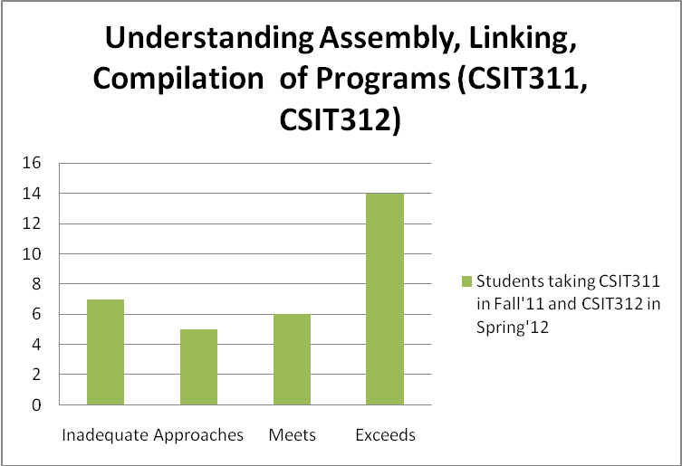  Figure 1: Assessment Results for PI 1 “Distinguish between the terms “translation,” “interpretation,” and “compilation.”  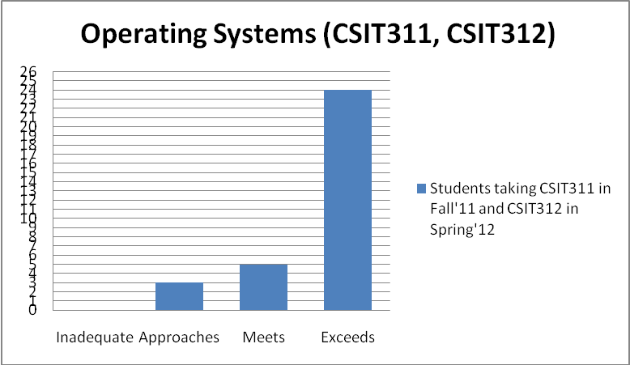  Figure 2: Assessment results for PI 2 “Describe the functions of the operating system.”  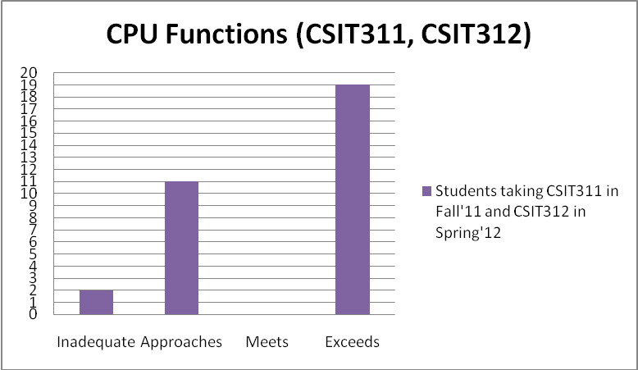  Figure 3: Assessment results for PI 4 “Describe the functions of the CPU.”  The results show that the students of CSIT311 and CSIT312 have exhibited good understanding of the concepts related to computer organization and system software. It was noted that the lowest score of 59% was in response to the question about CPU and its functions. It is recommended that the department convey to the instructors of CSIT311 and CSIT312 the concern that the students need further exposure to the CPU and its various functions and sub-units. In addition, they should get additional exposure to the difference between assembly, linking and compilation of the programs.
Outcome 3: | Clearly communicate the computer science/computer information systems concepts.
Assessment Method(s) | This learning outcome is assessed through Instructor and peer evaluations of the oral presentations of students in courses with oral communication component.
Data Source | The data will be collected from Instructors offering oral communications courses.
Assessment Results | The assessment of this learning outcome was not scheduled in 2011-12.
Outcome 4: | Be able to analyze a real-life problem, identify and define computing requirements for its solution and use appropriate software to solve it.
Assessment Method(s) | The Assessment Committee identifies three 400-level courses every year when Goal 4 is assessed, collects the projects and the student grades in these courses, reviews them and assesses Goal 4.
Data Source | The data will be collected from Instructors offering selected 400-level courses.
Assessment Results | The assessment of this learning outcome was not scheduled in 2011-12.
Outcome 5: | Indirect assessment of the Programs through an exit survey
Assessment Method(s) | The department secretary and the chair invite and encourage the graduating students to fill out the attached survey (Appendix II). The chair also reminds the faculty to identify the graduating students and remind them to fill out anonymously the survey.  This indirect method helps us refine the assessment of the Learning Goals.
Data Source | The data is collected by the department secretary. This year it was processed by the Department Chair following the pattern of last AY for easy comparison.
Assessment Results | Results of the 2012 Spring Graduates Survey  Seven students submitted responses to the graduates’ survey out of 25 students graduating in the Spring’12. This is a response rate of 28% and the results should be considered with that in mind. Of the surveys received, four were from CIS majors, two were from CS majors and one was from a CS minor.  Not counting transfer students (there was one), two started the program in 2007 and 4 in 2008. Therefore, all of the students graduated in less than 6 years. Three students changed their major. The interesting finding is that they changed it from Computer Science to Computer Information Systems which indicated that the students may not have initially sufficient information about CIS.  One of the respondents transferred into Fredonia from another school with a substantial number of transfer credits (more than 60). It took him/her 2 years in total to graduate.  When asked to rate their level of satisfaction with the CIS Department on a scale of 1 to 6, the average score was 5.1, which shows an increase from 4.5 last AY.  Only one of the students indicated to have lined up a job. This may be a result of the relatively early administering of the survey.  None of these students has been accepted into graduate school, mostly because they are more interested in immediately entering the job market rather than pursuing a graduate education. Two of the graduates do report that they expect to further their education at some point in the future.  When asked to name their favorite courses, a wide range of courses were specified, both within and outside the CIS department. The courses that were most often mentioned were CSIT 107 with 3 votes and CSIT 105, 201, 203, 205, 207, 241, 341, 425, and 433 – all with 2 votes.  When asked which electives they wish they had been able to take, we received two kinds of responses. Some people interpreted this as asking which of our courses they did not take because they didn’t have time, while others thought it meant which courses did we not offer that they wished we did offer. In the former category, the most often mentioned courses were Android Programming, Java, Ruby on Rails, Game Development, and more database and networking classes. Students also wish that we offered courses on Apple platform and modern technology.  Students were asked on a 1 to 5 scale whether they thought faculty offices and classrooms were accessible. The average score was 4.3. Students were also asked whether the workspace and equipment was adequate for them to do their coursework. This result was again 4.3 out of 5, but students indicated that they want more courses taught in labs.
Conclusions
Have you had an opportunity to discuss these results within your department? If so, what form did this take?  What conclusions  were drawn about student learning as a result of their assessment efforts? | A draft of the current report was posted on Angel for faculty review. The final version is posted on the department web site. Next semester, at the first department meeting, it will be discussed and measures towards curriculum improvement will be undertaken.  The results show that the students of CSIT311 and CSIT312 have exhibited good understanding of the concepts related to computer organization and system software. It was noted that the lowest score of 59% was in response to the question about CPU and its functions. It is recommended that the department convey to the instructors of CSIT311 and CSIT312 the concern that the students need further exposure to the CPU and its various functions and sub-units. In addition, they should get additional exposure to the difference between assembly, linking and compilation of the programs.  The exit survey demonstrates higher satisfaction of the education of CIS Department 5.1/6 – up 0.6 points. It also indicated the appreciation of the students of having more “hands-on” courses. The graduates indicate, however, that more courses should be taught in lab settings.

Dissemination and Use of Assessment Findings
During the past year, in what ways did your department discuss/share results from assessment done this year or in previous years? | In AY 2010-11, Learning Goal #1 was assessed. The results were disseminated among faculty still in June 2011 and posted on the department web site.  At department meetings on August 31, 2011 and September 28, 2011 the results were discussed. The main findings were that students need more practice to test the programs they develop and more practical courses. Accordingly, the department approved steps to make improvements in the curriculum (see below).
How were these findings used to improve teaching and learning in your department? Please specifically describe the actions that were taken as a result of the findings. | Describe how the data were used. Here are some examples to think about:  If no changes were made, please explain why: N/A
  Changes to the Assessment Plan | - revision of intended learning outcomes  - revision of measurement approaches  - changes in data collection methods  - changes in the sampling
  Changes to the Curriculum | X changes in teaching techniques  - revision of prerequisites  - revision of course sequence  X revision of course content  X addition of courses  - deletion of courses
  Changes to the Academic Process | - revision of admission criteria  - revision of advising standards or processes  - improvements in technology  - changes in personnel  - changes in frequency or scheduling of course offering

Closing the Loop: Review of Previous Assessment Findings and Changes
What is one change your department has implemented in recent years as a result of assessment data? | The results of assessment of Goal 1 indicated that most of our students in the intensive programming courses CSIT 205 and CSIT 221 are able to grasp the main concepts of developing software. The need for stressing program correctness and for testing the programs with own generated data was emphasized.  In the exit interview the students indicated that they would appreciate more “hands on” applied work.  At a department meeting we decided to include more testing practice in the courses CSIT 121 and 105 so that when reaching the courses CSIT 221 and 205 the students are able to independently test their results.  Regarding the “hands-on” work, we understand that this type of education is more appealing to students, but the theoretical foundations should also be covered. Thus, we introduced many innovative courses such as Android, iPhone, Windows Phone, Ruby on Rails, Blender, Game Development, and others giving practical experience and giving competitive advantage to our students at the job market. We have also incorporated in our curriculum some more applied elements, such as practical network management skills (including network security), database administration, and significant coverage of design patterns and UML.
Describe the process for implementing this change. | The decision was made at a department meeting. The changes were implemented specifically in individual courses by the course instructors. In addition, our network administrator and our student lab staff were instrumental in setting up a separate network (not attached to the college network) so students could work on network security issues. The additional courses were developed by the individual instructors.
How has this change been assessed? | Goal 1 will be reevaluated after one assessment cycle. Indirectly, through the survey, we can assess that the new “practical” courses are appreciated.
What were the findings of the assessment(s)? | The exit student survey indirectly assesses the changes. The students are satisfied by the new courses. We do not have data, however, about the assessment of the testing practice in CSIT 121 and 105.
How do you plan to (continue to) use this information moving forward? | It’s a delicate balance in our curriculum between theory and practice. We will continue to calibrate the quantity of each as we receive more information from student surveys.

Baccalaureate Goals: Planning Ahead

Alignment of Institutional Goals and Program Learning Goals
To what extent, if at all, has your department discussed or planned to discuss the alignment between your learning goals and the new Baccalaureate Goals? The alignment between our learning goals and the new Baccalaureate Goals occurs naturally for “Skilled” and “Creative” goals. For other goals, we have discussed the alignment with Marissa Cope, Assistant Director IRPA. She suggested that even if a learning outcome partially fulfills a goal, it can be linked to the goal. She recommended that we should map our learning outcomes to the new goals and the PEO’s that may be true 3-5 years after graduation. Based on her recommendation, we have attempted the alignment as shown below.

If you have already discussed alignment:
In the table below, please insert the learning outcomes and then map them to the four baccalaureate goals by placing an X in the corresponding box in order to demonstrate alignment between your current goals and the institution-level goals. Repeat as needed to address multiple sets of learning goals in your department. Alternatively, if you have already drafted a document outlining the connections, you may include it with the report.

Program: | Skilled | Connected | Creative | Responsible
Demonstrate core knowledge of computing/information technology and demonstrate robust programming skills | X |  | X
Be familiar with the computer organization and system software | X |  | X
Clearly communicate the computer science/computer information systems concepts. |  | X
Be able to analyze a real-life problem, identify and define computing requirements for its solution and use appropriate software to solve it. | X |  | X | X

Experiential Learning
Please indicate if your department offers each of the following learning experiences for students, and if so, please describe both the experience and the student learning assessment process:
 | No | Yes | Please describe the experience: | How is student learning from this experience currently assessed?
Community engagement | X
Creative endeavors |  | X | CSIT 499 Senior Project. The students work under the supervision of a faculty mentor on a computer and information sciences project. | The student, the mentor, the advisor and the department chair sign a learning contract. The performance of the student is assessed according to this contract. Since CSIT 499 is not a required course, it is not included in the assessment plan, but the documentation is available in student folders.
Internship |  | X | CSIT 300 Internship. The students work under the supervision of a faculty sponsor and site supervisor. The duration is between 40 hours a semester (for 1 credit) to a full-time job the whole semester (for 12 credits). This year 9 students took an internship. | The student, the faculty sponsor, the site supervisor, and the CDO Director sign a learning contract. The performance of the student is assessed according to this contract. Since CSIT 300 is not a required course, it is not included in the assessment plan, but the documentation is available in student folders.
Research |  | X | CSIT 497 Thesis. The students work under the supervision of a faculty mentor on a computer and information sciences research topic and write a thesis. | The student, the mentor, the advisor and the department chair sign a learning contract. The performance of the student is assessed according to this contract. Only a faculty with a Ph.D. in computer and information sciences is eligible to serve as a mentor. Since CSIT 497 is not a required course, it is not included in the assessment plan, but the documentation is available in student folders.
Study abroad | X
Teaching practicum | X

Implementation and Assessment of Baccalaureate Goals
What concerns does your department have regarding the implementation and assessment of the Baccalaureate Goals? | The implementation of new Baccalaureate Goals is not an issue as our department has aligned our learning outcomes to the new goals. However, the Baccalaureate Goal “Responsible” may not be assessed it immediately upon graduation.
What information or professional development would your department like to have regarding this new framework? | We may need professional help how to match the Baccalaureate Goals to ABET Learning Outcomes, because Baccalaureate Goals seem to be very general while ABET PEOs are very discipline specific.
Please share any other comments you have regarding the new undergraduate learning outcomes framework: | It is very difficult to get survey response from our alumni, especially from those that have graduated 3 to 5 year ago. We think, the Alumni Center should help distribute the survey and get a response so that we can assess the programs accordingly.

APPENDIX 1


State University of New York at Fredonia
Department of Computer and Information Sciences
2154 Fenton Hall (716) 673-4820

QUESTION SHEET FOR ASSESSMENT OF GOAL 2
“Be familiar with the computer organization and system software”

The students are asked to answer the following questions:

- (system software) Distinguish between the terms “translation,” “interpretation,” and “compilation.”

- (system software) Describe the functions of the operating system.

- (computer organization) Describe various storage media that could be used as secondary storage devices. Describe major characteristics of disk storage.

- (computer organization) Describe the functions of CPU.

The Assessment Committee evaluates each question using the scale:

Inadequate
Approaches Standards
Meets Standards
Exceeds Standards

Prepared by Dr. Barneva
APPENDIX 2
State University of New York at Fredonia
Department of Computer and Information Sciences
2154 Fenton Hall (716) 673-4820

SURVEY OF Computer Science/computer information systems GRADUATES
Please check the appropriate entry, or choose the most suitable option, or fill the blanks for each of the question given below where possible.

1. You earned your B.S. degree in
  - Computer Science
  - Computer Information Systems

2. a. Year started at SUNY Fredonia_____________ Year graduated_______________
b. Did you change your major? Yes _____ No______
If Yes:
c. What was your previous major?_________________________
d. Did you transfer from another college to SUNY Fredonia? Yes _____ No______
If Yes:
e. How many credit hours did you transfer?
Less than 30____ Between 30 and 60______ Between 60 and 75____ Over 75____
f. How many semesters overall you spent at college (at SUNY Fredonia and the college your transferred from)? ______
3. On a scale of 6 to 1 (with 6 being Excellent and 1 being very poor): How satisfied are you with your education at the Department of Computer and Information Sciences in SUNY Fredonia?

4. Do you already have a job offer?
- Yes b. No
If yes, is it related to your major?
  - Yes b. No

5. Do you plan to attend graduate school?
- Yes, already accepted into graduate school; Field: ___________
- Yes, applying now; Field: _____________
- Yes, in the future
- No
6. List five courses you liked the most at Fredonia
a. ___________________________________________
b. ___________________________________________
c. ___________________________________________
d. ___________________________________________
e. ___________________________________________

7. If you have a job offer, list four courses that were most beneficial to you in securing the job.
a. ___________________________________________
b. ___________________________________________
c. ___________________________________________
d. ___________________________________________

8. If you had the option to take more elective choices in the discipline, what topic areas would you have liked to have taken at SUNY Fredonia?
- _________________________________________
- _________________________________________
- _________________________________________
- _________________________________________
9. How accessible do you feel faculty offices and classrooms were?
(inaccessible) 1 2 3 4 5 (very accessible)

10. Do you think the access you had to workspace and equipment were sufficient for your coursework
(disagree) 1 2 3 4 5 (agree)

11. Do you have a positive remark/comment(s) to share? ____________________________________________________________________________
____________________________________________________________________________
____________________________________________________________________________
12. Do you have a negative remark/comment(s) to share?
____________________________________________________________________________
____________________________________________________________________________
____________________________________________________________________________

Prepared by Dr. Siddiqui
Revised by Drs. Arnavut, Barneva, Hansen, Ruslanov, Zubairi, and Prof. Mendez in Spring 2011. Approved by the Department on March 28, 2011.

