SUNY Fredonia
College of Arts & Sciences
Department of Computer and Information Sciences
Assessment Report
2010-2011

Department Information
Department | Computer and Information Sciences
Academic Programs | Computer Science; Computer Information Systems
Degrees | BS
Contact Person (This should be the person coordinating/reporting on the department’s assessment efforts)
Name | Junaid Zubairi
Title | Associate Professor
E-Mail Address | zubairi@fredonia.edu
Extension | 4694

Department Mission Statement and Goals
Mission Statement: In accordance with the SUNY Fredonia mission and SUNY principles, the mission of the Department of Computer and Information Sciences is to provide state-of-the-art education to our students to excel in key fields of computer and information sciences and engage them in activities that enhance the welfare of Western New York region and society at large. Through student-centered education in an environment that fosters creative thinking and innovative problem-solving, we prepare our graduates for an assortment of career goals including graduate studies. We view scholarly investigations and software development as an integral part of instruction, providing opportunities to students for active learning through practicum, research, and internship. Through active involvement in general education and interaction with cross-discipline course work, our programs embody students with life skills that help them become productive citizens of society.
Is your department’s mission statement posted on your department’s webpage? X Yes No
Current Goals and Objectives: (Please refer to the agreed upon goals for the department resulting from the past 5-year (periodic) review, or from the most recent accreditation report if program(s) are approved by discipline-based accrediting bodies (e.g., NCATE).)
Goals for AY 2010-11:
- Conducting the 5-year review.
- Development of new Assessment Plan.
- Improving the syllabi and preparing master syllabi for all the courses.
- Writing track lists for both Computer Science and Computer Information Systems.
- Updating and redesigning the web site.
- Writing department newsletters.
- Tenure-track replacement of the faculty that retire/resigned.
Please specify the progress your department made in 2010-2011 toward meeting your goals:
- Conducting the 5-year review. The 5-year survey was written and an external reviewer visit was arranged (thanks to Dean Kijinski).
- Development of new Assessment Plan. The plan was developed, approved by Assistant Dean Dr. Johnston-Robledo, and the first goal evaluated.
- Improving the syllabi and preparing master syllabi for all the courses. The master syllabi were created and are used by the instructors to prepare their specific syllabi.
- Writing track lists for both Computer Science and Computer Information Systems. The track lists for Computer Science and Computer Information Systems were developed by Drs. Hansen and Barneva and posted on the department web page.
- Updating and redesigning the web site. The web site was redesigned. A movie for the programs was created. The web site is maintained weekly.
- Writing department newsletters. The newsletters were written in January and sent to alumni.
- Tenure-track replacement of the faculty that retired/resigned. The goal was not met due to budget difficulties. We hope, however, that it will be met as soon as the ban on hiring is lifted.

Student Learning Outcomes and Curriculum Map
**Please append your curriculum map document (including student learning outcomes) to the end of this report
Are your student learning outcomes posted on your department’s webpage? X Yes No

Assessment of Student Learning Outcomes
Outcome 1: | Demonstrate core knowledge of computing/information technology and demonstrate robust programming skills
Assessment Method(s) | The instructors teaching CSIT 205 Visual Basic II and CSIT 221 Introduction to Computer Science II in Fall 2010 and Spring 2011 were informed about keeping programming assignment portfolios of the students. The instructors handed over the material to the Department Assessment Committee for processing at the end of Fall 2010 and Spring 2011. The committee performed the assessment using the rubric sheet as in Appendix-1.
Data Source | Upon Assessment Committee request, the Instructors of the courses CSIT 205 and 221 provided graded anonymous assignments of students in these classes. In Fall 2010, 20% of the students were selected randomly and all of their work was considered. In Spring 2011, three representative assignments containing appropriate work for the three performance indicators were collected of 58% randomly selected students. The data was forwarded to the committee chair for assessment analysis. The number of students assessed was 7 in Fall 2010 and 21 in Spring 2011.
Assessment Results | SUMMARY  The overall results of goal-1 assessment are quite positive. In CSIT205, nearly all students have exceeded expectations for the 3 measured PI’s. In CSIT221, most of the students have met expectations successfully. There was no negative result as none of the students was found in the “inadequate” category.  DETAILS  The charts below show a summary of the results in Figure-1, Figure-2 and Figure-3. For all the three performance indicators, there is no negative result. Figure-1 shows the results for Performance Indicator-1. 85% of the students are able to meet or exceed the standards of the syntax, semantics, control structures and data format of C++ and Visual Basic programming languages.  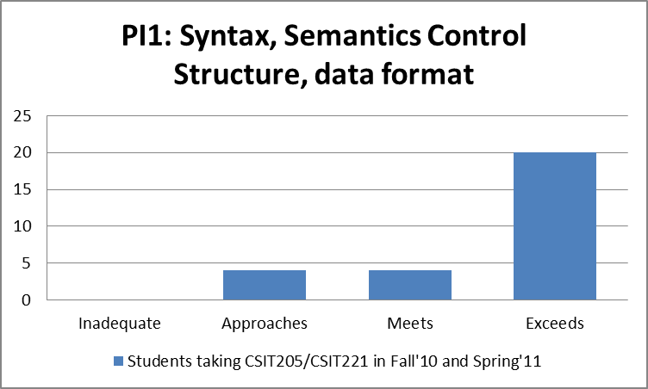  Figure 1: Assessment Results of Performance Indicator-1 “Demonstrate knowledge of and skill regarding the syntax and semantics of a high level programming language, its control structures, and its basic data representations”  ***  In a superb demonstration of their programming skills, an overwhelming majority of the students were able to master the data abstraction mechanisms by extending or using an ADT (Abstract Data Type) in their programs. Thus 93% of them met or exceeded the standard as shown in Figure-2.  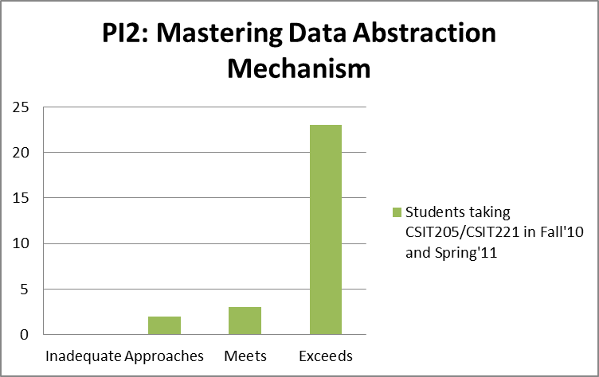  Figure 2: Assessment Results of Performance Indicator-2 “Demonstrate knowledge of and skill regarding common data abstraction mechanisms (e.g., data types or classes such as arrays, files, stacks, classes, etc.)”  ***  For the Performance Indicator-3, i.e. demonstrating skills and knowledge about program correctness issues, 89% of the students met or exceeded the standard by testing the program against a supplied data set or by generating their own test data for the program. The nature of the programming assignments was such that mostly the students of CSIT205 generated their own data to test the programs and the students of CSIT221 were given the test data. Figure-3 shows the results for Performance Indicator-3.  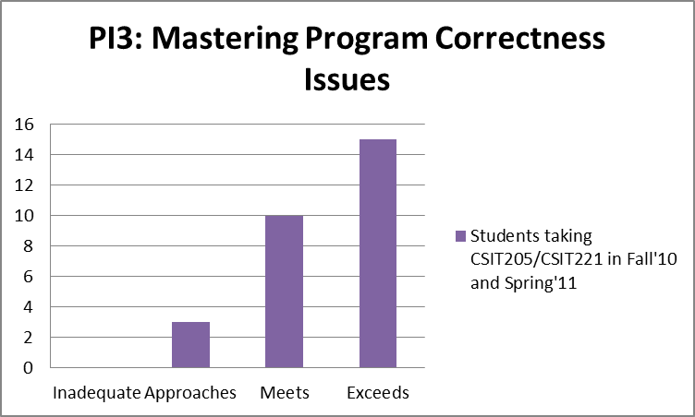  Figure 3: Assessment Results of Performance Indicator-3 “Demonstrate knowledge of and skill regarding program correctness issues and practices (e.g., testing program results, test data design, loop invariants)”
Conclusions
What conclusions did the department reach about student learning as a result of their assessment efforts? | The above results indicate that most of our students in the intensive programming courses CSIT 205 and CSIT 221 are able to grasp the main concepts of developing software. They demonstrate knowledge and skills of the syntax and semantics of high level programming languages, their control structures and data representations. They work with ADT’s and master complex tasks of extending or using ADT’s in their applications. They are able to test the programs with the data specified by the Instructor or generate their own test data. These findings indicate that the students are building strong foundations in software development with the help and guidance of excellent faculty members who motivate the students to learn and challenge them with programming projects of varying difficulty. The need for stressing program correctness and for testing the programs with own generated data is emphasized.

Dissemination and Use of 2010-2011 Assessment Findings
How have you shared/will you share assessment results with other faculty, staff, administration, and students? | Describe specifically how data has been or will be shared and with whom.  We have completed two rounds of assessment this year. The report of the first round has already been shared with faculty and the administration. This is the consolidated assessment report for the academic year 2010-11 which after approval will be placed on Angel and the department web site for sharing with the department faculty. The results will be discussed at the first department meetings in Fall’11. It will be forwarded to Assistant Dean Dr. Ingrid Johnston-Robledo for approval. As part of the department annual report, it will be share with the administration.
How will these findings be used to improve teaching and learning in your department? Please specifically describe the actions that will be taken as a result of the findings. | Describe how the data will be used. Here are some examples to think about:  Note: The changes below did not come solely from the assessment data. They were result of the 5-year review of our program, as a result of Dean’s request to go for professional accreditation, the high demand of interns in Computer Science and Computer Information Systems, the budget cuts, and the constantly developing technology and software innovations.  Changes to the Assessment Plan: Based on the results of the initial round of our graduating seniors survey, we completely revised the survey instrument. When we read the answers that students had provided, it became clear the students did not all interpret the questions in the same way. As a result, we revised the instrument to make the questions clearer. As mentioned above, we completely rewrote our assessment methodology this year. It is a bit early to evaluate how well this has worked out, but we anticipate that we will have to make substantial changes again in order to conform to ABET requirements. We agreed with the Dean to hold off any further significant changes on this until we have had a chance to become more familiar with ABET requirements. We anticipate sending representatives to an ABET workshop next year in order to fully come up to speed on ABET requirements.  Changes to the Curriculum: We have made some relatively minor changes this year, including introducing a few new courses (particularly those of interest to the software industry) and revising some prerequisites this year, but we are planning to undertake a more far reaching review next year in conjunction with the catalog revision cycle and our assessment of ABET accreditation. We believe we are going to have to eliminate or consolidate some tracks and courses in order to be able to continue to staff those courses that are essential and those courses that are of greatest interest to the software industry. We are also planning to encourage our students to have hands-on experience provided by the Technology Incubator Firms.  Changes to the Academic Process: In conjunction with our curriculum review next year one item we will be looking very closely at is the frequency of our course offerings so that we reduce the upper-level courses with low enrollment. However, no changes were made this year. We did hold two advising workshops in an effort to help faculty improve their advising processes. One change in technology that was made was that we offered one course this semester at both SUNY-Fredonia and SUNY-IT via a video link up. This was not a standard distance course; rather we attempted to create an in-classroom experience for students on both sides of the state.
  Changes to the Assessment Plan | - revision of intended learning outcomes  - revision of measurement approaches  X changes in data collection methods  - changes in the sampling
  Changes to the Curriculum | - changes in teaching techniques  - revision of prerequisites  - revision of course sequence  - revision of course content  X addition of courses  - deletion of courses
  Changes to the Academic Process | - revision of admission criteria  - revision of advising standards or processes  - improvements in technology  - changes in personnel  X changes in frequency or scheduling of course offering

Closing the Loop: Review of Previous Assessment Findings and Changes
What is one change your department has implemented in recent years as a result of assessment data? | We have incorporated into our curriculum some more applied elements to help students perform better in job interviews and in their early months in their jobs. These include some practical network management skills (including network security), database administration, and significant coverage of design patterns and UML.
Describe the process for implementing this change. | The changes were implemented specifically in individual courses by the course instructors. In addition, our network administrator and our student lab staff were instrumental in setting up a separate network (not attached to the college network) so students could work on network security issues.
How has this change been assessed? | Mostly this is still pending. We’ll most likely see the results of this first in our graduates’ survey.
What were the findings of the assessment(s)? | While we don’t have adequate data from our surveys yet to formally assess this, comments from students (particularly after they have been out on job interviews) have been very positive.
How do you plan to (continue to) use this information moving forward? | It’s a delicate balance in our curriculum between theory and practice. We will continue to calibrate the quantity of each as we receive more information from student surveys.

Appendix-I: Student Learning Outcomes and Rubric for Assessing Goal-1


State University of New York at Fredonia
Department of Computer and Information Sciences
2154 Fenton Hall (716) 673-4820

- Goals for student learning (Student Learning Outcomes):
In accordance with the department mission to provide outstanding education to its students we expect our graduates to be able to:
1. Demonstrate core knowledge of computing/information technology and demonstrate robust programming skills.
2. Be familiar with the computer organization and system software.
3. Clearly communicate the computer science/computer information systems concepts.
4. Be able to analyze a real-life problem, identify and define computing requirements for its solution and use appropriate software to solve it.

RUBRIC SHEET FOR ASSESSMENT OF GOAL 1
“Demonstrate core knowledge of computing/information technology and demonstrate robust programming skills”

Performance Indicator | Inadequate | Approaches Standard | Meets Standard | Exceeds Standard
Demonstrate knowledge of and skill regarding the syntax and semantics of a high level programming language, its control structures, and its basic data representations | The program does not produce correct results. | The program produces correct results but does not display them correctly. | The program works and produces the correct results and displays them correctly. It also meets the specifications. | The program works and meets all of the specifications. It is commented out well.
Demonstrate knowledge of and skill regarding common data abstraction mechanisms (e.g., data types or classes such as arrays, files, stacks, classes, etc.) | Does not demonstrate knowledge about ADT/class such as an array, file, stack, etc.). | Demonstrates knowledge about ADT/class such as an array, file, stack, etc.). | Select an ADT/class appropriate for a given task and appropriately use it. | Extend a given ADT/class with additional features or use it for an application.
Demonstrate knowledge of and skill regarding program correctness issues and practices (e.g., testing program results, test data design, loop invariants) | No output. | Determine whether a program operates correctly on a single example. | Test the program on a supplied data set. | Develop and implement a set of test data for a given problem.

Appendix-II: Curriculum Map
CURRICULUM MAPS
A mapping of Computer Information Systems courses to goals:

Code | Name | Goal #
Core courses:
CSIT 151 | Introduction to Information Systems | Goal 1
CSIT 105 | Visual BASIC I | Goal 1
CSIT 121 | Computer Science I | Goal 1
CSIT 205 | Visual BASIC II | Goal 1
CSIT 221 | Computer Science II | Goal 1
CSIT 107 | Web Programming I | Goal 1
CSIT 207 | Web Programming II | Goal 1
CSIT 251 | Information Systems Structures | Goals 2, 4
CSIT 312 | Computer Structures | Goal 2
CSIT 351 | Business Systems Development | Goal 4
Electives:
CSIT 203 | Multimedia Systems | Goal 1
CSIT 241 | Discrete Math for Computer Science I | Goal 2
CSIT 335 | Data Communications/Networks I | Goal 2
CSIT 341 | Data Structures | Goal 1
CSIT 425 | Software Engineering | Goals 3, 4
CSIT 435 | Data Communications/Networks II | Goals 2, 4
CSIT 455 | Relational/Object Databases | Goals 3, 4
CSIT 456 | Information and Decision Support Systems | Goals 3, 4
CSIT 461 | Intro to AI and Knowledge Engineering | Goals 3, 4
CSIT 462 | Computer Graphics | Goals 3, 4
CSIT 463 | Intro DIP/Computer Vision | Goal 4
CSIT 471 | Information Systems Management | Goal 4
CSIT 473 | Data Warehouse and Mining | Goal 4
CSIT 475 | Electronic Commerce | Goal 4
A mapping of Computer Science courses to goals:

Code | Name | Goal #
Core courses:
CSIT 121 | Computer Science I | Goal 1
CSIT 221 | Computer Science II | Goal 1
CSIT 224 | Problem Solving using Objects | Goal 1
CSIT 231 | System Programming | Goal 1
CSIT 241 | Discrete Math for Computer Science I | Goal 1
CSIT 311 | Assembly Language/Computer Organization | Goal 2
CSIT 321 | Paradigms of Programming Language | Goals 1, 2
CSIT 341 | Date Structures | Goals 1, 2
CSIT 242 | Discrete Math for Computer Science II | Goal 2
CSIT 413 | Computer Architecture | Goals 2, 3, 4
CSIT 425 | Software Engineering | Goals 3, 4
CSIT 431 | Intro to Operating Systems | Goal 2, 3
CSIT 433 | Compiler Construction | Goal 2, 3
CSIT 437 | Advanced Operating Systems | Goal 2, 3
Electives:
CSIT411 | Programming for Embedded Microcontrollers | Goals 2
CSIT435 | Data Communications/Networks II | Goals 2, 3, 4
CSIT441 | Analysis/Design of Algorithms | Goals 3, 4
CSIT443 | Theory of Computation | Goals 1, 2
CSIT455 | Relational/Object Databases | Goal 4
CSIT461 | Intro to AI and Knowledge Engineering | Goal 4
CSIT462 | Computer Graphics | Goals 3, 4
CSIT463 | Intro DIP/Computer Vision | Goal 4

Appendix-III: Results of Graduating Students Survey

Part I: The questionnaire
State University of New York at Fredonia
Department of Computer and Information Sciences
2154 Fenton Hall (716) 673-4820

SURVEY OF Computer Science/computer information systems GRADUATES
Please check the appropriate entry, or choose the most suitable option, or fill the blanks for each of the question given below where possible.

1. You earned your B.S. degree in
  - Computer Science
  - Computer Information Systems

2. a. Year started at SUNY Fredonia_____________ Year graduated_______________
b. Did you change your major? Yes _____ No______
If Yes:
c. What was your previous major?_________________________
d. Did you transfer from another college to SUNY Fredonia? Yes _____ No______
If Yes:
e. How many credit hours did you transfer?
Less than 30____ Between 30 and 60______ Between 60 and 75____ Over 75____
f. How many semesters overall you spent at college (at SUNY Fredonia and the college your transferred from)? ______
3. On a scale of 6 to 1 (with 6 being Excellent and 1 being very poor): How satisfied are you with your education at the Department of Computer and Information Sciences in SUNY Fredonia?

4. Do you already have a job offer?
- Yes b. No
If yes, is it related to your major?
  - Yes b. No

5. Do you plan to attend graduate school?
- Yes, already accepted into graduate school; Field: ___________
- Yes, applying now; Field: _____________
- Yes, in the future
- No
6. List five courses you liked the most at Fredonia
a. ___________________________________________
b. ___________________________________________
c. ___________________________________________
d. ___________________________________________
e. ___________________________________________

7. If you have a job offer, list four courses that were most beneficial to you in securing the job.
a. ___________________________________________
b. ___________________________________________
c. ___________________________________________
d. ___________________________________________

8. If you had the option to take more elective choices in the discipline, what topic areas would you have liked to have taken at SUNY Fredonia?
- _________________________________________
- _________________________________________
- _________________________________________
- _________________________________________
9. How accessible do you feel faculty offices and classrooms were?
(inaccessible) 1 2 3 4 5 (very accessible)

10. Do you think the access you had to workspace and equipment were sufficient for your coursework
(disagree) 1 2 3 4 5 (agree)

11. Do you have a positive remark/comment(s) to share? ____________________________________________________________________________
____________________________________________________________________________
____________________________________________________________________________
12. Do you have a negative remark/comment(s) to share?
____________________________________________________________________________
____________________________________________________________________________
____________________________________________________________________________

Part II: Analysis of returned surveys
Results of the 2011 Spring Graduates Survey

Ten students submitted responses to the graduates’ survey out of 33 students graduating in the Spring of 2011. This is a response rate of 30% and the results should be considered with that in mind. Of the surveys received, six were from CS majors, two were from CIS majors and two were from students majoring in both fields.

Not counting transfer students (there were 2), three started the program in 2006, 3 in 2007, and 2 in 2008. All but two of the students who took more than 4 years to graduate had changed majors during their time at Fredonia, and their previous majors were in one type or another of Education (Math Ed, Music Ed, Adolescent Ed). We may need to clarify this question because two of the students who indicated that they had changed majors listed their previous major as “undeclared” and “liberal arts”. Of the students who entered our department as Freshmen, all of them graduated in four years.

Two of the respondents transferred into Fredonia from other schools with a substantial number of transfer credits (more than 60). They did take longer than 4 years in total to graduate.

When asked to rate their level of satisfaction with the CIS Department on a scale of 1 to 6, the average score was 4.5. It is not clear whether this relatively low value is due to response bias (more satisfied students may have been less interested in filling out the survey) or not.

Job searches seem to be going well with 6 of the 10 respondents indicating that they already had lined up a job, five of these in the CS field. Again this may reflect response bias as students who are doing well are more likely to respond than students who are not.

None of these students has been accepted into graduate school, mostly because they are more interested in immediately entering the job market rather than pursuing a graduate education. The one student who is in the process of applying to grad schools is doing so in marketing. Most of our graduates do report that they expect to further their education at some point in the future.

When asked to name their favorite courses, a wide range of courses were specified, both within and outside the CIS department. The courses that were most often mentioned were CSIT 224 (4 votes), CSIT 431 (3 votes), CSIT 433 (3 votes), and CSIT 461 (3 votes).

When asked which courses were most helpful to them in securing a job, we also had a wide range of courses mentioned. Those receiving the most votes were CSIT 224, CSIT 321, and CSIT 425 (each with 3 votes). When asked which electives they wish they had been able to take, we received two kinds of responses. Some people interpreted this as asking which of our courses they did not take because they didn’t have time, while others thought it meant which courses did we not offer that they wished we did offer. In the former category, the most often mentioned courses were Android Programming, iPhone Programming, and more database classes. Students also wish that we offered courses in Java and C#.

Students were asked on a 1 to 5 scale whether they thought faculty offices and classrooms were accessible. The average score was 4.5. Students were also asked whether the workspace and equipment was adequate for them to do their coursework. Not surprisingly, this result came up lower, at 3.5 on the same 1 to five scale.

Students were asked for their general comments in the final questions. The comments covered a wide range of topics, but the only item that came up more than once was a desire for more “hands on” applied work.

