State University of New York at Fredonia
Interdisciplinary Studies
Web Programming Annual Report
2014-2015
Instructions: Fill in all of the requested information on or before June 15, 2015.

1. Department Information
Department | Interdisciplinary studies
Academic Program Titles | Interdisciplinary Web Programming Minor
Degrees Awarded | Minor
Chair/Contact Person | Reneta Barneva
Title | Coordinator/Professor
Email | Reneta.Barneva@fredonia.edu
Phone | 716-673-4750, secretary 716-673-4820

3. Summary of Curricular Changes/Developments/Innovations made as a result of student learning outcomes assessment (copy and paste blank table as needed for multiple outcomes assessed):

Note: Data was collected in Fall 2014 by the instructor of CSIT 207 Prof. Stephen Raghunath.

Goal 1: | An ability to analyze a problem and identify and define the programming/scripting requirements appropriate to its solution.
Assessment Method(s): | The formal assessment of all goals is done though the advanced web programming course CSIT 207. The instructor provided the Interdisciplinary Minor Coordinator with the results of the final exam in which there were appropriate questions. The questions were assessed using the rubric below, the items of which were transformed to a scale.
  Key | Does Not Meet | Meets | Exceeds
  Outlook | No project, or project does is not a Content Management Site as per the requirements | Project is a CMS, but does not display all the requirements | Project is a CMS and has all the requirements
  Error Handling | Site has no PHP error handling | Site does not display PHP errors on common tasks, but may display an error on a random use, or does not handle them well | Site does not display PHP errors or warnings for any reason and handles the error well
  Debugging | Site has no 404 handling | Site has 404 handling, but does not handle it well | Site has 404 handling and displays appropriately for such use cases
Data Source: | The data was collected in Fall 2014. There were 22 samples out of 24 students in the class (92%). The following Performance Indicators (PI’s) were assessed:  - Outlook  - Error Handling  - Debugging
Results: | The overall results of Goal 1 assessment show that 95% (21 out of 22) of the students are able to meet or exceed the standards for web site outlook, 91% (20 out of 22) for error handling and 95% (21 out of 22) of the students meet or exceed the debugging of web pages.  Figures 1 shows the results of the assessment of the three PIs for Goal 1. For all three PI’s 94% of the students meet or exceed the standards, which indicate excellent learning outcomes.  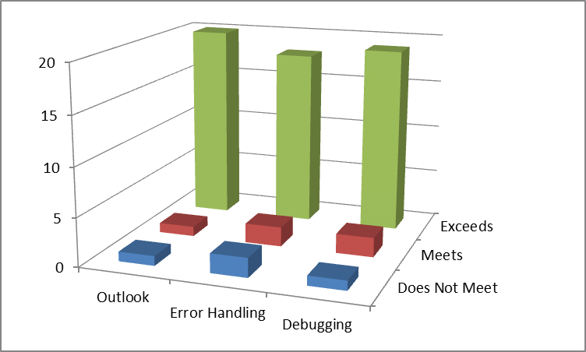  Figure 1: Assessment results for Goal 1.
  PI’s | Does not meet | Meets | Exceeds
  Outlook | 1 | 1 | 20
  Error handling | 2 | 2 | 18
  Debugging | 1 | 2 | 19
Conclusions/Changes Made: | The results indicate that the overwhelming majority of students (over 86%) meet or exceed this goal. It does not seem that any changes have to be made.

Goal 2: | An ability to design, implement, and evaluate a web programming/computing component to meet desired needs.
Assessment Method(s): | The formal assessment of all goals is done though the advanced web programming course CSIT 207. The instructor provided the Interdisciplinary Minor Coordinator with the results of the final exam in which there were appropriate questions. The questions were assessed using the rubric below, the items of which were transformed to a scale.
  Key | Does Not Meet | Meets | Exceeds
  Form | Site does not have a working form for creating entries | Site has a working form for creating entries, but is missing form standards | Site has a working form for creating entries, and conforms to web development standards
  Database | No conceptual paper on database structure and integrity | Paper on database structure is limited and non-descriptive | Paper on database structure accurately explains it's architecture and the benefits within
  Security | Site has no security measures | Site has at least user authentication or SQL injection protection | Site has user authentication and SQL inject protection
Data Source: | The data was collected in Fall 2014. There were 22 samples out of 24 students in the class (92%). The following Performance Indicators (PI’s) were assessed:  - Form  - Database  - Security
Results: | The overall results of Goal 2 assessment show that 100% (22 out of 22) of the students are able to meet or exceed the standards for using forms in their web sites, 60% (13 out of 22) for using databases, and 100% (22 out of 22) for using security components.  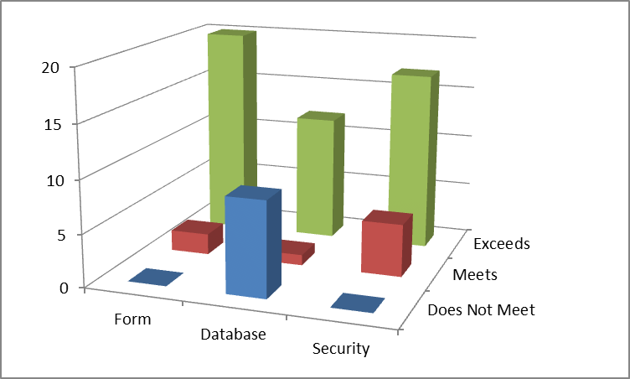  Figure 2: Assessment Results for Goal 2.
  PI’s | Does not meet | Meets | Exceeds
  Form | 0 | 2 | 20
  Database | 9 | 1 | 12
  Security | 0 | 5 | 17
Conclusions/Changes Made: | Figure 2 shows the results for the three PIs. The results for PI’s Form and Security show 100% achievement. The PI Database shows a significant increase from 45% to 60% of students that meet or exceed the standards, but there is still room for further improvement.

Goal 3: | An ability to design web site interface.
Assessment Method(s): | The formal assessment of all goals is done though the advanced web programming course CSIT 207. The instructor provided the Interdisciplinary Minor Coordinator with the results of the final exam in which there were appropriate questions. The questions were assessed using the rubric below, the items of which were transformed to a scale.
  Key | Does Not Meet | Meets | Exceeds
  Database | Site does not use a database | Site uses a database, but it is not in at least 3rd normal form | Site uses a database that is at least in 3rd normal form
  Formatting | Code has no formatting standards | Code has standard formatting with only a handful of readable errors | Code is well formatted with no formatting errors
  Conventions | Site does not meet Convention standards | Site uses some of the web development standards such as functions, includes, separate CSS files, separate PHP files for code reuse | Site uses all of the defined conventions for web development
  Design | Site show little or no aesthetic design elements | Site displays some depth to the aesthetic design | Site shows well thought out and congruent feel to the aesthetic design and implementation
Data Source: | The data was collected in Fall 2014. There were 22 samples out of 24 students in the class (92%). The following Performance Indicators (PI’s) were assessed:  - Data  - Formatting  - Conventions  - Design
Results: | The overall results of Goal 3 assessment are very strong. They show that 100% (22 out of 22) of the students are able to meet or exceed the standards for validating the data in the web site interface, 100% (22 out of 22) exceed the standard for use appropriate formatting, 100% (22 out of 22) of the students are able to meet or exceed the standards of following conventions, and 86% (3 out of 22) of the students meet or exceed the standard for using appropriate design.  Figure 3 shows the results for the four PIs.  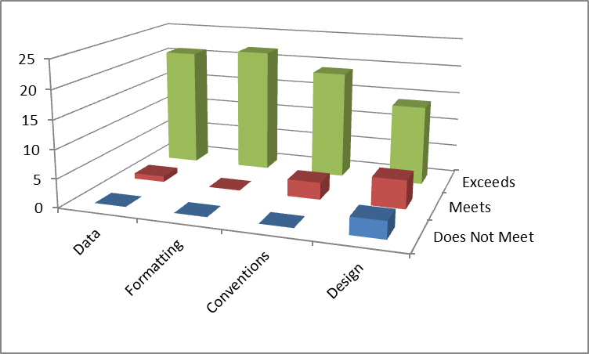  Figure 3: Assessment results for Goal 3.
  PI's | Does not meet | Meets | Exceeds
  Data | 0 | 1 | 21
  Formatting | 0 | 0 | 22
  Conventions | 0 | 3 | 19
  Design | 3 | 5 | 14
Conclusions/Changes Made: | The overall results are quite positive: for three out of the four PI’s – Data, Formatting, and Conventions –the students meet or exceed the standards 100%. For Design the standards are met 86%. These results are still positive, but lower than the other three. This is where the instructors should direct their efforts. It was discussed that it would be good to add a special course on design or Human-Computer Interaction to the minor.

