State University of New York at Fredonia
Interdisciplinary Studies
Web Programming Assessment Report
2015-2016

1. Department Information
Department | Interdisciplinary studies
Academic Program Titles | Interdisciplinary Web Programming Minor
Degrees Awarded | Minor
Chair/Contact Person | Reneta Barneva
Title | Coordinator/Professor
Email | Reneta.Barneva@fredonia.edu
Phone | 716-673-4750

3. Summary of Curricular Changes/Developments/Innovations made as a result of student learning outcomes assessment (copy and paste blank table as needed for multiple outcomes assessed):

Note: Data was collected in Fall 2015 by the instructor of CSIT 207 Prof. Stephen Raghunath.

Goal 1: | An ability to analyze a problem and identify and define the programming/scripting requirements appropriate to its solution.
Assessment Method(s): | The formal assessment of all goals is done though the advanced web programming course CSIT 207. The instructor provided the Interdisciplinary Minor Coordinator with the results of the final exam in which there were appropriate questions. The questions were assessed using the rubric below, the items of which were transformed to a scale.
  Key | Does Not Meet | Meets | Exceeds
  Outlook | No project, or project does is not a Content Management Site as per the requirements | Project is a CMS, but does not display all the requirements | Project is a CMS and has all the requirements
  Error Handling | Site has no PHP error handling | Site does not display PHP errors on common tasks, but may display an error on a random use, or does not handle them well | Site does not display PHP errors or warnings for any reason and handles the error well
  Debugging | Site has no 404 handling | Site has 404 handling, but does not handle it well | Site has 404 handling and displays appropriately for such use cases
Data Source: | The data was collected in Fall 2015. There were 32 samples out of 32 students in the class (100%). The following Performance Indicators (PI’s) were assessed:  - Outlook  - Error Handling  - Debugging
Results: | The overall results of Goal 1 assessment show that 88% (28 out of 32) of the students are able to meet or exceed the standards for web site outlook, 88% (28 out of 32) for error handling and 88% (28 out of 32) of the students meet or exceed the debugging of web pages.  Figures 1 shows the results of the assessment of the three PIs for Goal 1. For all three PI’s 88% of the students meet or exceed the standards, which indicate excellent learning outcomes.  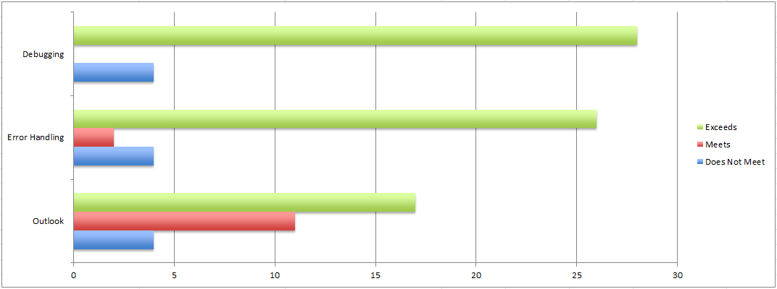  Figure 1: Assessment results for Goal 1.
  PI’s | Does not meet | Meets | Exceeds
  Outlook | 4 | 11 | 17
  Error handling | 4 | 2 | 26
  Debugging | 4 | 0 | 28
Conclusions/Changes Made: | The results indicate that the overwhelming majority of students (over 88%) meet or exceed this goal. It does not seem that any changes have to be made.

Goal 2: | An ability to design, implement, and evaluate a web programming/computing component to meet desired needs.
Assessment Method(s): | The formal assessment of all goals is done though the advanced web programming course CSIT 207. The instructor provided the Interdisciplinary Minor Coordinator with the results of the final exam in which there were appropriate questions. The questions were assessed using the rubric below, the items of which were transformed to a scale.
  Key | Does Not Meet | Meets | Exceeds
  Form | Site does not have a working form for creating entries | Site has a working form for creating entries, but is missing form standards | Site has a working form for creating entries, and conforms to web development standards
  Database | No conceptual paper on database structure and integrity | Paper on database structure is limited and non-descriptive | Paper on database structure accurately explains it's architecture and the benefits within
  Security | Site has no security measures | Site has at least user authentication or SQL injection protection | Site has user authentication and SQL inject protection
Data Source: | The data was collected in Fall 2015. There were 32 samples out of 32 students in the class (100%). The following Performance Indicators (PI’s) were assessed:  - Form  - Database  - Security
Results: | The overall results of Goal 2 assessment show that 88% (28 out of 32) of the students are able to meet or exceed the standards for using forms in their web sites, 88% (28 out of 32) for using databases, and 88% (28 out of 32) for using security components.  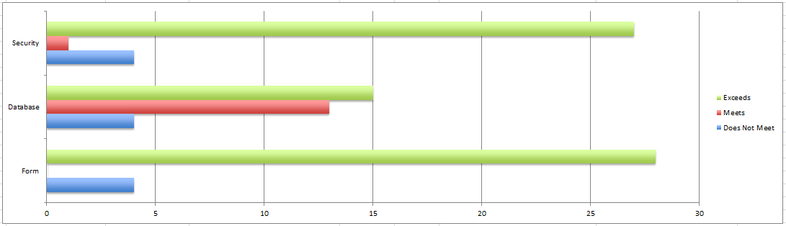  Figure 2: Assessment Results for Goal 2.
  PI’s | Does not meet | Meets | Exceeds
  Form | 4 | 0 | 28
  Database | 4 | 13 | 15
  Security | 4 | 1 | 27
Conclusions/Changes Made: | Figure 2 shows the results for the three PIs. The results for PI’s Form and Security show 88% achievement. The PI Database shows a significant increase from 60% to 88% of students that meet or exceed the standards.

Goal 3: | An ability to design web site interface.
Assessment Method(s): | The formal assessment of all goals is done though the advanced web programming course CSIT 207. The instructor provided the Interdisciplinary Minor Coordinator with the results of the final exam in which there were appropriate questions. The questions were assessed using the rubric below, the items of which were transformed to a scale.
  Key | Does Not Meet | Meets | Exceeds
  Formatting | Code has no formatting standards | Code has standard formatting with only a handful of readable errors | Code is well formatted with no formatting errors
  Conventions | Site does not meet Convention standards | Site uses some of the web development standards such as functions, includes, separate CSS files, separate PHP files for code reuse | Site uses all of the defined conventions for web development
  Design | Site show little or no aesthetic design elements | Site displays some depth to the aesthetic design | Site shows well thought out and congruent feel to the aesthetic design and implementation
Data Source: | The data was collected in Fall 2015. There were 32 samples out of 32 students in the class (100%). The following Performance Indicators (PI’s) were assessed:  - Formatting  - Conventions  - Design
Results: | The overall results of Goal 3 assessment are very strong. They show that 88% (28 out of 32) exceed the standard for use appropriate formatting, 88% (28 out of 32) of the students are able to meet or exceed the standards of following conventions, and 88% (28 out of 32) of the students meet or exceed the standard for using appropriate design.  Figure 3 shows the results for the four PIs.  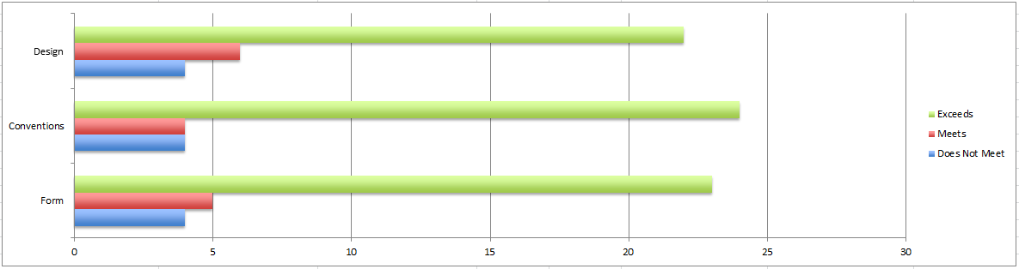  Figure 3: Assessment results for Goal 3.
  PI's | Does not meet | Meets | Exceeds
  Data | 0 | 1 | 21
  Formatting | 0 | 0 | 22
  Conventions | 0 | 3 | 19
  Design | 3 | 5 | 14
Conclusions/Changes Made: | The overall results are quite positive: for all PI’s – Formatting, Design, and Conventions – the students meet or exceed the standards 88%. Although this seems lower than the previous years, it should be noted that the same four students do not meet the standards. This probably is due to the fact that they stopped working on the course without withdrawing from it.  It is very positive that all the other students met all the standards.  There is an improvement in the PI Design, which is probably due to the fact that the course Human-Computer Interaction was added to the minor.

