Executive Board:

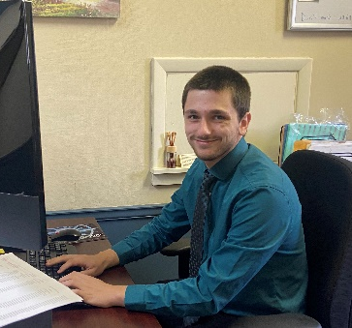
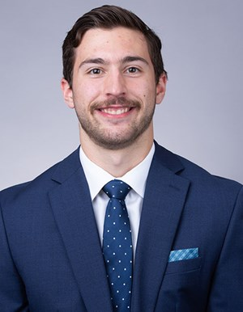
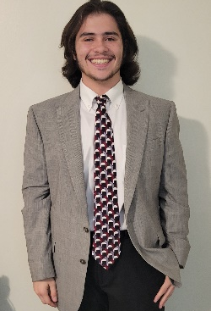

President: Nicholas Nosbisch Vice President: David Sudbrink Treasurer: Christopher Bollman

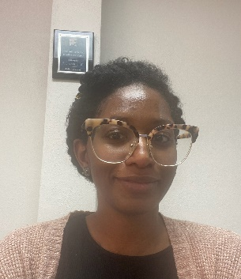
Program Chair: Julia DeLand Special Events: Jenna Leid

PR Chair: Kylie Beck PR Assistant: Portia McCrimmon
Find us on Instagram @fredaccountingsociety

