December 6, 2022

Dear Fredonia Bassoon Studio,

It’s time to think about the SPRING 23 semester, and the Ensemble Placement Auditions!
Bassoon auditions will take place on Saturday, January 21st at 12:30pm.

You will find ensemble audition information on the School of Music website, under the “current students” tab. This link is not yet updated for the spring auditions, but check here later this month. Here is the link:

http://home.fredonia.edu/music/instrumental-audition

Included with this letter is the audition music for the placement auditions. In addition to the three excerpts listed on the next two pages, your audition will include a sight-reading excerpt. The auditions will take place behind a screen.

I strongly recommend that you listen to recordings of these pieces so you understand the context and style of each excerpt. Check out this fantastic website, “The Orchestral Bassoon”:

http://www.orchestralbassoon.com/

All three of the audition excerpts are listed on the “The Orchestral Bassoon” website, including recording examples of these specific excerpts, parts and scores, and other useful information.

Work toward performance tempi as you practice, but when it gets close to audition day, choose a tempo that allows you play accurately (technically and rhythmically) and with a steady pulse. Also consider these aspects of your playing: intonation, tone, articulation, phrasing, and style. If you have any questions or concerns, email me at laura.koepke@fredonia.edu.

The audition excerpts are included here, on the next two pages.

Happy practicing!

Ms. Koepke

Spring 2023 Ensemble Placement Audition Excerpts, three in total

Violin Concerto in D Major, Op. 77
JOHANNES BRAHMS

II. Adagio
mm. 1 to 32, bassoon II

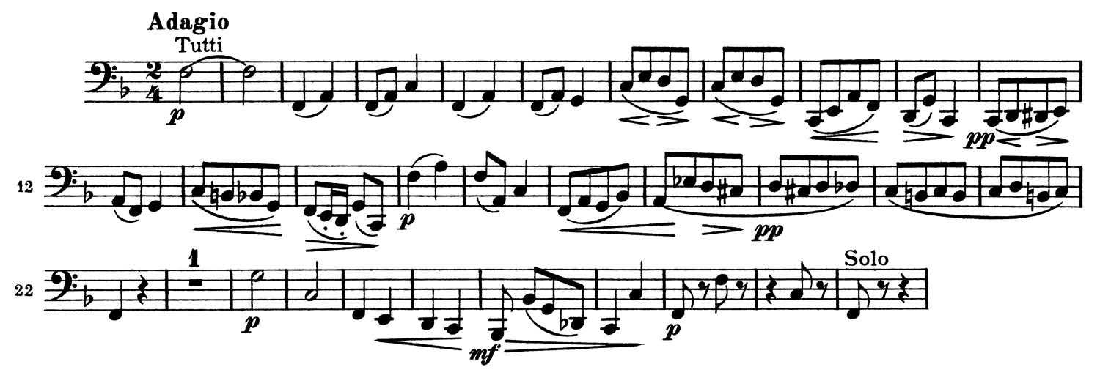

Symphony No. 3 in A Minor, Op. 56 'Scottish'
FELIX MENDELSSOHN BARTHOLDY

II. Vivace non troppo
mm. 48 to 67, bassoon I

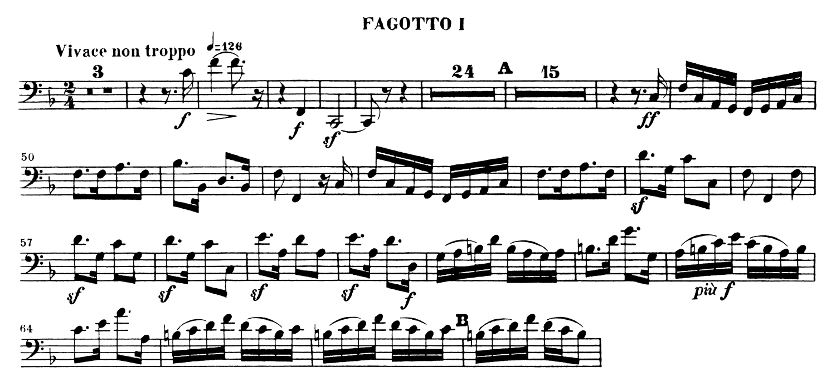

"Una furtiva lagrima"
FROM ACT II, SCENE VII OF L'ELISIR D'AMORE
GAETANO DONIZETTI

mm. 2 to 9, bassoon I

