Ensemble Auditions for Oboe Fall 2020
Friday, August 21st at noon.

Prepare all five excerpts below!!

Remember the most important things about preparing for and performing ensemble auditions, in order of importance:
- Clarity and consistency of pulse
- Musicality and making sense
- Internal rhythms and tempo that brings out the character
- Accuracy of technique and tuning
- Articulation and style (may be different for each excerpt)

Suggested tempi are provided for each excerpt, but they are only targets. Play the closest to the tempo you can and still give a convincing, accurate performance. How you “manage”, get through each excerpt is key.

Some of these excerpts are not explicit about phrasing and dynamics. The lack of expression markings does not mean that you should play without expression. Be musical! Make the piece make sense! Listen to recordings for ideas!
Listen to all these excerpts many times so you understand the context, and style. Listen to more than one recording. Naxos, YouTube, and Spotify all have good recordings. The audition committee can tell when you haven’t listened to the piece.
Also play along with these excerpts on YouTube with an orchestra. And you can slow down youtube as needed.
Remember these auditions will be blind and behind a screen. Don’t speak or give any indication of who you are during the audition.
Please let me know in advance of any class conflicts with ensemble rehearsal times and of your interest in playing, or not playing, English horn.
We may or may not get through all of these excerpts in your audition.

Please let me know if you have any questions!! Dr. H
- Ludwig Von Beethoven Symphony #6 (three excerpts)
The full part is available on IMSLP

Movement #1: Allegro ma non troppo
MM= quarter at 100

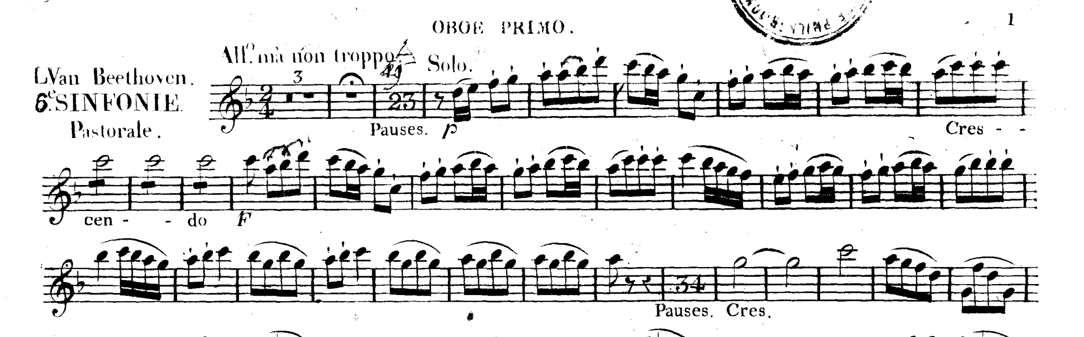

Movement #2: Andante Molto moto
MM= dotted quarter at 45-50. Start at “solo” marking and end on b after trill.

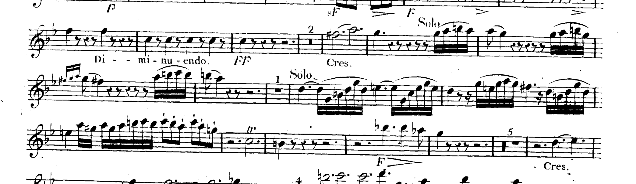

Movement #3: Allegro
MM= dotted half at 72-90 Start at “solo” and go until the double bar.

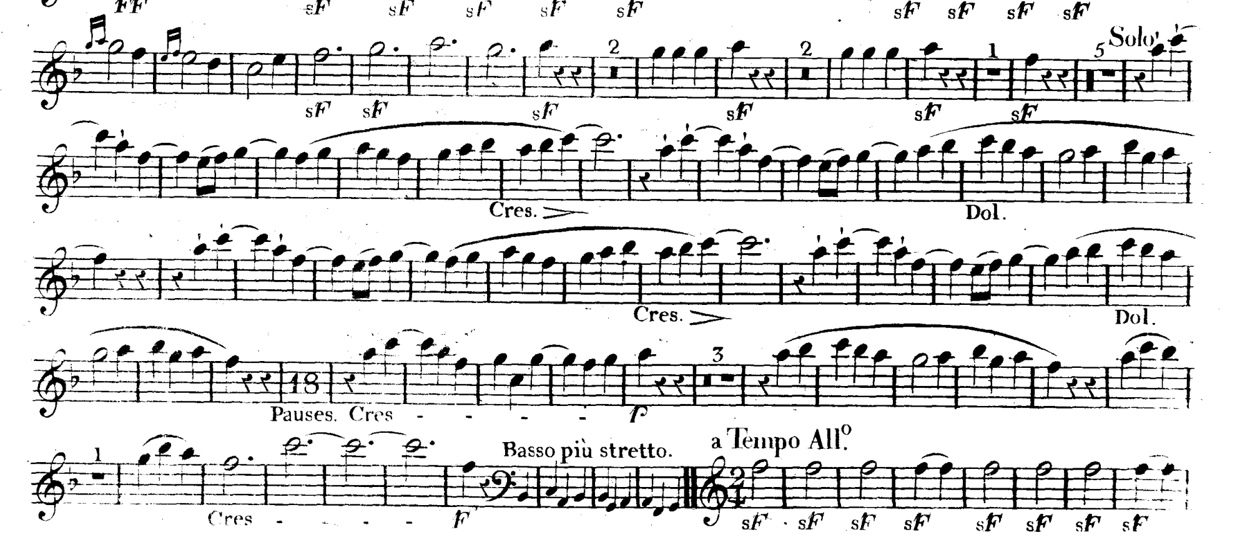

- Tchaikovsky Symphony 4 (two excerpts)
The full part is available on IMSLP

Movement #1: Moderato assai, quasi Andante
MM= eighth note at 112-126; dotted quarter at @40

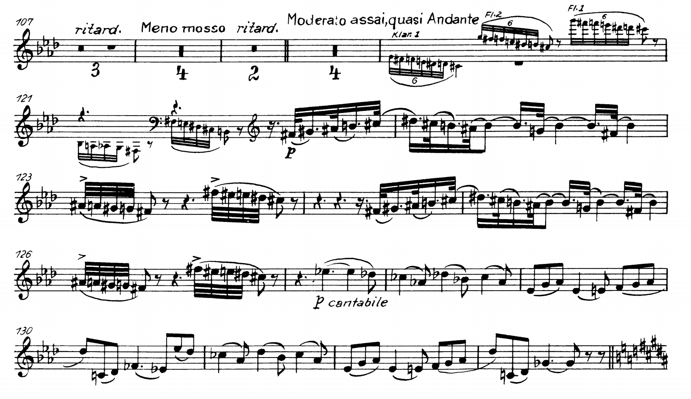

Movement #2: Andante in modo canzona
MM= quarter note @60, with only one breath at the most. Stop at A.
