Ensemble Seating Auditions for HORN
for the Fall 2020 Semester
August 21, 2020

HORN PLAYERS! Here are the excerpt passages for the ensemble seating auditions on 8/21/20. Use the excellent resources at https://www.hornsociety.org/hornexcerpts-org to prepare them for the audition: hear great players in world-class orchestras and try to sound like them. We will select from these passages only. Be in touch with me if there are any questions. Use guy@fredonia.edu or my cell # 716-679-5436.

While you are at the International Horn Society web page, consider joining. It’s how the world of horn comes close to you. You’ll see that members have access to special stuff, like the Randy Gardner tips on some of the excerpts you will be practicing; journals, people, information, equipment and opportunities. Consider it.

Most of these excerpts happen to be for horn in F. The final one is for horn in C basso… If you have any uncertainty about that transposition be in touch with me or talk to an experienced player. Use your metronome regularly. Let NOTES, RHYTHM and STYLE be your highest priorities. SOUND is always important, too…we never want to neglect that. I’m excited about the semester ahead of us!

– MG 6/10/20

Saint-Saëns, Symphony No. 3, mvt I

Excerpt 1 – I. Allegro moderato
dotted quarter = 72
(4 before N – 16 after N)
Horn 3 in F
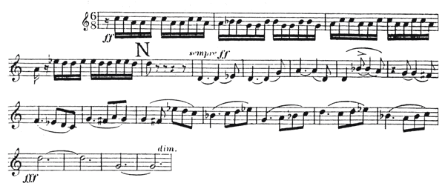

Excerpt 2 – I. Poco adagio
quarter = 60
(Q – S)

Horn 3 in F
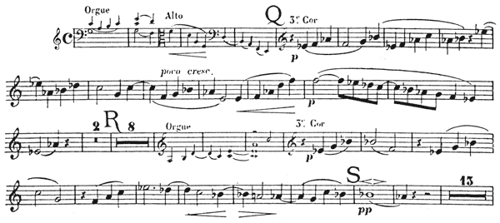

Beethoven, Symphony No. 6, op.68 (The Pastoral)

Excerpt 1 – III. Allegro
dotted half = 108
ms. 132-161 (50 after A – 77 after A)
Horn 1 in F
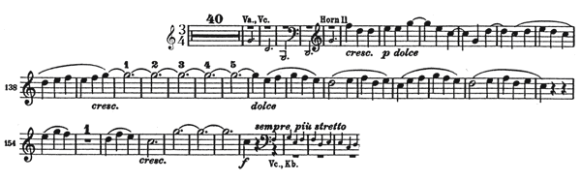

Schumann, Symphony No. 3, op.97 (The Rhenish)

Excerpt 3 – II. Scherzo: Sehr mässig
ms. 25-48
Horn 1 in F
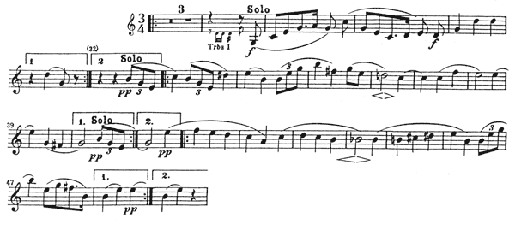

Strauss — Till Eulenspiegel, op. 28 (36 to 17 after 37)
Horn 4 in F
Weber, Overture to Der Freischutz

Horn 4 in C
